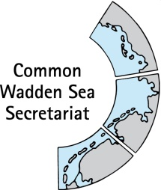
MEETING DOCUMENT
Ad hoc Working Group Swimway (WG-Swimway 20-3)
07 October 2020
Online meeting

Agenda Item: 3. Announcements
Subject: Announcements of participants
Document No.: WG-SWIMWAY 20-3/3
Date: 06 October 2020
Submitted by: all

This document contains announcements of meeting participants as sent beforehand to the Common Wadden Sea Secretariat (CWSS) under busch@waddensea-secretariat.org.

Proposal: The group is invited to note the information.
Announcements

WWF
- Technical Report on „The Living Planet Index (LPI) For Migratory Freshwater Fish” (Deinet et al 2020), including authors of World Fish Migration Foundation, Zoological Society of London (ZSL), World Wide Fund For Nature (WWF) and others has been published.
CWSS
- Ms Christina Nazarri has started as Project Officer to the Partnership Hub within CWSS in September 2020;
- Ms Marine Perrin has started an internship at CWSS in October 2020;
- The next Wadden Sea Board (WSB) meeting (WSB32) scheduled for 18 November 2020 will not be held in Esbjerg, DK, as originally planned. Wadden Sea Board meetings 2021 are scheduled to: WSB 33 Friday 9 April 2021, WSB 34 Friday 27 August 2021, WSB 35 Thursday 18 Nov 2021

