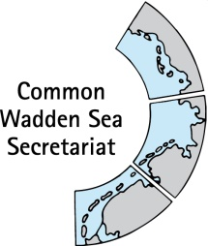
MEETING DOCUMENT
Task Group World Heritage (TG-WH 30)
29 April 2020
Virtual Meeting

Agenda Item: 3
Subject: Announcement The Netherlands
Document No.: TG WH 30/3/3
Date: 24 April 2020
Submitted by: The Netherlands

- Currently an environmental impact assessment is being performed for the electricity cables connecting the wind farms north of the Dutch Wadden islands to the mainland. Cables will be dug underground for the majority of the trajectory. Next to applying the cables, there will be the construction of a platform at the North Sea and a transformation station at land. The environmental impact assessment will also assess the impact on the world heritage site.

- The municipality of Het Hogeland approved on 15th of April the spatial plan for the harbour area of Lauwersoog where the new Wadden Sea World Heritage Visitor Centre will be build. The centre will contain – next to the visitor centre - a restaurant, knowledge institute and seal centre. The plan has been changed from an earlier plan, it is now significant lower, less than 20 Metres, which also the hight of the sluices at Lauwersoog. Also the hotel from the earlier version has been left out. For the realisation of the centre a community consisting of various relevant actors has been formed, our world heritage coordinator is a member. The design will be by the same architect that also developed the centre in Ribe and the new centre in Wilhelmshaven. UNESCO will be informed.

- Due to the Corona crisis all events in the Netherlands are cancelled until the end of August. This means that also the “Dag van het wad” can’t take place at the end of June. Nevertheless we will celebrate 11 years of World heritage by producing an inspirational video with a lot of attention to the OUV and drawing attention to key experiences in the Wadden Sea area.

- PRW is looking with partners in the Dutch Wadden Sea at opportunities to connect our ambitions for the Wadden Sea with new European financing opportunities.

- The Wadden Sea managing authority (Beheerautoriteit Waddenzee) started on the 1st of March 2020.

