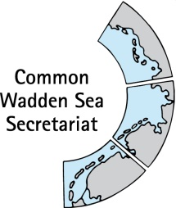

TASK GROUP
World Heritage
TG-WH 26

31 January – 1 February 2019
Bremen

Agenda Item: 7
Subject: Workshop Marine Litter and World Heritage Sites
Document No.: TG-WH 26/7/1
Date: 13 December 2018
Submitted by: CWSS

The document informs on the workshop on impacts on marine litter on World Heritage marine sites, Norderney, 14 – 16 November 2018.
http://whc.unesco.org/en/news/1904

The workshop was jointly organized with the World Heritage Marine Programme (UNESCO WHC) and was financially supported by BMU and MinLNV within the Supplementary Budget 2018 (International cooperation, UNESCO World Heritage Marine Programme).

The workshop also contributes to the implementation of the Leeuwarden Declaration 2018, Article 22 and 23 regarding marine litter.

Proposal: The meeting is invited to note the information and to comment as appropriate.

UNESCO World Heritage marine site managers join forces on Norderney to focus on marine litter
International Workshop on “Impacts of Marine Litter on marine World Heritage Sites”
Norderney/Germany, 14 - 16 November 2018

The workshop was organized by CWSS, the Lower Saxon Wadden Sea National Park Authority, UNESCO World Heritage Marine Programme, with support from the German Federal Ministry for the Environment, Nature Conservation and Nuclear Safety, Dutch Ministry of Agriculture, Nature and Food Quality, Schleswig-Holstein Wadden Sea National Park Authority. KIMO International and the University of Oldenburg
Background
The UNESCO World Heritage List includes 49 ocean sites – distributed across 37 countries – which are therewith recognized for their unique marine biodiversity, singular ecosystem, unique geological processes or incomparable beauty.
As World Heritage sites are of global importance and require special protection to protect and maintain the “Outstanding Universal Value” (OUV) for all humankind, the potential impact of the increasing amount of marine litter needs special attention. This workshop is the first to focus on the problems associated with marine litter specifically in World Heritage marine sites and to look at which of these needs a strategic global solution and what can be done locally.
The workshop aims to analyse the specific challenges and needs to protect the OUV of marine WH sites from pollution by marine litter. Furthermore, the workshop will analyse the strategic role of World Heritage marine sites in reducing the impacts of marine litter on nature values locally and internationally by supporting WH site managers in exchanging best practice examples, mutual learning, creating synergies, and raising awareness on marine litter impacts on the OUVs.
The workshop
To address these issues, World Heritage marine managers and marine litter experts from 11 different nations joined forces this week at a UNESCO workshop hosted at the Wadden Sea island of Norderney. The three-day workshop was held in the framework of the network of managers of the 49 World Heritage marine sites – among them the Wadden Sea, Komodo National Park (Indonesia) and Aldabra Atoll (Seychelles).
The workshop was addressed by Dr Mechtild Rössler, Director of UNESCO’s World Heritage Centre in a video message. She underlined that World Heritage sites are of global importance and require special protection to conserve and maintain their ‘Outstanding Universal Value’ for all humankind, and that the potential impact of the increasing amount of marine litter needs special attention. She regarded the workshop on Norderney is an example of the Wadden Sea countries commitment towards international cooperation and partnering for World Heritage and thanked them organizing this workshop in cooperation with the WH Centre.
During the workshop, the specific challenges and needs to protect World Heritage marine sites from pollution by marine litter were discussed, and best practices on marine litter monitoring, awareness raising and clean up campaigns were exchanged. This provided an opportunity to exchange local experiences on marine litter and reduction measures with other site managers.
Results
In preparation of the workshop, KIMO International conducted a survey amongst all 49 World Heritage marine sites (response rate 94%) which provided a comprehensive overview of the current state of play as to how marine WH sites deal with the challenge of marine litter in order to maintain or even enhance the OUV, as well as negative impacts on socioeconomic aspects. The findings were presented at the workshop and served as basis for the discussion and recommendations:
- Marine litter is an important issue at all WH marine sites (47% very visible, 53 % yes but not very visible.
- Potential effects on coastal and marine life are most likely (multiple answers) on marine mammals (71%), turtles (67%), seabirds (65%), and fish populations (53%). Less than 50% covers plants and animals on land and on or near the ocean floor, and coral reefs.
- Negative impacts on the OUV were regarded for criterion vii ‘Beauty” 72%, criterion ix ‘ecological processes’ 49%, and criterion x ‘biodiversity’ 49 %.
- Main socio-economic impacts of marine litter are tourism (67%), recreation (39%), commercial fishing (20%) and recreational fishing (18%).
- Main sources of marine litter are shipping (61%) and fisheries (53%). A high proportion is local sources (45%) (mainly poor waste management, and litter form tourist and visitors).
The report also concluded that, although marine litter potentially impacts a broad range of organisms, the knowledge about effects of marine litter on organisms the OUV and the local economy. The magnitude, nature and effects of micro- and nano-litter are not well understood neither.
The participants presented a number of examples how the WH sites area dealing with marine litter, such as monitoring and assessment of marine litter (such as NOAA, OSPAR), clean-ups and awareness campaigns (such as beach cleaning activities, beach litter box , and cooperation with stakeholders (e.g. Fishing for Litter, KIMO Green Deal, German Round Table Marine Litter), and addressed also the international perspective (OSPAR, EU-MFSD, UNEP, GESAMP).
The workshop also discussed strategic perspectives in order in order to strengthen the connection between local, national and international programmes, initiatives and action plans, and which role World Heritage could play.
Workshop Report
A summary of the workshop recommendations is in preparation and will be available by end of December 2018. Together with the results from the online survey, the workshop report will be presented during the next global World Heritage marine managers’ conference in 2019, with the objective to strengthen further our collaboration in areas of knowledge exchange and awareness raising.

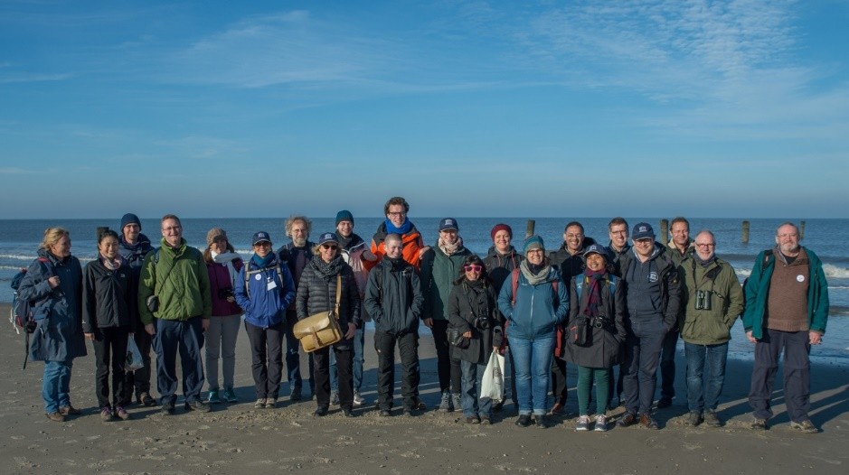

The photo shows the workshop participants on excursion at the White Dune of Norderney and is free to be used in the framework of reporting on the UNESCO workshop. Please refer to “CWSS/ Joachim Trettin”.

ANNEX 1

International Workshop
Impacts of Marine Litter on marine World Heritage Sites
Conversationshaus, Am Kurplatz 1, Norderney
14 - 16 November 2018
Organized by: Common Wadden Sea Secretariat,
Lower Saxon Wadden Sea National Park Authority, in collaboration with UNESCO World Heritage Centre Marine Programme
With support from: German Federal Ministry for the Environment, Nature Conservation and Nuclear Safety, Dutch Ministry of Agriculture, Nature and Food Quality, Schleswig-Holstein Wadden Sea National Park Authority. KIMO International, ICBM University of Oldenburg,

PROGRAMME

Wednesday, 14 November 2018
9:00 Registration
9:15 Opening and welcome addresses (Chairperson: Harald Marencic)
Harald Marencic, Deputy Executive Secretary, Common Wadden Sea Secretariat, Mechtild Rössler, Director UNESCO World Heritage Centre (video message), Gregor Scheiffarth, Lower Saxon Wadden Sea National Park Authority
Municipality of Norderney
9:40 Gregor Scheiffahrt, Lower Saxon National Park Authority
The Wadden Sea World Heritage and National Park
9:55 Robbert Casier, UNESCO World Heritage Centre
World Heritage marine programme – navigating the future
Session 1: World Heritage and marine litter (Chairperson: Robbert Casier)
10:15 Peter Kershaw, Chair GESAMP Working Group on Plastics and micro-plastics
Marine Litter as a global challenge
10:45 Coffee break
11:15 Mike Mannaart, Netherlands-Belgian KIMO network
Inventory and state of play in marine World Heritage sites. Main challenges and knowledge gaps, overview of existing regulations, strategies and activities (UNEP, EU)
11:45 Plenary Discussion
Role of WH in preventing pollution by marine litter for OUV protection, connection to existing marine litter initiatives (themes, priorities, need): What specific challenges doe World Heritage marine sites have? Define questions or themes which should be dealt with in the following sessions and should be addressed in the workshop report.
12:30 Lunch

Session 2: Monitoring and research (Chairperson: Mike Mannaart)
13:30 David Fleet, Schleswig-Holstein Wadden Sea National Park Authority, Germany
Marine litter monitoring in the Wadden Sea and the North-East Atlantic (OSPAR)
13:50 Rosanna Schöneich-Argent, University of Oldenburg, Germany
Macroplastic in the Wadden Sea - monitoring and research
14:10 Maria Rosda Lima Panggur, Komodo National Park World Heritage site, Indonesia
Citizen science for litter monitoring and awareness activities
14:30 Coffee break
15:00 Angel Omar Ortiz Moreno, Sian Ka’an World Heritage site, Mexico (online presentation to be confirmed)
Monitoring of marine litter and cooperation with fishing and tourism sector
15:20 Floris van Bentum, Rijkswaterstaat, The Netherlands
Marine litter monitoring in the Dutch Wadden Sea
15:40 Athline Clark, NOAA, Hawaii, USA (online presentation)
Introduction to monitoring in Marine Debris Program and examples from the Papahānaumokuākea World Heritage site (mixed site), Hawaii, USA
16:00 Plenary discussion
Exchange between World Heritage marine sites, global monitoring and research programmes, support monitoring, assessment and reporting of potential impacts of marine litter on OUV. Suggested questions to be addressed:
- Do we know the impacts of marine litter on the OUV attributes and World Heritage values? How can we gain more knowledge
  - for a better monitoring, assessment
  - appropriate measures
  - WH reporting obligations (SoC, Periodic reporting, IUCN outlook)
- How to give stakeholders a better role in monitoring.
16:45 Gregor Scheiffarth, National Park Authority / local projects
Introduction next day’s field trip: the island of Norderney and how marine litter is managed (beach cleaning, waste management, awareness, local cooperation)
17:15 End of day 1
19:00 Dinner

Thursday 15 November 2018:
Session 3: Measures/solutions including awareness and public engagement
(Chairperson: Gregor Scheiffarth)
09:00 Christopher Corbin, UN Caribbean Environment Programme; Jamaica
Marine litter removal, awareness raising and engaging with partners
09:30 Best practice examples (1)
20-min presentations of best practice examples from marine and coastal sites that lead to a reduction of marine litter and prevention of further inputs, as well as increased awareness and change of behaviour
- Frauke Fleischer-Dougley, Aldabra Atoll World Heritage site (Seychelles): Beach cleaning campaigns.
- Galápagos Islands World Heritage site (Ecuador): Campaign and clean ups involving local communities, mitigation measures.
- Kirsten Dau, Lower Saxony Water Management, Coastal Defence and Nature Conservation Agency (Germany): Round Table Marine Litter in Germany- stakeholder platform.
10.45 Coffee Break
11:15 Field trip Norderney (with lunch box)
Organized by Nationalpark Authority in cooperation with the municipality of Norderney
Bus transport to the “Weisse Düne, information about beach cleaning, 14:00 guided tour at the visitor centre “Wattwelten”
15:00 Coffee break
15:15 Feedback from field trip
15:45 Best practice examples (2)
- Thayná Mello, Brazilian Atlantic Islands: Fernando de Noronha and Atol das Rocas Reserves World Heritage site (Brazil): Award winning campaign to reduce plastic and training of rangers.
- Dorothea Seeger, BUND Meeresschutzbüro (Germany): Project plastic free islands, Wadden Sea.
- Mike Mannaart, KIMO (The Netherlands): Fishing for Litter / Green Deal.
- Harald Marencic, CWSS: The International Wadden Sea School – Environmental Education and marine litter.
17:00 Plenary / panel discussion (Panellists: speakers)
Exchange among World Heritage sites, connection to other programmes / initiatives, as well as at global scale with UNESCO and other institutions:
1. How to make use of experiences and to learn from each other?
2. How to apply solutions / measure in cooperation with partners?
3- How to involve the young generation (education, awareness)?
17:45 End of day 2
19:00 Dinner

Friday 16 November 2018:
Session 4: Conclusion and recommendations
Subgroup chairs and rapporteurs
- Robbert Casier, Harald Marencic,
- Gregor Scheiffarth, Annika Bostelmann
- Mike Mannart, Jan Joris Midavaine
09:00 Discussion in subgroups on the following themes (themes may be adapted as outcome of day 1 and 2) with practical arrangements (who/what/when).
- How to provide World Heritage site managers with best practice examples and tools to enhance awareness, research, monitoring and management of marine litter, in relation to the protection of the OUV,
- How to use the World Heritage brand as tool to enhance involvement of stakeholders on local, national and global level to protect the OUV and to support the prevention of pollution by marine litter worldwide;
- How to deal with the challenges of marine litter and the way forward in implementing regional action plans, including possibilities for cooperation and exploring how they link to other regional and international legislation and other processes;
10:30 Coffee Break
11:00 Plenary discussion of subgroup results (Chairperson Mike Mannaart)
Draft Recommendations to 4th World Heritage Marine Managers Conference 2019 (e.g. developing monitoring and assessment tool for impacts of marine litter on OUV, and strategies how to reduce impact of marine litter and prevents its intrusion, future cooperation and exchange on marine litter, selection of themes for outreach and communication, capacity building)
12.15 Closing and Lunch
12:45 Departure to ferry harbour
13:15 Departure of ferry (arrival Bremen airport 17:33)

