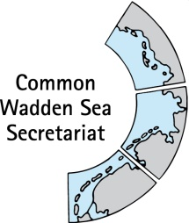
MEETING DOCUMENT
Task Group Management (TG-M 20-3)
20 October 2020
Online meeting

Agenda Item: 6. Single integrated management plan (SIMP): particularly Sustainable fisheries and Energy
Subject: Framework-Sustainable Fisheries-Status
Document No.: TG-M 20-3/6/2
Date: 14 October 2020
Submitted by: CWSS

At the Wadden Sea Board (WSB) meeting 31 held on 18 June 2020, the Board endorsed a proposal on how to handle the issue of sustainable fisheries as submitted by the Task Group Management (TG-M). This working approach includes an overview of the current situation/practices of sustainable fisheries based on the “Framework for sustainable fisheries” (Annex 3 Tønder Declaration). Products will also serve as basis for the key topic ‘sustainable fisheries’ in the single integrated management plan (SIMP)
This approach includes as product 2: Document with status and recommendations for principles of the Framework for Sustainable Fisheries (Annex 3 Tønder Declaration), including analysis how existing legislative framework, regulations, agreements and initiatives support the Framework for Sustainable Fisheries.
This document contains a template for the status of the Framework Sustainable Fisheries with its seven principles as agreed on the online topical meeting sustainable fisheries by TG-M and fisheries experts on 17 July 2020. This template was filled in by TG-M members in an email consultation.
Original wording for the principles are set in light blue and italics, agreements on the general content for each principle in orange, requested actions in yellow. Members of the Task Group Management Email consultation as a follow up of TG-M 20 Topical Meeting Sustainable Fisheries
The group had agreed to do the exercise from the ecosystem approach, while keeping additional components of sustainability in mind, such as social, economic, cultural.
The term “recommendations” includes procedural recommendations and may be revised..

Proposal: Agree on the level of detail required and next steps

Product 2: Six years after Tønder: Status and recommendations for principles of the Framework Sustainable Fisheries in the Wadden Sea

Summary
To be added when 2 – 4 are close to final. Who: TBD

Introduction
To be added. Who: TBD

Principles of the Framework Sustainable Fisheries: Status and [recommendations]

Appropriate assessment or equivalent impact assessments
Within the framework of relevant EU legislation (e.g. the Habitats Directive, the Bird Directive, the Marine Strategy Framework Directive and the Water Framework Directive), assessments should be applied to all fisheries sectors in the Wadden Sea. This should be done as an exchange of knowledge and experiences trilaterally in relation to impact assessments, with the aim to secure comparable methods and standards between the trilateral countries. These assessments must be based upon nature conservation objectives, specified to the extent possible, scientifically robust, trilaterally comparative and transparent. The use of regular impact assessments by all Wadden Sea regions would also level the playing field and may facilitate the dialogue between the fishery managers, the industry and environmental NGOs at a trilateral level
Status:
The group agreed compiling a table with impact assessments of the different sectors of fisheries applied by the states within the respective legal framework. As (near) trilateral activity, assessment done within the MSC for brown shrimp fishery may be added to the status
Which impact assessments are applied to all fisheries sectors in the Wadden Sea? Are these based upon nature conservation objectives, specified to the extent possible, scientifically robust, trilaterally comparative and transparent? Are there comparable methods and standards? Please add to the table below.
Table 1: Overview on Impact assessments for fisheries sectors applied by the states within the respective legal framework as compiled by TG-M and fisheries experts (September 2020).
State | Fisheries sector | Legal framework | Impact assessment (please include details, such as on content, frequency, methods, and standards, etc. Please also indicate nature conservation objectives)
DK
SH | Blue mussel fisheries | State Fisheries Act, Schleswig-Holstein Coastal Fisheries Regulation (KüFO), Federal Waterways Act, Federal Nature Conservation Act (BNatSchG), State Nature Conservation Act (LNatSchG), National Parks Act, mussel fishery programme | All necessary fishery and nature conservation permits, which are granted for mussel fishing and mussel culture activities, are checked for their compatibility with the conservation objectives of the Natura2000 areas. Approvals are only granted if they are compatible and permissible according to § 34 BNatSchG in conjunction with § 25 LNatSchG.  Permits exist for seed mussel fishery, mussel culture plots and seed collectors (duration 2017 to 2031).  The FFH compatibility test is carried out in agreement between the fisheries and nature conservation authorities.  Seed import has to be approved by the National Park Authority and the fisheries authority. Import of seed mussels is currently not taking place.
SH | Shrimp fisheries | Common Fishery Policy, State Fisheries Act, Schleswig-Holstein Coastal Fisheries Regulation (KüFO), Federal Waterways Act, National Park Act (shrimp fishery allowed in zone 1 and 2, prohibited in no-take-zone, between the islands of Sylt and Föhr) | In 2017 shrimp fishery in the Wadden Sea and adjacent areas was certified by the Marine Stewardship Council (MSC) which includes a Brown Shrimp Management Plan.  Besides there is ongoing research on the ecological impacts of shrimp fishery.
SH | Oysters (cultivation and hand-picking) | Federal Nature Conservation Act (BNatSchG), State Nature Conservation Act (LNatSchG), Habitats and Birds Directive, National Park Act, mussel fishery programme, State Fisheries Act | Seed picking has to be approved by National Park Authority.
LS
NL | All fisheries |  | Next to the stock counting, no specific impact assessments are performed.

[Recommendation] for management action for the upcoming five (?) years:
Identification of gaps and recommendations will be based on the status. These may contain procedural recommendations. Please do not add to these at this time.

Fishing gear/best practice
The application of appropriate fishing gear and best practices is another essential element in operationalizing sustainable fisheries, in particular with the aim of reducing impacts on the bottom and reducing bycatch. Best practice is understood to be a combination of fishing techniques and fishing effort, minimising impacts. A detailed analysis of fishing gear (application, site specific impact) may be part of the dialogue with the stakeholders. The fishing industry should be encouraged to develop more sustainable techniques and practices.
Status
The group agreed to collect best practice examples on how fishing gear was/can be improved over the years by the states.
Please add examples on how fishing gear was/can be improved by the states, in particular to reducing impacts on the bottom and reducing bycatch (you may also refer to 3.7 Pilot studies). Best practice is understood to be a combination of fishing techniques and fishing effort.
Shrimp fishery
Denmark:
TBD

Schleswig-Holstein Shrimp fishery
One condition of the MSC certification is to increase the cod end mesh size from originally 20 mm to 26 mm according to the Brown Shrimp Management Plan. There are further conditions of the MSC certification that support ecological improvements.
In Schleswig-Holstein a so called innovation programme is currently carried out. The aim of the programme is to support shrimp fishers in testing out new ideas to improve fishing gear. Results are expected for 2021.

Lower Saxony Shrimp fishery
TBD

Netherlands shrimp fishery:
In the course of MSC certification, the mesh size is intended to increase from originally 20 mm to 24 mm according to the Brown Shrimp Management Plan.
See the text on the innovative projects later below.

Mussel fishery
Denmark:
No mussel fishery. Is there collection of spat form Danish waters?

Schleswig-Holstein Blue mussel fishery
One goal of the mussel program, which has been in place since 2017, is to reduce the impact of the mussel fishery on the sea floor. Therefore, tidal basins are closed for the mussel fishery. Instead of harvesting from the seabed, mussel seed is now increasingly harvested from hanging cultures (seed collectors).
Lower Saxony Shrimp fishery
TBD

Netherlands mussel fishery:
See the text on the innovative projects later below.

Closed areas
Closed areas are a management option for sustainable fisheries in the Wadden Sea Conservation Area, in particular to allow natural processes to proceed in an undisturbed way, to achieve the conservation objectives and biodiversity and in cases where there is insufficient knowledge about impacts. Sufficiently large closed areas can also serve as reference and recovery areas. The designation of such areas is in the responsibility of the national state, taking into account the relevant EU regulations.
Status:
The group agreed to display closed areas and changes over time (since 2010) on a map to show progress, and to set these areas in relation to the Wadden Sea Conservation Area. Vessel Monitoring System (VMS) data over closed areas may be included.
Several areas are closed for shrimp and mussel fishing activities, with different extent over the three countries. Denmark has banned shrimp and mussel fishery entirely (Figure 1) (Baer et al. 2017). “The effects of mussel fishery are limited by the permanent closure of considerable areas and the reservation of sufficient amounts of mussels for birds. In addition, the management of fishery on mussels should not be in conflict with protecting and enhancing the growth of natural mussel beds and Zostera fields.” Wadden Sea Plan 2010: 4.23 (identical to 9.6)
TG-M and fisheries experts to provide shape files for permanently closed areas for mussel fishery and closed for shrimp fishery for 2010 and for 2020. Please also indicate if there are temporal/seasonal closures and provide shape files if possible.

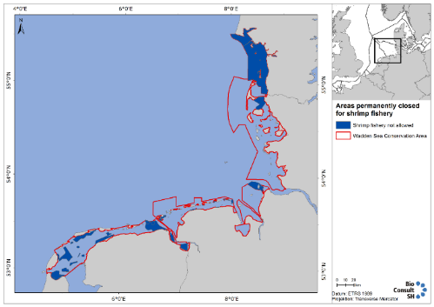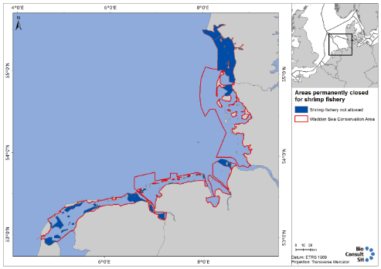
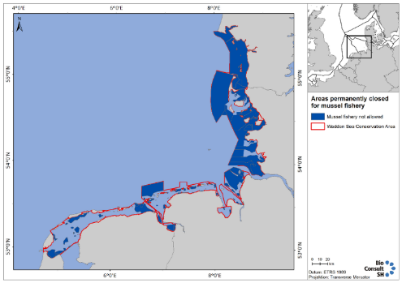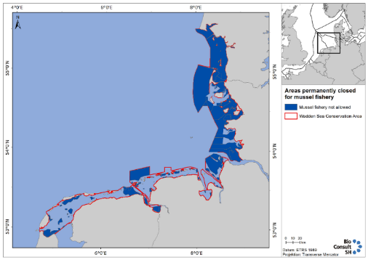
Figure 1: TO BE UPDATED BY CWSS (currently dummy maps). Maps showing areas permanently closed (dark blue) in Wadden Sea Conservation Area (red line) for shrimp fishery (upper panels) and mussel fishery (lower panels) in 2010 (left panels) and 2020 (right panels). -> may also show status 2020 and changes since 2010.
Are closed areas respected?
Closed areas were, however, not completely avoided by brown shrimp fishery (German vessels, 2007 – 2013) (Kuechly et al. 2016).
Possible Figure: Maps showing areas permanently closed (dark blue) in Wadden Sea Conservation Area (red line). Left: shrimp fishery; right mussel fishery and fishing activity (VMS data, “fishery” vs “steaming” algorithm.

Monitoring/control/black box
This includes monitoring of fishing activities and the status of fished and closed areas. The fisheries sector is co-responsible for monitoring of fishing activities. Black boxes, or equivalent systems (e.g. VMS), are an important precondition for co-management, including nature protection.
Status:
The group agreed to compile the status of monitoring for VMS and bycatch as currently implemented in the states.
Data from Automatic Identification System (AIS) and the Vessel Monitoring System (VMS) messages show low to very high fishing intensity in the Wadden Sea Cooperation Area (JRC,).
Fishing activity of members (MSC) are monitored through VMS mapping every year to monitor the risk of any expansion into sensitive habitats (vessel Monitoring System (VMS) plots for brown shrimp fishery are provided for the Netherlands, Germany and Denmark within the MSC certification process, compare figure 8 in Addison et al 2019).
Please add how monitoring of fishing activities and effort/VMS and bycatch are currently implemented in the states.
Denmark
TBD

Schleswig-Holstein
Fishery control in the coastal waters
The fishery supervision is carried out in the coastal waters by the Schleswig-Holstein water protection police, controls in the ports are carried out by the State Office for Agriculture, Environment and Rural Areas Schleswig-Holstein.
The Schleswig-Holstein water protection police carried out a total of 74 control trips (one-day and multi-day strips) in the North Sea in 2019. The controls include:
- Log book controls on board
- Fish room controls
- Fishing documents to be carried
- Identification of fishing equipment and ships
- Mesh measurement controls
- Fishing license controls

The State Office for Agriculture, Environment and Rural Areas Schleswig-Holstein (LLUR) carried out a total of xx controls in the North Sea ports in 2019. The controls include:
- Log book controls on board / in port
- Landing / fishing room / market controls
- Fishing documents to be carried
- Identification of fishing equipment and vessels
- Mesh measurement controls
- Fishing license controls
- other controls (not further defined)

VMS-Monitoring
Since 2005 all European fishing vessels >15 m length are VMS mandatory. The VMS data are satellite-based and contain two-hour information ("pings") in which the ship's identification, position, direction and
Speed of the ship. The German Federal Agency for Agriculture (BLE) has data to describe the distribution of the fleet, catch and shrimp in the North Sea.

The final project report of the project "Bundling knowledge for a sustainable management of the shrimp fishery in the territorial sea including the Wadden Sea National Parks (MaKramee)" describes:
In the years 2007-2013, an average of 106,500 hours per year - corresponding to approx. 4400 effort days – shrimps were fished in the Wadden Sea National Park Schleswig Holstein. This corresponds to 39.17% of the total German shrimp fishing effort. Per year around 40% of the German landings of consumer shrimp, corresponding to 4239,173 t, are achieved within the Wadden Sea National Park Schleswig Holstein (average 2007-2013).

Monitoring of bycatch has been part of the EU's data collection program for the fisheries sector since 2008.

The North Sea Brown Shrimp fishery is under de minimis for the Landing Obligation (LO), whereby each member state is obliged to set up a sampling scheme to obtain further data on the bycatch percentage of TAC species in the catches. In the North Sea Brown Shrimp fishery each member state has set up their own sampling scheme as a joint set-up could not be agreed. Currently all vessels are obliged to record all ETP bycatch, following a list of the more commonly encountered ETP species. The development of a definitive list of ETP species to record as part of the bycatch is ongoing, with the aim to find a working compromise between as much detail as possible and practicality on board fishing vessels. (MSC North Sea Brown Shrimp 2nd Surveillance Report July 2020)

Lower Saxony
TBD

The Netherlands:
TBD

Table 2: Overview on monitoring of fishing activities in the Wadden Sea Conservation Area as currently implemented in the states, compiled by TG-M and fisheries experts (September 2020).
 | DK | SH | HH | LS | NL
How and by whom is fishing activity on shrimps monitored? |  | Fishing activity is monitored by LLUR and BLE. |  |  | The total fishing hours is monitored by Wageningen Marine Research (WMR) while using VMS/AIS data and data from the electronic logbook.
How and by whom is fishing activity on mussels monitored? |  | Blue mussels:  Mainly by upper fishery administration (LLUR) (via Blackbox-data, operational diaries, on-site inspections); nature conservation requirements also through National Park Authority (esp. via Blackbox-data)  Oysters: Mainly by LLUR; nature conservation requirements via notification/reports of national park service, NGOs or by contractors of the mussel bank monitoring. |  |  | Fishing activity is monitored by PO Musselculture (PM). Monitoring is based on the data of Wageningen Marine Research.
What is the fraction of boats not covered by monitoring listed above (e.g., boats < 12m, tracking frequency of VMS) |  |  |  |  | The Dutch fleed fishing for mussels and shrimps has no ships smaller than 12 meter.
Are closed areas specifically monitored (and by whom)? |  | The national park administration checks on a random basis (using black box data) whether the requirement not to fish on reefs, sandbanks and in closed areas is being met. |  |  | Closed areas are monitored by WMR
How and by whom is bycatch monitored for shrimp and mussel fishing activities? |  | For shrimp fisheries there is no monitoring on bycatch, just some studies. |  |  | WMR monitors bycatch of shrimp fisheries via self-monitoring. Mussel fishery hardly has any bycatch.

Stock assessment
Regular stock assessments must be carried out to serve as a basis for stock management as clarified in the EU Common Fisheries Policy and other relevant EU legislation. This is an essential element for sustainable fisheries. Fishing impact should be such that stable food webs are restored and maintained, supporting natural populations of predators.
Status
The group agreed to restrict to the official assessment of commercially exploited stocks in the Wadden Sea and to provide a list of nationally applied stock assessment to CWSS.
Status shrimps: Until 2016 there were no annual stock assessments for brown shrimps in the North Sea, yet there are signs of growth overfishing for this species (Tulp et al 2016). For this short-lived species, a conventional age-based stock assessment is not possible. “ICES advised that the development of a harvest control rule (HCR) based on a comparison of the most recent commercial landings per unit effort (LPUE) data with pre-defined trigger levels (based on previous LPUE data) was the most appropriate approach for this short-lived species. ICES also advised that Crangon should be taken into account within the framework of ICES advice regarding North Sea mixed fisheries because of the significant bycatch of other species in the small-meshed net Crangon fisheries, and in relation to multispecies interactions because future recovery of gadoid populations could have an impact on shrimp population dynamics” (Addison et al 2019).
Please add if and how commercially exploited stocks are assessed.

Table 3: Overview official assessment of commercially exploited stocks in the Wadden Sea Conservation Area as currently implemented in the states, compiled by TG-M and fisheries experts (September 2020).
 | DK | SH | HH | LS | NL
Stock assessment shrimps |  | See “Status shrimps” above |  |  | No stock assessment takes place.
Stock assessment blue mussels |  | No stock assessment for blue mussel fishery |  |  | Stock assessment is performed every spring and fall.
Stock assessment other if applicable (specify) |  | No stock assessment for oyster cultivation and handpicking |  |  | WMR monitors yearly shellfish in the Dutch coastal areas.

Appropriate knowledge<>responsibility of all parties involved
In the process of operationalizing sustainable fisheries, use must be made of best available knowledge. There is a responsibility of all parties involved in supporting knowledge about the status of the ecosystem.
Status
The group agreed to display the shared responsibility of sustainable fisheries in the states, e.g., if there are regular meetings of different stakeholders, such as fisherfolk, authorities and nature NGOs.
Dialogue on brown shrimp fishery by Joint Working Group (NGOs, shrimp fishery) on-going in course of MSC surveillance.
Please add examples.
Denmark
TBD

Schleswig Holstein
Within the scope of the shrimp fishery advisory council in SH there are discussions ongoing about the ecosystem status. Stakeholder from nature conservation NGOs as well as shrimp fishers meet regularly to achieve substantial steps for a more sustainable shrimp fishery in SH.
Blue mussel fishery
MELUND invites to an annual meeting to discuss the successes or possible problems in the implementation of the mussel fishery program with the parties involved. These meetings should provide data on blue mussel fisheries and culture, management and monitoring.
Lower Saxony
TBD

The Netherlands
The Netherlands involves the different parties by agreeing on different covenants. The most important ones are:
- Shrimp fishery; on the basis of the agreements as given in the Convenant VISWAD (Nature-NGOs, Government and Shrimp fishery sector) the shrimp fishery sector will apply for the necessary Nature Protection permit. Horizon of the VISWAD is 2026. The ambition for 2026 is to reduce the impact of shrimp fishery with 50%, a.o. by reduction of the fleet by 20-30%, using best-available –techniques, closed areas.
- Mussels; the Ministry of agriculture, nature and food quality agreed with several NGO’s a ‘mussels covenant’ in 2008. Agreements have been made on improving the sustainability of the mussel fishery sector and strengthen nature recovery in the Wadden Sea. Therefore the fishery sector should realize non-soil-contacting seed mussel fishing, by using artificial seed collector farms (now 8 operational) or by importing from the South-Western Delta. The covenant aimed to fully end the mussel fishery in the subtidal part by 2020 (100%). This process is going slower than expected. 28% of the subtidal part is now closed for seed fishery. It is expected to increase this to 35.7% by the end of the year. The covenant partners are now trying to reach an agreement on closing the remaining subtidal.
- Common Cockles; the ministry, the province of Friesland and NGO’s agreed in 2011 the following: the sector needs continuity and is allowed to harvest cockles in years with a limited number of cockles available (maximum of 2.5%), the most important bird areas will be permanently closed, a number of valuable areas for birds will be closed in the years few cockles are present, in other areas there will be limited fishing and fishing in these areas is allowed in years with an abundance of cockles while fishery will be spread over the Wadden Sea.
- Pacific oysters; fishery on Pacific oyster takes place by manual collection following an agreement reached between the province of Friesland, the manual collectors, nature NGO’s and the ministry of Agriculture, Nature and Food Quality. The fishery is currently in a transition phase with 18 permits. The total number of permits will be limited to a maximum of 12.

Pilot studies (learning by doing)
Transition towards sustainable fisheries also implies that there must be ample possibilities for testing new methods and practices. Knowledge gained in pilots should be spread among all parties involved
Status
The group agreed to list projects and pilot studies which should serve as basis to inquire how this knowledge may be trilaterally spread.
Several projects have been and are being conducted. Amongst them is CRANNET (Thünen Institute 2020), in which improvement of cod end selectivity (result: cod ends with T0 or T90 meshes and a mesh size of 26 mm or square mesh cod ends (T45) with a mesh size of 24 mm were identified to increase the sustainability of brown shrimp fisheries in terms of ecological and economic aspects) and reduction of by-catches in brown shrimp fishery were in the focus from 2012 – 2015.
The CRANIMPACT project on impacts of shrimp fisheries on habitats and communities in the coastal seas of the Federal States of Schleswig-Holstein, Hamburg and Lower Saxony is on-going (2018 – 2022) (Thünen Institute 2020).
Please add projects
Denmark
TBD
Schleswig-Holstein
TBD
Lower Saxony
TBD
The Netherlands
The Netherlands is working on the sustainability plan for shrimp fishery. This is part of the VIBEG and Viswad agreements. In the table below is an overview of innovative practices implemented for shrimp fishery:

Table 4: Overview on innovative practices implemented for shrimp fishery in the Netherlands.
Measure | Explanation
Limitation of fishing hours to a maximum of 4.800 per year | Has been taken as a condition within the MSC management plan
Maximum width of mesh; 22 mm

Mailbox Wadden Sea | Change within the nets which intends to dump fish below water, contributing to more selective catch. In the summer periods, there is a lot of ‘green products’ (such as algae and seaweed) caught in the net causing higher bycatch of young fish. The Mailbox innovation offers a solution.
Spoelsorteertrommel (‘coil sorting tin’) of at least 6 mm
Maximum fishing gear weight of 3.800 kg.

Zeeflap with maximum widt of mesh; 60 mm | Change within the nets focussed on reaching less by-catch.
Innovation fishnets  Innovatie visnetten | Waddenfund project ‘selectiviteit garnalenvisserij’ which tests various items. It is tested on board of the WR 57, WR 289 and ZK 1.
Cleaning and cooling without loss | Effort with a focus on removing the so-called (extra) vibrating screens.

Discussion and conclusions
To be added. Who: TBD

References
To be added.

Endangered, Threatened and Protected (species)

