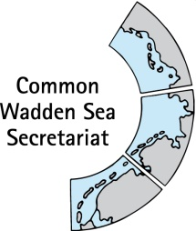
MEETING DOCUMENT
Task Group Management (TG-M 20-2)
14 May 2020
Virtual meeting

Agenda Item: 5. Implementation of the Leeuwarden Declaration
Subject: Guideline “Coastal Cleanups in the Wadden Sea National Park”
Document No.: TG-M 20-2/5/2 (previous TG-M 20-1/5/2)
Date: 10 March 20
Submitted by: National Park Authority Schleswig-Holstein

More and more people are concerned with the problem of marine litter. Many coastal dwellers and holiday guests would like to play an active role in clearing the Wadden Sea National Park of marine litter. With this guide, the National Park Authority provides important advice and information for the implementation of coastal clean-up events in the Schleswig-Holstein Wadden Sea National Park.

Proposal: TG-M is invited to note the information

Coastal Cleanups in the Wadden Sea National Park
Information of the National Park Authority Schleswig-Holstein Wadden Sea

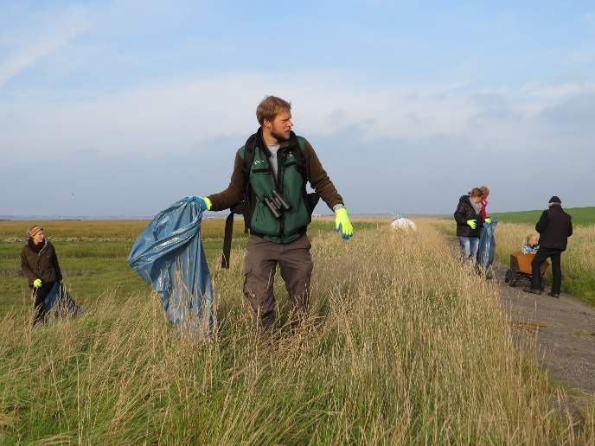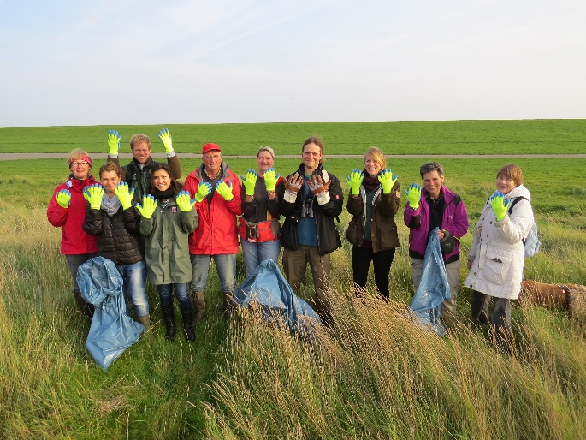
Coastal Clean-up in Wesselburenerkoog | © Claußen/LKN.SH

1) Introduction

Litter in the sea - this global problem is presently being discussed intensively in public. The media continuously report on the increasing burden of human litter on the world's oceans. The Wadden Sea UNESCO World Heritage Site is also affected. With every tide, waste is deposited on the shoreline. The results from monitoring (= scientific long-term observation) in the Schleswig-Holstein Wadden Sea National Park show that plastic waste washed ashore is predominantly composed of fishing nets and various packaging materials. This type of marine litter is not only a danger to the environment, but is also cost-intensive for coastal communities and the shipping industry as well as being an eyesore in the landscape.

More and more people are concerned with the problem of marine litter. Many coastal dwellers and holiday guests would like to play an active role in clearing the Wadden Sea National Park of marine litter. With this guide, the National Park Authority provides important advice and information for the implementation of coastal clean-up events in the Schleswig-Holstein Wadden Sea National Park.

2) Coastal Cleanup events

Coastal Cleanups are a proven means of removal and correct disposal of marine litter from the coast. Such events are also good for raising public awareness of this issue.

Coastal cleanups on the Wadden Sea coast are generally welcome. However, for nature conservation and safety reasons any coastal cleanup event needs to be well prepared and planned. Above all, time and place must be taken into account. Many coastal towns regularly clean their beaches or dike sections of marine litter. Also jetsam (= remains of salt marsh plants and algae, which are washed ashore during high tides) contains large amounts of litter. The Schleswig-Holstein Agency for Coastal Defence, National Park and Marine Conservation (LKN.SH) regularly collects and disposes of the litter in the jetsam on the state-owned dikes, especially after storm events.

The most effective way to help reduce the amount of litter in the marine environment and thus make an important contribution to the protection of the Wadden Sea is to remove it from the coastline, where it is concentrated by wind, waves and ocean currents.

3) Rules and tips for carrying out coastal cleanup events

Litter does not belong into the environment and should be removed. However, when removing it, there are some rules, which must be observed, especially in the national park. For example if there is risk of destroying the clutches of breeding birds in search of litter on the beach and in the salt marshes, it is better to leave the litter where it is. The same applies if there is risk of disturbing roosting birds or seals.

Nature conservation

- Please only collect litter where breeding or roosting birds as well as other wild animals cannot be disturbed! For nature conservation reasons, there are therefore limitations on where and when litter can be collected:
  - In the protection zone 1 and designated breeding and roosting areas access is forbidden throughout the year, even for coastal cleanups.
  - Do not collect litter in the salt marshes and dunes, as these are particularly sensitive habitats, which may only be accessed on designated paths.
  - From 1 April to 31 July, litter should not be collected in areas where beach-breeding birds could breed (beaches and dunes). Organised coastal cleanup activities should not take place there until the beginning of August.
  - Do not collect marine litter during high tide (+/- 2 hours), during this time the salt marshes and other more elevated higher areas are used as roosting sites by birds and there is a high risk of disturbance. At low tide, on the other hand, many birds are out feeding in the tidal flats and are less sensitive to disturbances.
- Stay at the foot of the dike, on the dike defence roads or on the beach. Do not go into the saltmarshes. Please close the gates located on the dike again after passaging through.
- Coastal cleanup events in the areas with limited access mentioned above are only possible with the consent of the National Park Authority. If coastal protection facilities have to be used or accessed by car, you will need the consent of the coastal protection authority (LKN.SH). A permit must be applied for at the national park authority or the coastal protection authority. Please inform the National Park Authority about larger coastal cleanup events in the National Park even if they do not require a permit (nationalpark@lkn.landsh.de).
- If you find dead or injured common- or grey seals, please keep a safe distance and do not touch them! Inform the local seal hunter, the seal station in Friedrichskoog (phone 04854 1372) or, if necessary, the police.
- If you find dead birds with a ring on their leg, you can report the ring number to the ornithological station Helgoland: www.ifv-vogelwarte.de/das-institut/beringungszentrale/ring-gefunden.html/das-institut.html. In the case of transmitters, a contact address is usually imprinted on the device. Important: Put on protective gloves to handle the carcasses and disinfect your hands afterwards.

Aids and equipment

- Gloves should be worn at all times to protect hands from dirty or sharp objects.
- Hand grabbers are suitable for picking up smaller objects. They also provide protection against dirty or sharp objects made of glass (e.g. shards) or metal. Special care must be taken when collecting and transporting such objects!
- Garbage bags are necessary for the collection and the proper disposal of the litter. They also prevent the collected litter from being blown away again by wind and weather. If the weather is dry strong paper bags can be used, during wet weather conditions plastic bags are preferable. Close the bags with a piece of string.
- Buckets are suitable for collecting sharp objects that could perforate garbage bags.
- A hand cart can be helpful for taking the bags filled with garbage to the waste disposal sites.

Findings

- Only objects made of plastic, cardboard and metal should be collected, no paraffin lumps or natural objects such as seaweed, wood or animal carcasses.
- In general, paraffin wax should not be touched or collected. This is because, what is popularly called paraffin, is not always paraffin and if paraffin it often contains impurities.
- Do not touch unknown objects or carcasses! Do not open canisters, cans etc. and do not inhale the content of containers! In the case of potentially dangerous objects or substances, inform the person(s) responsible for the coastal cleanup event immediately.
- If you find ammunition, ammunition remnants or pieces of phosphorus, please inform the police (Tel. 110). If you find oil or canisters with dangerous contents or if there are large amounts of paraffin on the beach, please inform the LKN.SH on weekdays (Tel. 04841 898411) or the police on weekends (Tel. 110).
- Document the litter you find on the beach e.g. with photos or tally lists. In this way, an overall picture of the types of litter found becomes visible for all participants. The information on labels attached to litter objects or imprinted on them often reveals where the litter items might have come from and how old they are.

Disposal

- The disposal of the collected litter must be clarified in good time before begin with the municipality in which the clean-up takes place. Where clean-up events are carried out on the state protection dikes, the disposal must be clarified in good time beforehand, with the LKN.SH division 5 (Tel.: 04841 667-236). Please note: the LKN.SH does not dispose of litter collected by individual persons. Optimal and more cost-effective disposal requires pre-sorting of the litter into recyclable and non-recyclable materials.
- Fluorescent tubes, batteries and other hazardous waste must be collected and disposed of separately.
- The waste bins located on the beach in St. Peter-Ording and Büsum, (among other places) are not to be used for the disposal of marine litter from clean-up events. Due to the large quantities of litter from these events, the disposal must be organised independently.

Safety and liability

- Instruct all participants of the rules for coastal cleanup events within the National Park and the correct handling of marine garbage.
- Be sure to point out that participation in a coastal cleanup event is at the participants own risk.
- Observe local tides and weather forecasts.
- Only choose terrain that is easy to walk on in order to avoid falls or similar accidents.
- Have a first aid kit ready for emergencies during the event.

Support in public relations for coastal cleanup events

Generally the National Park authority will not advertise coastal cleanup events in or around the Schleswig-Holstein Wadden Sea National Park, in which the National Park Authority or the LKN.SH are not involved as organisers, . However, in some cases (e.g. if the coastal cleanup event contains programme items relating to the Wadden Sea National Park or for raising awareness about the problem of marine litter) the National Park Authority may support the campaign, by announcing it in the monthly newsletter "National Park News", on the National Park website or on the Facebook page of the National Park. Proposals for public coastal cleanup events can be submitted to the Press Office of the National Park Authority.

4) Coastal cleanup events of the National Park Authority

Twice a year, in March and September, the beach cleaning event "SPO klart auf - Aufklaren und Aufklärung für den Strand am Nationalpark" takes place in St. Peter-Ording. In addition to collecting marine litter, short lectures on nature conservation and waste avoidance sensitise participants to the topic. Refreshments are provided for the participants. The event is organised and carried out by the St. Peter-Ording Tourism Centre, the National Park Authority, the Schutzstation Wattenmeer and other national park partners and supporters. Further information and dates:
www.st-peter-ording.de/eventsuche/veranstaltungen/veranstaltung/spo-klart-auf-1950.html

5) Educational offer on the subject of marine waste

The Multimar Wattforum National Park Centre in Tönning offers a learn program on marine litter, which can be booked by school classes and other groups on request. Further information and booking requests for the "Marine Litter Research Laboratory" can be found at:
https://multimar-wattforum.de/bildung/angebote/forscherlabormeeresmuell.html.
As additional material, a media and link list on the subject of marine litter can be downloaded.
National Park Centre Multimar Wattforum
Dithmarscher Straße 6a, 25832 Tönning
Infotelephone 04861 96200 | www.multimar-wattforum.de
Opening hours: daily and all year round (except on 24.12.)

6) Further initiatives and information

- The association “Küste gegen Plastik e.V.” (a registered group in St. Peter Ording) is active in providing information on the topic of marine litter, carries out media work and runs information booths as well as coastal clean-up events. In addition, the association has developed the free ReplacePlastic app for smartphones. Further information and contact details: www.kueste-gegen-plastik.de/
- Many coastal towns and organisations participate in the annual Coastal Cleanup Day. NABU is committed to this nationwide. Further information can be found at: www.nabu.de/natur-und-landschaft/aktionen-und-projekte/meere-ohne-plastik/cleanup/index.html.
- In the Fishing for Litter project initiated by NABU, marine litter caught in fishing nets is collected and professionally disposed of.
- Many measures are currently being developed and implemented to reduce the amount of waste in Germany and worldwide A good overview of measures in Germany is provided by the Round Table on Marine Waste on the website www.muell-im-meer.de .
- Tips: What can each individual do?
- Avoid waste - reusable instead of disposable, avoid secondary packaging
- Separate and dispose of waste properly - this increases the rate of recycling.
- Dispose of cigarette butts in the household waste - they are not only a source of microplastics, when they disintegrate, but also pollute the environment.
- Collect litter - use the waste bins on the coast and on the islands. Where available (e.g. St. Peter-Ording and Büsum), dispose of the garbage from the tideline in the 'beach garbage boxes' - but please do not dispose of dog poo bags in these special waste bins - in respect for the people who empty the containers!
- For water sports enthusiasts: Dispose of waste in the port facilities or at home.
- Join up with others: Acting together can motivate and be fun! Together you can do more! Make others aware of the topic.
Publisher:
The Department of the Schleswig-Holstein Agency for Coastal Defence, National Park and Marine Conservation (LKN.SH)/ National Park Authority Wadden Sea Schleswig – Holstein
Schlossgarten 1, D-25832 Tönning
Phone: 04861 616-0
E-Mail: nationalpark@lkn.landsh.de
status: october 2019

