Network Group
Sustainable Tourism
NG-ST 25
ZOOM meeting
10 September 2020

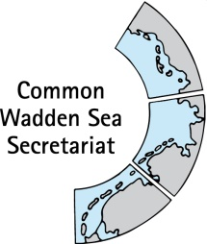
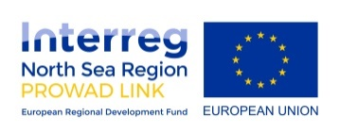

_________________________________________________________________________

Agenda Item: 2

Subject: World Heritage Management Plan (also referred as SIMP)

Document No. NG-ST 25-2-1

Date: 01 September 2020

Submitted by: CWSS
___________________________________________________________________________________

Please find following preparatory material for the interactive session on Tourism and the role of NG-ST within the scope of the World Heritage Management Plan (also referred as SIMP).

The additional Excel document NG-ST 25-2-2 _ key values matrix includes a preliminary analysis for your review and enrichment with a list of impacts, the level of risk and trends as well as a list of opportunities, the level of importance and trends on the OUV key values.

Proposal

The meeting is proposed to

- confirm or identify further (potential) impacts of touristic activities on the Outstanding Universal Value (OUV) of the Wadden Sea,
- confirm or identify further (potential) opportunities and positive effects of touristic activities on the OUV of the Wadden Sea,
- and discuss what can we do (recommendations as procedures or actions) to reduce impact and leverage opportunities.

World Heritage Management Plan
Subject: Sustainable Tourism management in the Wadden Sea

1. Background
A single integrated management plan (SIMP) was a request by the World Heritage Committee in 2014, when the Danish Wadden Sea was included in the World Heritage Property. The Leeuwarden Declaration (2018) includes the task to develop the SIMP. The SIMP is a political agreement of the Trilateral Wadden Sea Cooperation (TWSC), meaning it is a legally non-binding document of common political interest. Existing policy documents and legally binding instruments at the trilateral, regional, national, or local level are not altered or affected by the SIMP. The recommendations presented in the SIMP which are derived from the process of developing the key topics are to be implemented by the three countries in cooperation, and individually, by the competent authorities on the basis of existing legislation and through the participation of interest groups.
The agreed timeline for its development is a first complete draft by October 2020, a broad review process involving all the necessary organisations and stakeholders during 2021 and a final adoption in the Ministerial Conference in 2022.
The purpose of the SIMP is to further facilitate the continuous improvement of management coordination for the protection and maintenance of the Wadden Sea World Heritage Outstanding Universal Value (OUV) by:
- providing a clear overarching description of the management system at the regional, national and trilateral level;
- addressing key topics that need ongoing attention to protect and maintain the OUV.
The selected key topics were recommended by managers of the three countries, prioritized by the Task Group World Heritage and endorsed by the Wadden Sea Board in November 2019. The key topics are:
- Fisheries
- Tourism
- Shipping and ports
- Renewable energy and energy from oil and gas
- Coastal flood defence and protection measures

The recommendation of what to address in the key topic tourism is an overview of the current status based on the available information, the trilateral agreements regarding tourism, the legal framework for tourism management, the effect of touristic activities on the OUV key values including threats and opportunities, monitoring, the effect of climate change on tourism, future trends, recommendation of strategies or management actions and ideas for joint projects (see “Annex 1: Referential content structure” for a description on each point). As well as a show case of the tourism partnerships to illustrate its importance to support management.

1.2. Tourism and the role of NG-ST within the scope of the SIMP
The NG-ST includes various of these points in their action plan. For instance, within objective 2, action 1: World Heritage partnerships, action 2: Visitor management and impact assessment, and action 6: Impacts of tourism / LAC for tourism development. The development of the SIMP can be of added value to NG-ST to collaborate in the achievement on those action points. Furthermore, the recommendations by NG-ST resulting from the SIMP development represent an input for decision making.
The role of the NG-ST is to lead the development of the chapter and to use this in their favor to bring their action plan forward. The draft document on key topic Tourism that you can download under this link is a basis for further development and reflection as well as for identifying whether there is the need to update certain information and if there is additional relevant information that requires to be considered. This document is based on the referential structure for tourism (Annex 1) and it is a draft to discuss upon, revise and improve.
A summary of the content of this chapter feeds into the overall SIMP-document (see Figure 1 for the overall scope of the SIMP). Additional relevant and background information goes to an online microsite under the CWSS website and in coordination with the knowledge exchange platform.
The overall draft SIMP content development process is being oversighted by TG-WH. CWSS coordinates and supports the content development through the SIMP officer and the respective CWSS staff in each TWSC group involved.

The timeline
Comments can be sent until September 4. A new version, including the submitted comments and the results of the NG-ST 25 workshop will be prepared by September 23. TG-WH will review all documents and produce a first complete draft version of the SIMP by October 26 to be discussed by the WSB 32 in November. As mentioned before, 2021 will be dedicated to a broad review process involving all the necessary organisations and stakeholders.
Box 1. The scope of the SIMP.
Tourism is a key topic and partnerships are means to support management (underlined in red).
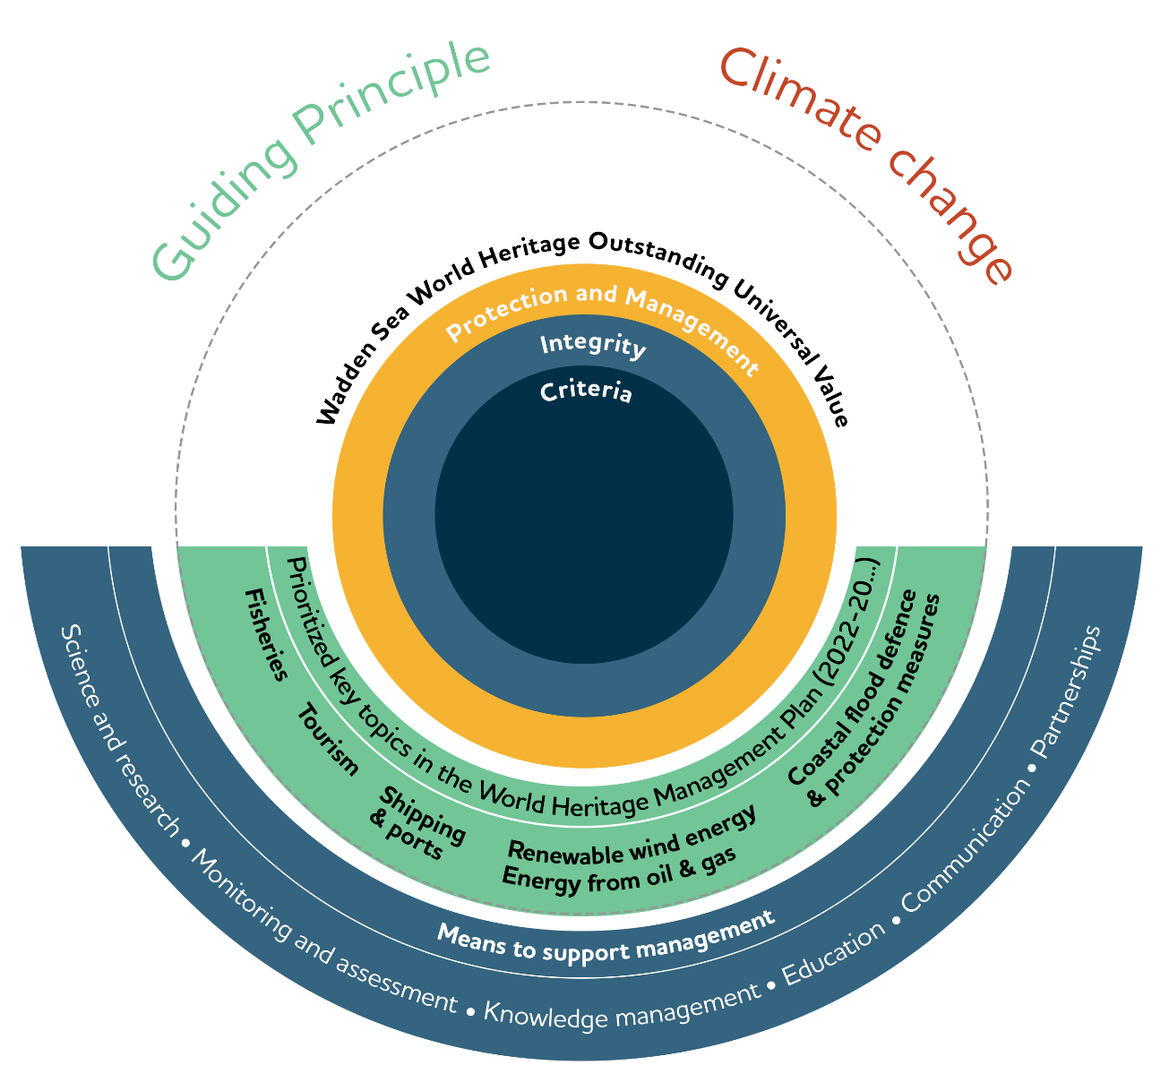
The focus of the SIMP is the Wadden Sea World Heritage site and therefore the appreciation and care of the unique characteristics of the Wadden Sea reflected in the statement of Outstanding Universal Value (OUV). The SIMP presents a simple overview of the management structures in Denmark, Germany and the Netherlands and at the trilateral level, the existing strategies and plans, as well as of the monitoring system and data handling in the context of the management cycle.
The prioritized key topics relate to uses in the Wadden Sea, which have an impact on the OUV (fisheries, tourism, shipping and ports, renewable energy and energy from oil and gas and coastal flood defence and protection measures). Based on an updated inventory, the SIMP presents updated and adapted proposals for management requirements (procedures, actions and strategies) laid down in an action plan. For each key topic, a referential content structure was developed as a guide.
All key topics and the OUV are under the influence of climate change effects, and the respective mitigation and adaptation activities. Climate change is therefore addressed in the SIMP as a cross-cutting topic. The Guiding Principle of the TWSC is the guideline to decide on any management activity. Communication, education, partnerships, research, monitoring, and knowledge management are presented in the framework of the SIMP as key means to support management.

The workshop exercises
The proposed exercise is a qualitative analysis to identify how potential or existing impacts from touristic activities affect the World Heritage Outstanding Universal Value, as well as opportunities or positive effects from tourism that benefit the OUV.
For this purpose, we will use the OUV key values. OUV key values break down the Statement of OUV into key phrases (Figure 1). In this way it is easier to relate any assessment and actions to the OUV of the Wadden Sea World Heritage. For your reference, the full Statement of OUV and the respective key values is included in the additional Excel document NG-ST 25-2-2 _ key values matrix.
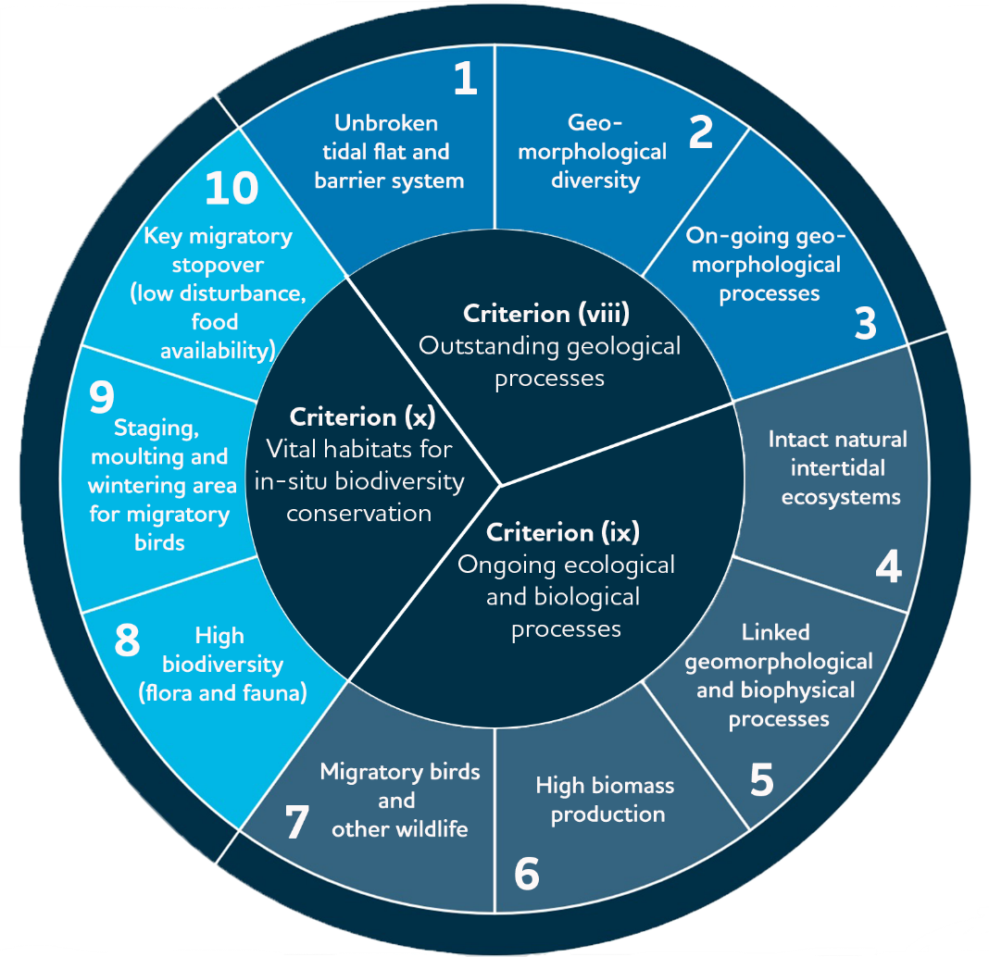

Figure 1. OUV key values directly derived from the Statement of OUV of the Wadden Sea World Heritage (preliminary figure).
The matrix “tourism-key values” (in Excel document NG-ST 25-2-2 _ key values matrix) includes a preliminary analysis for your review and enrichment with a list of impacts the level of risk and trends on the OUV key values. As well as opportunities or positive effects from tourism on the OUV key values that can be leveraged and shared as show cases.
In the matrix “tourism-key values” (in Excel document NG-ST 25-2-2 _ key values matrix):
- confirm or identify further (potential) impacts of touristic activities on the Outstanding Universal Value (OUV) of the Wadden Sea,
- confirm or identify further (potential) opportunities and positive effects of touristic activities on the OUV of the Wadden Sea,
- review the preliminary risk level, importance and trend entered, and
- think in advance (fill in the matrix) to discuss during the workshop what can we do (recommendations as procedures or actions) to reduce impact and leverage opportunities.
low | medium | high

In the matrix, risk is shown in colors:

low | medium | high
In the matrix, importance of opportunities is shown in colors:

Trends are shown as arrows:
increasing stable decreasing

