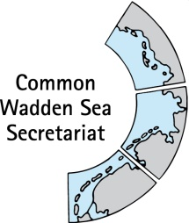
MEETING DOCUMENT
Expert Group Swimway (EG-Swimway 21-1)
17 November 2021
Wilhelmshaven, Germany

Agenda Item: 3 SWIMWAY trilateral
Subject: Overview on SWIMWAY in trilateral set-up
Document No.: EG-Swimway 21-1/3
Date: 5 November 2021
Submitted by: CWSS

This document contains an overview on Wadden Sea SWIMWAY in the Trilateral Wadden Sea Cooperation (TWSC) set-up with
- A quick view on the organisational structure of the TWSC and expert groups
- List of key documents for EG-Swimway (Leeuwarden Declearation, Wadden Sea Plan and QSR with Fish Targets, Trilateral Wadden Sea Swimway Vision Action Programme)
- Terms of Reference EG-Swimway (Annex 1)

Proposal: The meeting is invited to note the document.

Overview on SWIMWAY Trilateral Wadden Sea Cooperation (TWSC)

Trilateral Expert Group Swimway
In 2019, an ad hoc Working Group Swimway Vision Initiation (WG-Swimway) was installed with the overarching objective to solve tasks which could lead to a formation of an Expert Group Fish.
At the Wadden Sea Board meeting 32, an Expert Group was installed with Terms of Reference for 2021 – 2024. WSB 32/5.2/3 Expert Group Swimway Draft Terms of Reference (Annex 1).

Trilateral Wadden Sea Cooperation (TWSC)
Since 1978, Denmark, Germany and the Netherlands have been cooperating to protect the Wadden Sea as an ecological entity. The Guiding Principle of the Trilateral Cooperation on the Protection of the Wadden Sea, in short Trilateral Wadden Sea Cooperation (TWSC), is
“to achieve, as far as possible, a natural and sustainable ecosystem in which natural processes proceed in an undisturbed way”.
The Trilateral Wadden Sea Cooperation comprises two levels of decision making: the Trilateral Governmental Council and the Wadden Sea Board (WSB). They are supported by the Common Wadden Sea Secretariat (CWSS) as the coordinating body and first contact point, advisors from NGOs, Task Groups as well as Expert Networking Groups (Figure 1).
Regarding Expert Groups, the following recommendations were drafted within a general TWSC review process, and presented at the WSB meeting 28 (WSB 28/7/1.1 TWSC TOR):
Expert Groups are generally long-term or permanent technical groups – exceptions are allowed. They have operational and advising tasks and
- report to the Common Wadden Sea Secretariat (CWSS) – WSB may allow exceptions; EGs are also connected or in some cases report to relevant TGs;
- are chaired by CWSS staff or a group member;
- are (in principle, but not necessarily) permanent;
- have the opportunity to report annually to WSB.
All Expert Groups shall address their reports to both Task Groups TG-M and TG-MA if both management and monitoring matters are covered and each of the two Task Groups should address those elements of the reports falling under its respective remit;
To take account of the general wish expressed by the groups for enhanced communication between them, suggestions should be brought forward on how to achieve this, e.g., by mutual representation or “sharing of” members between different groups, back-to-back meetings, joint symposia, etc. The WSB is requested to instruct chairpersons of the respective groups and secretaries towards achieving this
Annual written reports of Groups are not necessary and should be removed from all TOR. TGs should report regularly to WSB, EGs and NGs should have the opportunity to report to WSB annually, if they wish to do so;
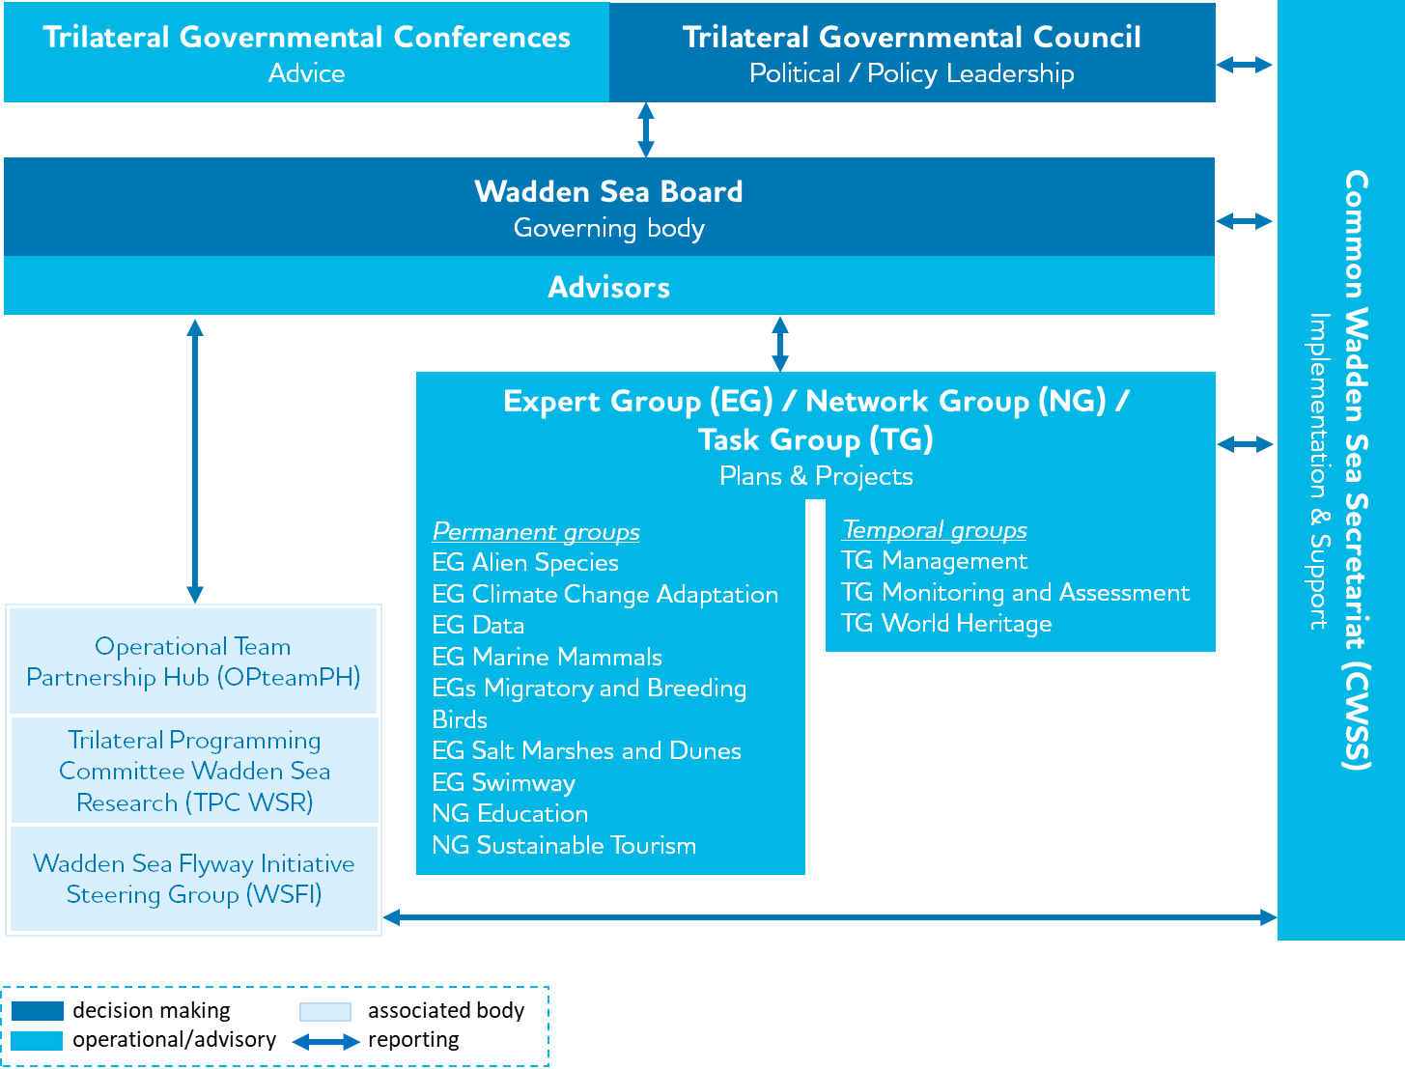
Figure: Organisational structure of the Trilateral Wadden Sea Cooperation

Key documents for SWIMWAY Wadden Sea
Leeuwarden Declaration
The Leeuwarden Declaration, signed at the 13th Trilateral Governmental Conference in Leeuwarden, Netherlands, on 18 May 2018, contains key points for the 2018-2022 period of the Trilateral Cooperation on the Protection of the Wadden Sea. Amongst these:
The Ministers..
13. Instruct the Wadden Sea Board to further develop and contribute to implementing the SWIMWAY Vision (at Annex 3) as an integrated approach to achieving the Trilateral Fish Targets by investigating, monitoring, managing and communicating topics concerning the ecology of fish of the Wadden Sea Area;
During the Trilateral Wadden Sea Conference held in conjunction with the Trilateral Governmental Council and open to stakeholders, a Swimway Vision based on the 2016 Swimway Initiative was signed.
Wadden Sea Plan
The Trilateral Wadden Sea Plan (WSP) 2010 is the common policy and management plan for the protection and sustainable management of the Wadden Sea Area. It is also the common management plan for the Wadden Sea World Heritage Site. A unique and basic feature of the Wadden Sea Plan is that it aims at achieving the full scala of habitats, which belong to a natural and dynamic Wadden Sea. Each of these habitats, for which common trilateral Targets have been adopted, needs a certain quality (natural dynamics, absence of anthropogenic disturbance, absence of pollution), which can be reached by proper management of the area.
The WSP 2010 contains Fish Targets (page 77 ff)
- Viable stocks of populations and a natural reproduction of typical Wadden Sea fish species.
- Occurrence and abundance of fish species according to the natural dynamics in (a)biotic conditions.
- Favourable living conditions for endangered fish species.
- Maintenance of the diversity of natural habitats to provide substratum for spawning and nursery functions for juvenile fish.
- Maintaining and restoring the possibilities for the passage of migrating fish between the Wadden Sea and inland waters
Note: Tulp et al propose in the Wadden Sea Quality Status Report (QSR) 2017 thematic report on Fish that
“These targets were not formulated in a testable way, which makes it impossible to evaluate them quantitatively. Furthermore, the formulations are not all easy to comprehend, allowing multiple interpretations. To facilitate objective evaluation in the future, we propose to restructure and reformulate the targets as follows:
Overall target: There should be no human-induced bottlenecks in the Wadden Sea for fish populations or their ecosystem functions.
Targets (all in reference to the overall target):
Maintain or improve:
- Robust and viable populations of estuarine resident fish species;
- The nursery function of the Wadden Sea and estuaries;
- The quality and quantity of typical Wadden Sea habitats;
- Passage ways for fish migrating between the Wadden Sea and inland waters;
- Conservation of endangered fish species.
Clarifications:
- Fish populations: we include species currently present, but also consider niches that are currently vacant (e.g., large predators), regardless of the species that used to fill these niches historically;
- Ecosystem functions: e.g., food for birds and mammals in the Wadden Sea;
- Maintain or improve: requires an evaluation beforehand;
- Robust: can withstand extreme events;
- Viable: self-sustaining;
- Diversity of habitats required for diversity of species and functions (e.g., spawning, nursery);
- Endangered: As evaluated by national red lists.
The next step is to formulate quantitative and testable sub-targets for each target. These sub-targets must focus on fish parameters that are influenced by (manageable) human activities. At this stage, knowledge on human impacts, population dynamics and ecology of typical Wadden Sea fish species is too limited to enable quantitative sub-targets. The recommendations on research (see below) aim at acquiring sufficient knowledge to enable setting such quantitative sub-targets in the future.”

Trilateral Wadden Sea Swimway Vision Action Programme
This action programme is written by a trilateral coordination team. It describes actions suitable to improve knowledge on relevant processes, optimize population monitoring, adjust policies and develop, realise and evaluate measures towards reaching the Trilateral Fish Targets. Therefore, activities such as coordinating, facilitating collaboration, fundraising and project development are part of this action programme. Collaboration with existing activities and programmes that address the Fish Targets is a prerequisite for success. Communication and education are also key elements of the SWIMWAY Programme, helping to increase public awareness to facilitate holistic, ecosystem- and evidence-based fish conservation in the Wadden Sea.

Annex 1 Terms of Reference EG-Swimway
2021 – 2024
Background
At the Ministerial Council Meetings in 2014 and 2018, Denmark, Germany and the Netherlands stated and decided to work on the further implementation of the five Trilateral Fish Targets as laid down in the Wadden Sea Plan 2010. To that effect, the trilateral Swimway Vision 2018-2024 was approved by the ministers at the 13th Governmental Conference on the protection of the Wadden Sea on 18 May 2018 in Leeuwarden, NL, and the Trilateral Wadden Sea Swimway Vision Action Programme as adopted by the Wadden Sea Board (WSB) at WSB28. EG Swimway reports to the Common Wadden Sea Secretariat (CWSS) and to the Task Groups Management (TG-M) and Monitoring and Assessment (TG-MA) if appropriate. The implementation of the Framework Sustainable Fisheries and other issues related to fisheries are excluded from the scope of work for this Expert Group.
In fulfilling its mandate, this group will duly take into account and seek to promote the achievement of the United Nations Sustainable Development Goals (SDG).
Objective
The overarching goal of the group is to contribute to improving the situation for fish in the Wadden Sea. This goal is to be achieved by fostering trilateral collaboration on the implementation of the trilateral fish targets as laid down in the WSP 2010 and to provide an overarching SWIMWAY approach as umbrella for initiatives related to achieving the targets according to the Swimway Vision Action Programme and its four pillars: research and monitoring; policy; measures and stakeholder involvement, communication and education.
Tasks
(1) Develop, initiate, /support, document existing projects and evaluate activities targeted at improving the situation for fish in the Wadden Sea. Activities concern research, monitoring, conservation and restoration measures, capacity building, development of best practices, education and advice;
(2) Exchange on national monitoring programmes and development of a possible future (harmonized) trilateral fish monitoring programme as part of the Trilateral Monitoring and Assessment Programme (TMAP), including the promotion of complementary research programmes;
(3) Overseeing progress towards reaching the trilateral fish targets under the Trilateral Wadden Sea Cooperation (TWSC), in particular by liaising with and/or participating in relevant actions to improve the conservation status of Wadden Sea fish, such as national and international research projects and action plans;
(4) Conduct regular assessments based on the monitoring programme and relevant, scientific programmes in order to provide advice to management relevant for fish life cycles in the Wadden Sea. Contribution to and update of the thematic report on fish of the Quality Status Report (QSR);
(5) Define a concept for a forum to stimulate and support exchange of information on Wadden Sea fish, and for coordination with other, EU – wide or global SWIMWAY and related activities;
(6) Promote communication of its work and actions to other national, trilateral and international groups as part of the communication work of the TWSC via CWSS, including organization of Swimway conferences.
(7) Coordination and implementation of the Swimway Vision and Action Programme; including elaborating recommendations of the Swimway policy review.
(8) Acquisition of collaborative projects with relevance to the SWIMWAY vision and action programme, such as joint research projects, including an early exchange of information;
Deliverables
(1) Regular documentation of how the group work has contributed to the improvement of the situation for fish in the Wadden Sea;
(2) Recommendation for operational fish monitoring programme(s) under TMAP;
(3) Regular trilateral progress reports on the status of Wadden Sea fish, including QSR thematic reports on fish, based on recent monitoring and under consideration of additional data, provide advice for measures to management;
(4) The group to function as platform for communication and for exchange of information with other SWIMWAY initiatives and entities to consider the wider geographical context of migrating fish; Collaboration and exchange, e.g. via Swimway conferences, support of the development of information material;
(5) Activity plan for implementation of SWIMWAY Vision and Action Programme with clearly defined products and results and division of tasks, with continuous updates.
Composition/Membership
Chairperson plus
1-2 members per region (DK, HH, LS, NL, SH), preferably with scientific expertise in Wadden Sea fish and from monitoring and administrative/ management level, plus 1 -2 representatives of NGOs with Wadden Sea fish expertise.
Participation by additional experts to EG-Swimway meetings and activities is welcome upon invitation on specific tasks/topics.
Time schedule
Permanent group.
According to the decision by the Ministerial Conference, the implementation of the Swimway Vision/Action Programme is foreseen to be accomplished within the German Presidency plus two years i.e. in the period 2021 – 2024.

