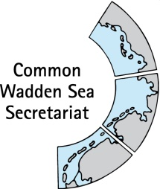
DRAFT AGENDA v0.2
Expert group Climate Change Adaptation
(EG-C 11)
8 December 2021
Online meeting

- Opening of the Meeting and adoption of the Agenda
The meeting will be opened by the Chairperson at 09:00 on 8 December 2021.
Proposal: Adopt the draft agenda of the meeting

- Adoption of the draft summary record
Document: EG-C11-2-SR-EG-C10
Proposal: Adopt the draft Summary Record of EG-C 10.

- Announcements
Announcements of participants.
Proposal: Note the information

- Trilateral Monitoring and Assessment Programme (TMAP) & Quality Status Report (QSR)
Presentation of State Master Plan for Coastal Flood Defense and Coastal Protection by Jacobus Hofstede. Information on Schleswig-Holstein situation climate monitoring will be fed into a panned TMAP climate workshop.
Proposal: note the information, compile list of TMAP climate workshop participants

- Trilateral Governmental Conference and Ministerial Declaration
Document: EG-C11-5-TGC-MD
Discuss EG-C contribution to Ministerial Declaration (MD) and possible activities at the TGC based on online document
Proposal: Agree on articles for submission to Ministerial Conference Declaration drafting group and start planning side event(s) (and suggest to German presidency)

- Any Other Business and next meeting
Any other business

EG-C 12 Wednesday 9 February, 2022 (online)
EG-C 13 Tuesday 26 April, 2022 (in person?)
Proposal: Note the information

- Closing
The meeting will be closed no later than 12:00 on 8 December 2021.

