Single integrated management plan (SIMP)
Wadden Sea World Heritage

Draft version 0.9 (07.07.2022) – Includes input from Consultation for TG-WH 37 Discussion
Authors: Trilateral Wadden Sea Cooperation (TWSC)

This publication should be cited as:
Common Wadden Sea Secretariat. 2022. Single integrated management plan for the Wadden Sea World Heritage. Common Wadden Sea Secretariat, Wilhelmshaven, Germany.

Preface/Foreword

Contents
Preface/Foreword 2
Executive Summary 4
Main messages 5
1. Introduction 9
1.1. Background 9
1.2. The Purpose of the SIMP 10
1.3. The Status of the SIMP 11
1.4. The Scope of the SIMP 11
1.5. The Process of Developing the SIMP 14
1.6. The Added Value 15
1.7. Review of the SIMP 15
2. The Outstanding Universal Value of the Wadden Sea 16
2.1. The OUV: Criteria and Key Values 17
2.2. The OUV: Integrity 18
2.3. The OUV: Protection and Management Requirements 19
3. Nature Conservation Management 20
3.1 Trilateral Cooperation Structure 23
3.2 National Administration and Management Systems 24
3.3 Site managers 26
3.4 Management Cycle 27
4. Climate Change Vulnerability and Adaptation 33
4.1 Climate Stressors in the Wadden Sea 33
4.2 Adaptation and Mitigation Agreements 33
4.3 Proposals for Management Activities 34
5. Towards a Sustainable Management of the Wadden Sea 36
5.1 Key Topic Fisheries 37
5.2 Key Topic Tourism 40
5.3 Key Topic Shipping and Ports 42
5.4 Key Topic Energy 45
5.5 Key Topic Coastal Flood Defence and Protection 48
6. Complementary Activities to Support Management 51
6.1 Science and Research 51
6.2 Monitoring and Assessment 52
6.3 Knowledge Management 53
6.4 Education for Sustainable Development and Interpretation 54
6.5 Communication 55
6.6 Collaborations and Partnerships 56
7. Global Dimensions 58
7.1 Global Interconnections 58
7.2 International Cooperation 59
7.3 Contributions to the EU Biodiversity Strategy for 2030 60
7.4 Contributions to the SDGs of the UN Agenda 2030 61
8. Abbreviations 63
9. References 63
Annex 1 64
Endnotes 69

Executive Summary
The global importance of the Wadden Sea as the largest unbroken intertidal back-barrier sand and mudflat ecosystem in the world, the longstanding conservation efforts of the Trilateral Governmental Cooperation of the three Wadden Sea States and the support from the Wadden Sea region and its stakeholders are recognised by its World Heritage status. With the inscription of the Wadden Sea on the UNESCO’s World Heritage List as transboundary site, came the request by the World Heritage Committee to develop a single integrated management plan (SIMP) with the purpose of further facilitating the continuous improvement of transboundary management coordination for the protection and maintenance of the Outstanding Universal Value (OUV).
The SIMP provides a clear overarching description of the nature conservation management structures in Denmark, Germany, and the Netherlands and at the trilateral level. It also describes how existing management elements are implemented trilaterally in the context of a continuous cycle of adaptive management.
In the process of developing the SIMP, five topics were prioritised as of high importance for joint management to maintain the integrity of the Site. These key topics were identified in an iterative and participative process that included the selection criteria of urgency, direct effect on the OUV and need to address at the trilateral level submitted in the Leeuwarden Declaration (2018), the Wadden Sea’s site managers’ recommendations, and a prioritisation by Task Group World Heritage. These topics are also mentioned by the World Heritage Committee in the Statement of Outstanding Universal Value as needing continuous attention. Pending management tasks and activities are suggested for all key topics based upon the site managers’, experts’, and policy makers’ proposals to give possible further steps.
The SIMP also presents the complementary activities to support management in the Wadden Sea and shows how the Trilateral Wadden Sea Cooperation (TWSC) is addressing the overarching effects of climate change. The SIMP highlights the Wadden Sea World Heritage Site’s global role and its link to global responsibilities. Cooperation with partners in the area and globally is instrumental in and supportive of the long-term protection of the Wadden Sea.
The single integrated management plan (SIMP) for the Wadden Sea is a political agreement within the Trilateral Wadden Sea Cooperation (TWSC), meaning it is a legally non-binding document of common political interest. Existing policy documents and legally binding instruments at the trilateral, regional, national, or local level are not altered or affected by the SIMP. The SIMP is complementary to the Wadden Sea Plan 2010 (WSP).

The main target audiences of the SIMP are decision and policy makers and the site managers working in nature conservation of the Wadden Sea area in the three countries. Further important target audiences are environmental NGOs and other strategic partners, the scientific community, the administrations from socio-economic sectors (e.g. education, fisheries, tourism and shipping) addressed in the SIMP, and the local population.
The SIMP will be revised regularly (every 10-12 years) by the Wadden Sea Board (WSB) presenting the opportunity to adapt the SIMP based on the outcomes of the trilateral monitoring and assessment programme as well as management requirements of the TWSC, including the selection of key topics, with the support and participation of all parties involved in implementing the plan. It is intended that the SIMP review will be aligned as much as possible with other process.
Different trilateral groups and site managers from Denmark, Germany, and the Netherlands were involved in the process of developing the SIMP. The SIMP went through a consultation phase in the three countries before its adoption at the Trilateral Governmental Conference in Wilhelmshaven 2022.

Main messages

- The management system of the Wadden Sea World Heritage Site is a combination of the existing national protection and management systems and the trilaterally coordinated management of the Cooperation Area. By providing a clear and up to date overview of the existing administrative nature conservation structures and their legal basis, the SIMP aims to improve the understanding of the Wadden Sea World Heritage management system.

- Climate change adaptation measures in the Wadden Sea are guided by the Trilateral Climate Change Adaptation Strategy (CCAS) towards a climate resilient Wadden Sea ecosystem. Mitigation measures aim towards developing the Wadden Sea Region into a CO2-neutral area by 2030. CO2-reduction policies and plans at the national and regional levels include the transition to renewable energy, as well as habitat restoration. Further proposals for management activities require the further operationalisation and update of the CCAS, also to include blue carbon habitats and emphasis on mitigation. In addition, improved communication of the World Heritage value and climate change effects in relation to economic, social, and cultural values, and trilateral knowledge exchange and interdisciplinary discussions are essential.

- The SIMP key topics are related to human activities relying on ecosystem services and taking place inside of and adjacent to the World Heritage property. The five key topics are: 1) Fisheries, 2) Tourism, 3) Shipping and Ports, 4) Renewable Energy and Energy from Oil and Gas and 5) Coastal Flood Defence and Protection.

- Limiting possible impact on the OUV of each of these key topics is embedded in European and/or national regulations and agreements. Where there is an added value for a trilateral approach, this will be implemented under the framework of the SIMP.

- The Statement of Outstanding Universal Value as adopted by the World Heritage Committee in 2014, notes that these topics may pose threats to the integrity of the Wadden Sea World Heritage Site and therefore need continuous attention. At the same time, if practices in the key topics evolve towards more sustainability, these topics will support the area’s conservation.

- The activities agreed upon for the prioritised five key topics aim to be performed by the TWSC bodies in close collaboration with the relevant groups. In the proposed implementation of the activities, the existing nature conservation standards and policies are to be maintained or improved to sustain the area’s OUV for future generations. The implementation of the activities shall in no way lead to the lowering of existing nature conservation standards.

- In the key topic fisheries, the objective is to advance towards the implementation of the Framework for Sustainable Fisheries (Annex 3, Tønder Declaration 2014) considering that the existing nature conservation standard should be improved or maintained. The activities aim to be performed by the TWSC bodies in collaboration with the relevant groups to i.a. stimulate exchange of knowledge, best practices and management experiences while keeping an overview and feeding the Wadden Sea World Heritage with the relevant information of other existing groups treating fisheries and aquaculture at the local, national, and regional levels. Awareness of the Wadden Sea World Heritage values and vulnerability and best practices and fish research should continue to be improved.

- In the key topic tourism, the objective is to increase the support of visitors, local entrepreneurs, destination marketing organisations and other stakeholders for nature conservation by continuing to advance the implementation of the Sustainable Tourism Strategy (Annex 1, Tønder Declaration 2014) and Action Plan. The activities aim to be performed by the TWSC bodies in collaboration with the relevant groups to continue to improve awareness, enhance the nature conservation aspect in sustainable tourism by adding the expertise of site managers, and to strengthen initiatives for cross-border cooperation for fostering nature conservation by i.a. addressing gaps of knowledge regarding the impacts of tourism on the OUV.

- In the key topic shipping and ports, the objective is to further improve shipping safety, building on the comparatively high status of prevention of accidents, preparedness and emergency response, to foster nature based operations, and the way to climate neutrality. The activities aim to be performed by the TWSC bodies in collaboration with the relevant groups to discuss the further implementation of the Operational Plans for the Wadden Sea PSSA (Annex 5, Tønder Declaration 2014), continue to raise awareness and to stimulate trilateral exchange and dialogue to i.a identify priorities to address with the related sectors and explore ways to implement and/or make use of best practices, existing technology, and international standards.

- In the key topic renewable energy and energy from oil and gas, the objective is to avoid any negative impact on Wadden Sea habitats or species in particular through exploitation of gas and oil, but also by renewable energy, in or in the vicinity of the Wadden Sea, to intensify the application of common best practices to protect the Wadden Sea, to support a nature friendly energy transition, and to foster a level playing field at highest applied environmental standards for all three countries in a collaborative approach with the energy sector. There should be an exit from exploitation of fossil energy by 2030. Short-term demand for gas and other resources such as LNG fuels must not override the long-term commitment of protecting the Wadden Sea World Heritage Site. The activities aim to be performed by the TWSC bodies in collaboration with the relevant groups to i.a. facilitate trilateral exchange and enhance and maintain dialogue and collaboration with agencies, energy companies and authorities and to ensure that Best Available Techniques and Best Environmental Practice are applied.

- In the key topic coastal flood defence and protection, the objective is to enhance the use of nature friendly measures and maintenance practices in a collaborative approach with the competent authorities, implementing and updating the Climate Change Adaptation Strategy (Annex 4, Tønder Declaration 2014). The potential of coastal habitats in protecting the coast, conserving biodiversity and sequestering blue carbon must be better put into action, in line with the Guiding Principle. The activities aim to be performed by the TWSC bodies in collaboration with the relevant groups to i.a. enhance collaboration to introduce, where adequate and feasible in no-regret measures and nature-based solutions, stimulate trilateral exchange of best practices, formulate relevant research questions, and continue to improve awareness. It is vital to stimulate societal debate and motivation for adapting to inevitable sea level rise in a nature- and climate-friendly manner.

- Trilateral exchange of knowledge and best practices for the benefit of nature conservation management and raising awareness/advocacy are relevant for all five key topics. Trilateral knowledge exchange and advocacy activities need to be continuously improved to strengthen the Cooperation’s joint arguments for nature conservation and to be able to adapt to thematic as well as technological and societal changes.

- Science and Research, Monitoring and Assessment, Knowledge Management, Education, Communication, and Collaboration and Partnerships are fundamental complementary activities to support management in the Wadden Sea. The SIMP comprises trilateral strategies, plans and initiatives, challenges, and outlook in these fields.

- The global dimension of the Wadden Sea is not only apparent in its status as World Heritage property, but also in the fact that it is highly interconnected with other sites. Collaboration in programmes like the Wadden Sea Flyway and Swimway Initiatives, international cooperation with other World Heritage properties, and the UNESCO World Heritage Centre thematic programmes allow for mutual learning and developing solutions to enhance protection.

- The Wadden Sea World Heritage Site, as one of the largest protected areas in Europe, contributes to the EU Biodiversity Strategy for 2030, especially to the nature protection targets of protecting at least 30% of the EU’s land and sea, with at least one third thereof for strict protection, and aids to build a coherent Trans-European Nature Network.

- The TWSC actively contributes to the implementation of the Agenda 2030 for Sustainable Development, with its globally accepted Sustainable Development Goals (SDGs).

- Introduction
  - Background
The Wadden Sea was inscribed on UNESCO’s World Heritage List in 2009 (and extended in 2014) in recognition of its Outstanding Universal Value (OUV). The global importance declared in the Statement of OUV recognises that the Wadden Sea is the largest unbroken intertidal back-barrier sand and mudflat ecosystem in the world. Natural processes continue to thrive largely undisturbed, creating a variety of barrier islands, channels, flats, gullies, saltmarshes, and other coastal and sedimentary features. The Wadden Sea is rich in species specially adapted to these environmental conditions. These conditions also make the Wadden Sea a vital spot for migratory birds in the East Atlantic Flyway, which plays a critical role in the conservation of African-Eurasian migratory waterbirds.
To ensure the protection of this unique ecosystem for the benefit of present and future generations of humankind, Denmark, Germany, and the Netherlands are committed to working together to build a comprehensive national and international nature conservation system. In this framework, the Trilateral Governmental Cooperation on the Protection of the Wadden Sea, in short Trilateral Wadden Sea Cooperation (TWSC) was established in 1978 as a tool for cooperation and coordination of nature conservation. This commitment, the Objective of the Cooperation, its Guiding principle, Vision, the areas of cooperation as well as institutional and financial agreements are specified in the Joint Declaration on the Protection of the Wadden Sea: Working together to meet present and future challenges (1982, revised in 2010). The listing of the Wadden Sea as a World Heritage property, the utmost international acknowledgment for a natural area, shows great appreciation and is the recognition of the longstanding trilateral cooperation, the support from the region and its stakeholders, and the conservation efforts.
The overriding and overarching objectives of the TWSC are framed by the Vision for the Wadden Sea and the Guiding Principle and are in line with the Outstanding Universal Value of the Wadden Sea World Heritage (Figure 1). Denmark, Germany, and the Netherlands have built independently, and jointly during their over 40 years of trilateral cooperation, a comprehensive management system addressing some of the most urgent and important key aspects. In addition to the Wadden Sea Plan (WSP, 2010) which is the commonly agreed policy and management plan, there are various trilateral, regional, and local strategies, management plans, plans of actions and networks. In short, plenty has already been achieved and the work towards important milestones is under way, but there are still challenges to be faced.

Figure 1. Guiding Principle, Vision and Objectives of the Trilateral Wadden Sea Cooperation (Joint Declaration 2010) and Management Principles (Wadden Sea Plan 2010, p. 9) as basis for the SIMP.

  - The Purpose of the SIMP
Considering the wealth and diversity of management systems and instruments that are in place in the Wadden Sea World Heritage Site, the purpose of the SIMP, as agreed by the TWSC and stated in Annex 1 of the Leeuwarden Declaration (2018), is to further facilitate the continuous improvement of management coordination and of the actual management measures for the protection and maintenance of the Outstanding Universal Value by:
- providing a clear overarching description of the management system at the regional, national, and trilateral level,
- addressing key topics presenting concrete present and potential impacts to the Outstanding Universal Value which have been prioritised as pending management tasks,
- present existing joint management activities across the property and showcase gaps which need enhanced joint efforts to maintain or improve the area’s Outstanding Universal Value.
  - The Status of the SIMP
The SIMP for the Wadden Sea is a political agreement of the Trilateral Wadden Sea Cooperation (TWSC), meaning it is a legally non-binding document of common political interest.
Existing policy documents and legally binding instruments at the trilateral, regional, national, or local level are not altered or affected by the SIMP.
The SIMP does not change neither the content nor the function of existing national or trilateral plans, thus it is complementary to the Wadden Sea Plan (WSP) (further detail about WSP is presented as the foundation of Section 3. Nature Conservation Management). The SIMP acts as an umbrella for existing plans and policies and provides information on how these are implemented trilaterally for nature conservation management.
  - The Scope of the SIMP
The focus of the SIMP is the Wadden Sea World Heritage Site and the conservation of its Outstanding Universal Value (OUV, explained in Section 2). The SIMP presents (Figure 2) a clear overview of the nature conservation management structures in Denmark, Germany, and the Netherlands and at the trilateral level, describes how the work is done together. The existing management elements in the context of the management cycle (as defined in § 111 of the Operational Guidelines for the Implementation of the World Heritage Convention) are also presented.
In the process of developing the SIMP (Section 1.5, Figure 3), five aspects have been prioritised as key topics for joint management. By referring to them as “key topics” it is not meant that other topics (i.e. related to nature conservation) are less important. The SIMP key topics are related to human activities relying on ecosystem services and taking place inside of and adjacent to the World Heritage property.
The five key topics are: 1) Fisheries, 2) Tourism, 3) Shipping and Ports, 4) Renewable Energy and Energy from Oil and Gas and 5) Coastal Flood Defence and Protection. These key topics were identified in an iterative and participative process that included the selection criteria of urgency, direct effect on the OUV and need to address at the trilateral level submitted in the Leeuwarden Declaration (2018), the Wadden Sea’s site managers’ recommendations in 2019, and a prioritisation by Task Group World Heritage.
Additionally, the Statement of OUV notes that these topics may pose key threats to the integrity of the Wadden Sea World Heritage Site and therefore need permanent attention. At the same time, if practices in the key topics evolve towards more sustainability this can support the area’s conservation. Furthermore, these topics are challenging, since the work of the TWSC on these topics has to actively engage the competent authorities and integrate the range of competences of site managers in those key topics. Addressing these at a trilateral level leverages the existing opportunities.

As Science and Research, Monitoring and Assessment, Knowledge Management, Education, Communication, and Collaboration and Partnerships are fundamental complementary activities to support management in the Wadden Sea, the SIMP compiles useful information for site managers in these fields. In the same way, the SIMP shows how the TWSC is addressing the overarching effects of climate change.
Additionally, the SIMP highlights the Wadden Sea World Heritage Site’s global role and its link to global responsibilities. Cooperation with partners worldwide is instrumental in and supportive of the long-term protection of the Wadden Sea.
The main target audience of the SIMP are decision and policy makers and the site managers working in nature conservation of the Wadden Sea area in the three countries. The SIMP should inform decision and policy makers, and the site managers and improve the coordination of management among the site managers. Further important target audiences are environmental NGOs and other strategic partners, the scientific community, administrations, and colleagues from socio-economic sectors (e.g. fisheries, tourism and shipping) addressed in the SIMP, and the local population.

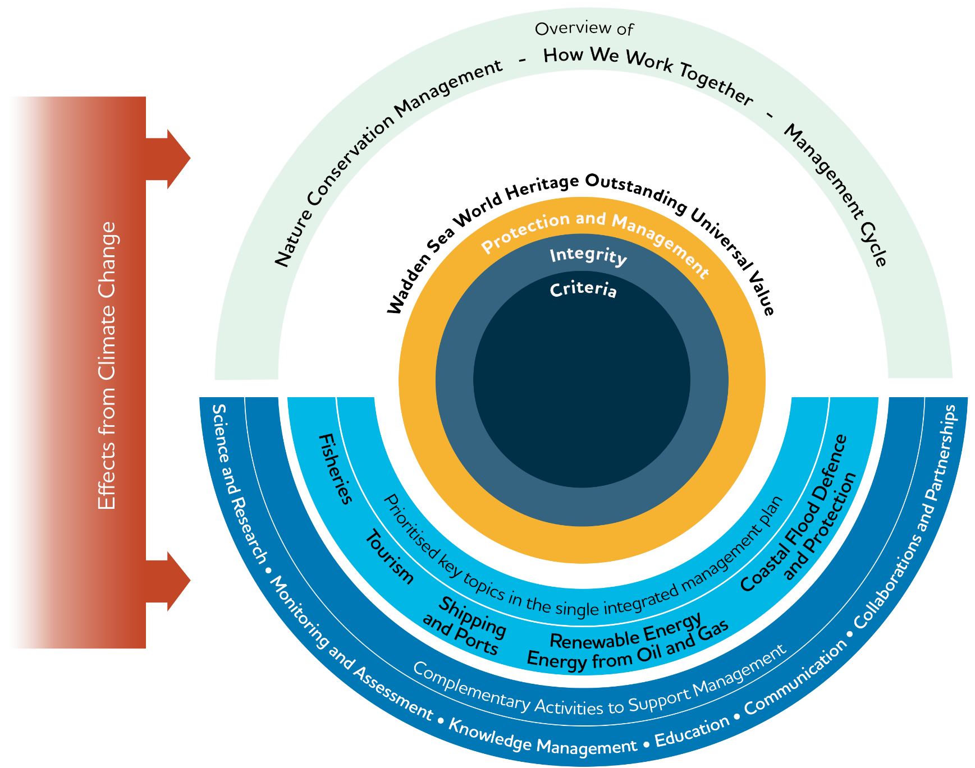

Figure 2. The scope of the SIMP has the Wadden Sea World Heritage Outstanding Universal Value at the core. The SIMP acts as an umbrella providing an overview of the management systems, tools, and collaboration. Five prioritised key topics are addressed considering how to improve information exchange and dissemination to better coordinate nature conservation management activities. To maintain the Wadden Sea World Heritage Outstanding Universal Value, the SIMP provides information about the complementary activities to support management. All considering the crosscutting effects of climate change.
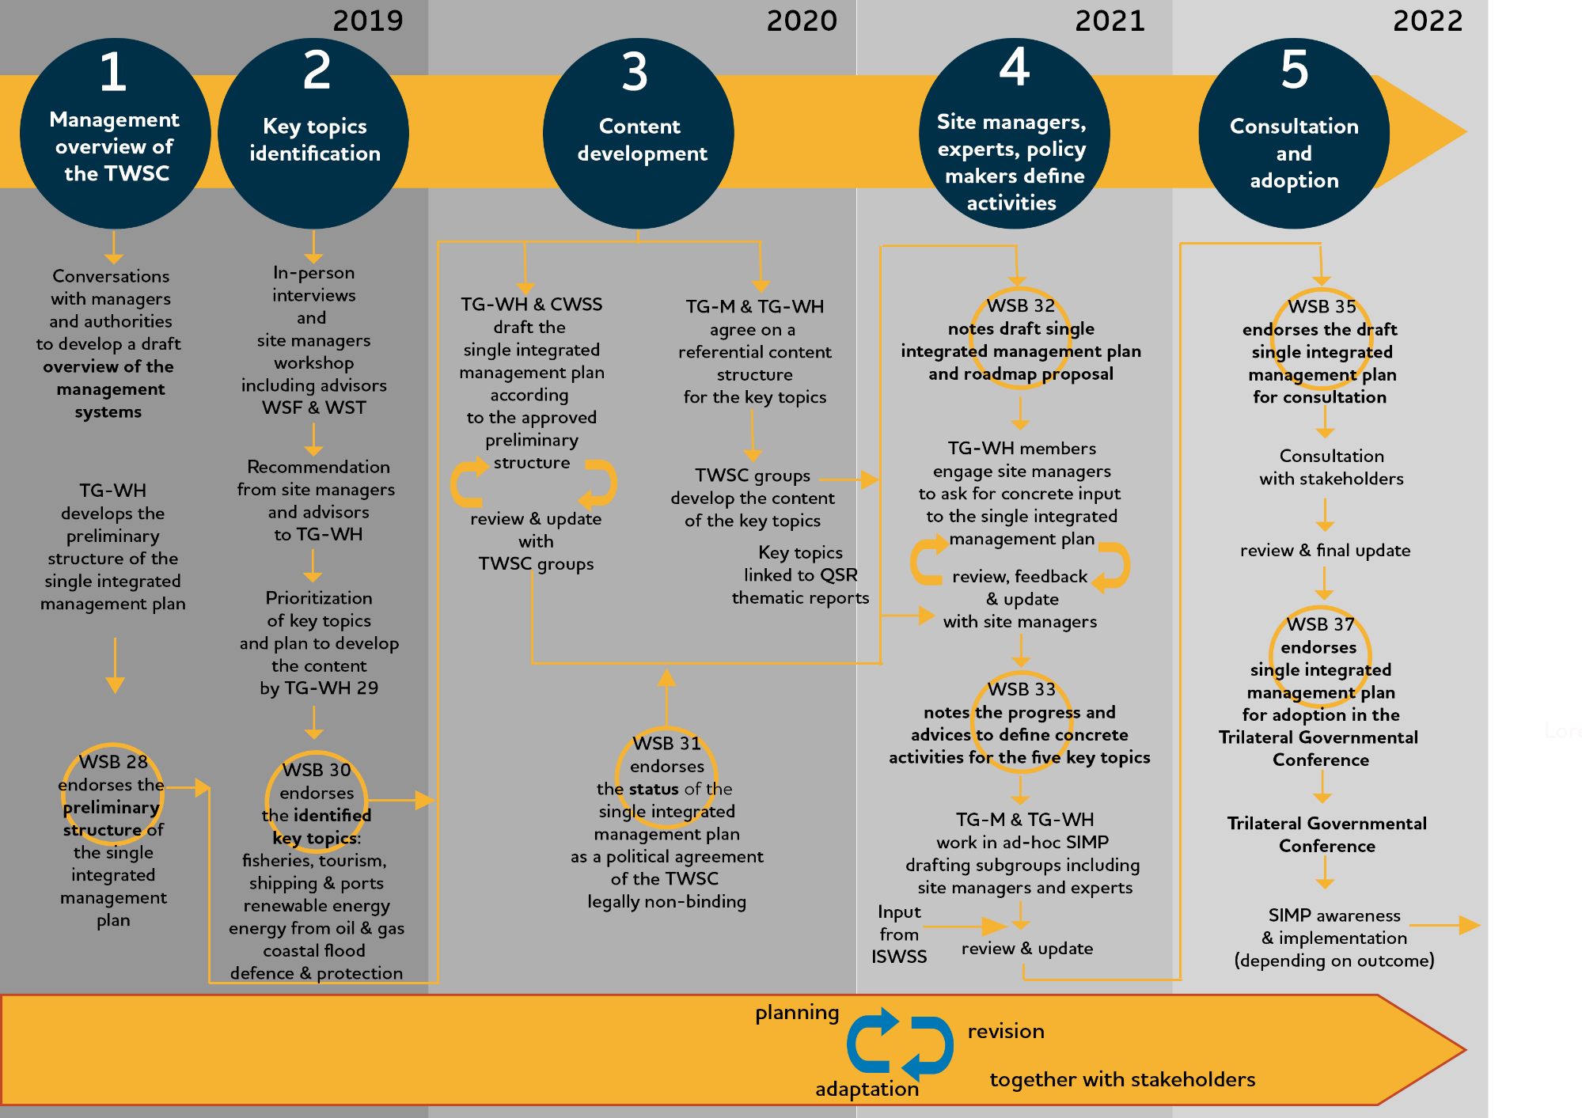
  - The Process of Developing the SIMP

[Note In the future this figure will be simplified to show only the main steps relevant for site managers and other readers.]

Figure 3. The five phases of the development of the SIMP 2019-2022, and the detail of each phase.

Abbreviations:
CWSS: Common Wadden Sea Secretariat
ISWSS: International Scientific Wadden Sea Symposium
TG-M: Task Group Management
TG-WH: Task Group World Heritage
TWSC: Trilateral Wadden Sea Cooperation.
WSB: Wadden Sea Board

  - The Added Value
There are several important added values in the SIMP. By providing a clear and updated overview of the existing nature conservation structures, the SIMP aims to improve the understanding of the Wadden Sea World Heritage management system.
The SIMP compiles the status and management approaches to manage the key topics affecting the property addressed in a comprehensible and accessible way, which can be easily communicated and used on the operative level. The SIMP links each key topic directly to the OUV, describes the common ground expressed in the WSP and other trilateral tools and shows how each country implements measures.
The SIMP contributes to the definition of feasible and innovative means to further the exchange of management approaches, experiences, knowledge, and lessons learned at different levels of management and among site managers, partners of the Wadden Sea Area, decision makers, multipliers, and volunteers.
Such an exchange supports the joint development or the review of trilateral initiatives. Exchange further allows for connecting the existing and the future trilateral strategies and plans with regional and local strategies and plans, thus showing how the work is done together and highlighting the key aspects on which the cooperation could be further strengthened. In this way, local, regional, and national actions are backed at the trilateral level and trilateral decisions are integrated into the local, regional, and national strategies and plans.
Finally, in the framework of the SIMP, the TWSC, including the site managers agree on aspects where trilateral cooperation can contribute towards their tasks of protecting the OUV (see Section 5). The SIMP acknowledges the existing differences in the legal responsibilities and competences of site managers in the three countries.
  - Review of the SIMP
The SIMP will be revised regularly by the Wadden Sea Board (WSB). Given the nature of the SIMP, a review cycle of 10-12 years is foreseen. This review presents the opportunity to adapt the SIMP to the management requirements of the TWSC, including the selection of key topics, with the support and participation of all parties involved in implementing the plan. Regular evaluation processes under trilateral and national obligations (i.e. Wadden Sea Quality Status Report, UNESCO Periodic Reporting, Natura 2000 Reports, etc.) will feed into the SIMP review. It is intended that the SIMP review will be aligned as much as possible with other processes.

- The Outstanding Universal Value of the Wadden Sea
The OUV describes why a property is among the most remarkable places on Earth. Its conservation is of importance for the present and future generations of all humanity.
The World Heritage Committee considers a property as having Outstanding Universal Value if the property meets at least one out of ten selection criteria and whether it meets the requirements of integrity, and protection and management (Figure 4). The World Heritage Committee adopts a Statement of the OUV when inscribing a property in the World Heritage List which describes how the criteria and the requirements of integrity, and protection and management are met. The Statement of OUV for the Wadden Sea World Heritage can be found in the UNESCO website.

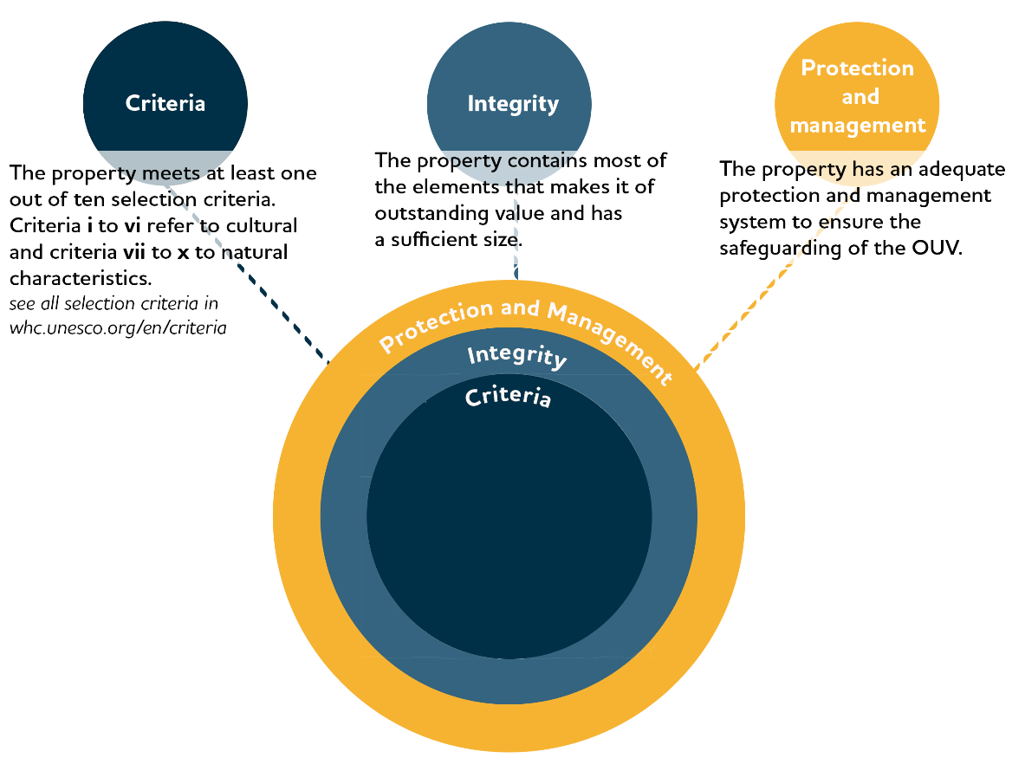

Figure 4. The Outstanding Universal Value (OUV) consists of three conditions: selection criteria, integrity, and protection and management.

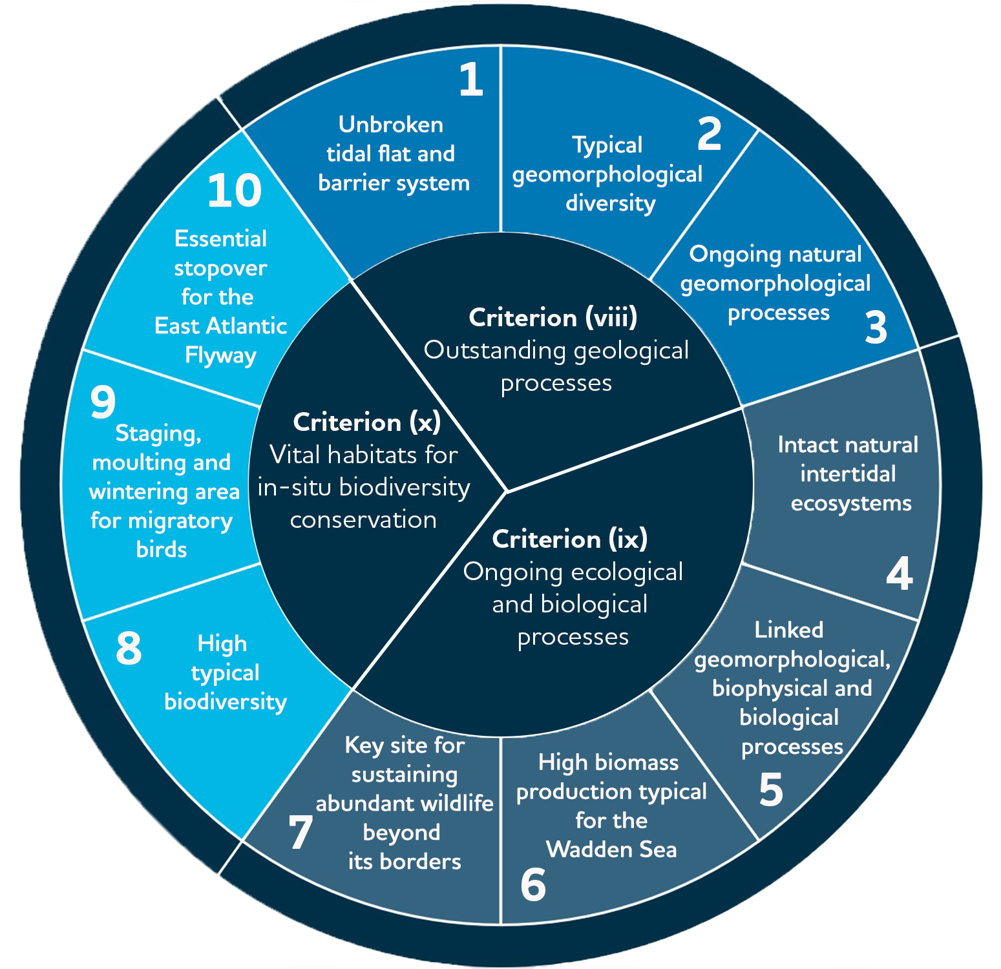
Figure 5. The WSWH criteria and the respective 10 key values derived from the Criteria described in the Statement of OUV of the Wadden Sea whc.unesco.org/en/decisions/1946/.
  - The OUV: Criteria and Key Values
The Wadden Sea World Heritage Site meets three out of four criteria for natural sites:
- (viii) Outstanding geological processes
- (ix) Ongoing ecological and biological processes
- (x) Vital habitats for in-situ biodiversity conservation
The fourth Criterion (vii) Exceptional natural phenomena and beauty has not been applied for.
Criteria viii, ix and x described in the Statement of OUV of the Wadden Sea World Heritage, are expressed through 10 key values (Figure 5) that show the elements that make the Wadden Sea of universal importance.

  - The OUV: Integrity
Integrity is a measure of the wholeness and intactness of the natural heritage and its attributes (§ 88, Operational Guidelines for the Implementation of the World Heritage Convention). The integrity is given by the elements included in the property that reflect its OUV, as well as to the appropriateness of the property’s size to maintain the features and processes, and its ability to cope with exposure to adverse effects, including those from outside the property.
In that respect, the Wadden Sea World Heritage Site, from Denmark through Germany to the Netherlands, includes all the Wadden Sea ecosystem components and features (species, habitats, processes) that constitute a natural and dynamic Wadden Sea. The area is large enough to ensure that these exceptional aspects are included and maintained (see the Statement of OUV 2014).
The Wadden Sea World Heritage Site is subject to a comprehensive protection, management, and monitoring system. The Statement of OUV (2014) recognises that the key threats require ongoing attention to maintain the integrity of the property. Key threats include fisheries activities, developing and maintaining harbours, industrial facilities surrounding the property including oil and gas rigs and wind farms, maritime traffic, residential and tourism development and impacts from climate change.

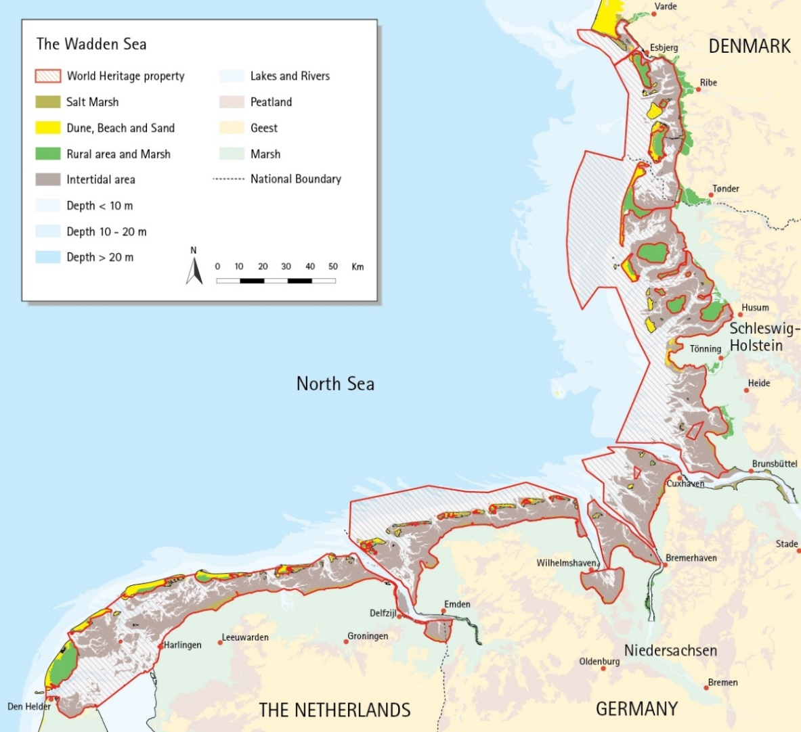

Figure 6. The Wadden Sea World Heritage Site encompasses all the natural habitats, species and processes that constitute the Wadden Sea ecosystem.

  - The OUV: Protection and Management Requirements
The TWSC provides the overall framework and structure for integrated conservation and management of the Wadden Sea World Heritage Site as a whole, and coordination between all three States including national, regional, and local levels. In fact, the Wadden Sea’s highly effective conservation status is the result of four decades of joint nature protection efforts of Denmark, Germany, and the Netherlands, where the Wadden Sea has been designated as national parks, nature reserves and Natura 2000 sites. Each State Party has comprehensive legal protection measures in place. Working together in the TWSC, these countries ensure the coordinated management of the area (see the Statement of OUV 2014).
- Nature Conservation Management

At the beginning of the Trilateral Wadden Sea Cooperation in the late 70’s, nature conservation management of the Wadden Sea was mainly a national matter. But for the past 30 years, the European Union (EU) has made increasing effort to protect the European natural heritage. The present-day management system of the Wadden Sea World Heritage Site is almost entirely covered by European Union law and international conventions in addition to the national regulations. The five most relevant European Union directives are described in Table 2.
In 1979 the EU Birds Directive (2009/147/EC) was adopted, which was the first EU regulation aimed at protecting the environment. Since then, nature protection has been a cornerstone in the EU. But practical planning- and implementation steps need to be taken at national, regional, and local levels by the competent authorities. The environmental laws comply with the principle of subsidiarity, leaving it as far as possible to the responsible authorities to set up their priorities and manage their programs. Differences in political and administrative structures in the three Wadden Sea countries regarding the implementation of EU law into national legislation, present challenges in complying with the expressed political intentions of managing the Wadden Sea as a common entity. At the same time, these differences between the countries can also be utilised for strengthening nature management by aiming for the best possible effect of policy and measures for nature.
In Denmark, since 1939, when the first game reserve was established in parts of the Danish Wadden Sea the area has been subject to an increasing degree of protection until 1998 when the present level of protection was reached with the inclusion of provisions based on Natura 2000 (EU Birds- and EU Habitats Directives 92/43/EEC). Thus, the national implementation processes of EU legislation into national law and subsequently into binding management plans for the public authorities, consider as well trilateral strategies and plans (listed in Figure 7), such as Declarations and most recently the SIMP, which can be characterized as a meta-strategy. In 1985 a major update of the Statutory Order on conservation of the Danish Wadden Sea was derived from the Copenhagen Declaration of 1982. The latest example is the inclusion of the SIMP in the Danish EU Marine Strategy Framework Directive (2008/56/EC) action plan, along with more specific fields of action (fish, alien species, marine mammals, and birds) building upon some of the TWSC strategies approved by the three countries.
In Germany, due to the federal system, the (political, administrative, and legal) structures differ from those in Denmark and the Netherlands. In Germany, nature conservation laws on federal as well as on federal state level have long been in place. There are specific acts for the Wadden Sea National Parks of the federal states. EU directives are usually implemented by integration into existing national laws and legal ordinances, so existing laws had to be supplemented with the EU regulations. The entire German Wadden Sea is designated as protected area under the EU Habitats and/or Birds Directive (92/43/EEC, 2009/147/EC) and lies within the scope of the EU Marine Strategy Framework Directive (2008/56/EC). The inner Wadden Sea is also subject to the scope of the EU Water Framework Directive (2000/60/EC).
In the Netherlands, the EU Birds Directive (2009/147/EC) and EU Habitats Directives (92/43/EEC) were transposed through the Nature Conservation Law 1998. The Nature conservation Law 1998 has been replaced by the Law on Nature Conservation (2015) which continues to implement both the EU Birds and EU Habitats Directives, as well as the Water Framework Directive (2000/60/EC). The entire Dutch Wadden Sea is designated as protected area under the Habitats and Bird Directives and the Water Framework Directive.

Table 2. Overview of the most relevant European Union legislation and the national laws in which these are transposed and plans. Abbreviations are SH: Schleswig-Holstein, HH: Hamburg, LS: Lower Saxony, SAC: Special Areas of Conservation, SPA: Special Protection Areas.
EU-directive | Adop-tion | Status in The Netherlands | Status in Germany | Status in Denmark
Natura 2000 Directives  (Birds Directive 2009/147/EC and Habitats Directive 92/43/EEC) | Birds: 1979  Habitats: 1992 | Transposed in the Law on Nature Conservation.  Natura 2000 plans are reviewed and updated periodically. | Transposed in:  Federal Nature Conservation Act (Bundesnaturschutzgesetz BNatSchG).  State Nature Conservation (Implementation) Acts (SH, HH, LS) (Landesnaturschutzgesetz/ Ausführungsgesetz zum BNatSchG).  National Park Acts (SH, HH, LS).  Specific conservation objectives for each N2000 site (SAC and SPA) are covered by the National Park Acts in LS and HH; SH has a separate document published by the Ministry for the Environment of SH.  Wadden Sea Plan (WSP 2010) functions as the Habitats & Birds Directive management framework for the German part of the Wadden Sea, in LS concretised by the Management Planning for the SAC Wadden Sea. | Transposed in the Marine Protection Act, the Environment Protection Act, and the Nature Conservation Act.
Water Framework Directive 2000/60/EC | 2000 | Transposed in the Law on Nature Conservation, the Water Law, the  National Water Policy Plan, the Regional Water Policy plans of the provinces. | Transposed in:  Federal Water Resources Act (Wasserhaushaltsgesetz), State Water Law (Landeswassergesetz), Management plans for the river basins. | Transposed in the Environment Protection Act.
Marine Strategy Framework Directive 2008/56/EC | 2008 | The Marine Strategy Framework Directive is not implemented in the Dutch Wadden Sea. | Transposed in:  Federal Water Resources Act (Wasserhaushaltsgesetz), State Water Law (Landeswassergesetz), the management plan is the programme of measures 2016 (currently working on an update) | Transposed in the Danish Marine Strategy II and the Danish Marine Strategy Act.
Marine Spatial Planning Directive 2014/89/EU | 2014 | Transposed in the National Water Policy plan. | Transposed in:  Spatial Planning Act (Raumordnungsgesetz, ROG), Lower Saxony Regional Planning Act (Niedersächsisches Raumordnungsgesetz, NROG), Schleswig-Holstein State Planning Act (Landesplanungsgesetz – LaplaG) | Transported in the Act on Maritime Physical Planning (ACT no. 615 of 08/06/2016) and Statutory Order no. 400 of 06/04/2020

In summary, the management system of the Wadden Sea World Heritage Site is a combination of the existing national protection and management systems (Annex Figures A3-5) and the trilaterally coordinated management including a number of trilateral plans, strategies and action plans (see Figure 7).
The Wadden Sea Plan (WSP) 2010 constitutes the common framework for the protection and sustainable management of the Wadden Sea as an ecological entity and is the accepted coordinated management plan for the Wadden Sea World Heritage property, as stated in the Nomination dossier presented to the World Heritage Committee (2013). The WSP presents the trilaterally agreed targets, policies, and measures for the Wadden Sea Cooperation Area as an ecological entity, as well as its landscape and cultural heritage, within the cultural entities. The targets agreed upon for landscape and culture, water and sediment, salt marshes, the tidal area, beaches and dunes, estuaries, the offshore area, the rural area, birds, marine mammals, and fish are the base for the trilaterally and regionally existing topic specific visions, strategies, and plans. In Germany, the WSP serves as the Natura 2000 and national parks' management plan, that is where deemed necessary, supplemented by further detailed management tools (such as for certain habitat types, sectoral plans, or management concepts).
The following sections (3.1 and 3.2) provide an overview of the management system at the trilateral and the national levels. These serve to communicate and disseminate the trilateral management framework in an easy and clear way to national site managers as well as to all stakeholders and the general public.
  - Trilateral Cooperation Structure
The Trilateral Wadden Sea Cooperation (TWSC) comprises two levels of decision making (Governance Arrangements, 2010):
I. The Trilateral Wadden Sea Governmental Council, composed of the responsible ministers of the participating governments to oversee the Cooperation, provides political leadership and strategic guidance, assures international policy development, harmonisation, and decision-making between the three governments. Every period of three to four years, the three countries alternate the presidency of the Cooperation. Presidencies are handed over during the Trilateral Governmental Conferences (TGC).
II. The Wadden Sea Board (WSB) is the governing body composed of delegations appointed by each participating Government. Each delegation includes a representative from the lead Ministry for the Cooperation, and three further members from decentralised governments, other related Ministries, or experts. The WSB oversees the operational and advisory bodies and secures relations with key stakeholders.
The WSB receives further support from Advisors outside the governmental Cooperation, but with expertise and experience relevant to the Cooperation. Appointed advisors are the Wadden Sea Forum, representing stakeholders from the different sectors of society including municipalities and counties, and the Trilateral Wadden Sea Team of environmental NGO’s.
The Common Wadden Sea Secretariat (CWSS) is responsible for supporting the WSB and the Council and for implementing the CWSS’s workplan.
The operational bodies of the TWSC are four types of groups with specific functions and composition:
- Task Groups (TG) are appointed by the WSB to prepare expert topics for the Board and to undertake specific tasks, plans or projects in line with the Ministerial Declarations. TGs are usually time limited.
- Expert Groups (EG) are generally long-term or permanent technical groups. They have operational and advising tasks.
- Network Groups (NG) are similar to Expert Groups but with more of a networking platform character, stakeholder involvement is explicitly necessary and appreciated.
- (ad hoc) Working Groups (WG) are temporarily installed by TGs or the WSB for elaborating on certain aspects of issues targeted in the corresponding TG.

All trilateral groups are requested to generally foster exchange with other groups during the various processes (TWSC review process, 2019). The structure of the TWSC is reproduced in Figure A.1 in Annex 1. Members, supporting organisations and advisors of the WSB are presented in Figure A.2 in Annex 1.

  - National Administration and Management Systems
Denmark
The Ministry of Environment and the Danish Environmental Protection Agency are responsible for writing national legislation and national management plans which are enforced by themselves and/or by other agencies and municipalities. Among their responsibilities are the implementation of Natura 2000, Marine Strategy Framework- and Water Framework Directives, and more specifically the Nature Protection Act and its Statutory Order on the Wadden Sea Nature and Wildlife Reserve. Marine physical planning, also concerning the Wadden Sea, is under the responsibility of the Danish Maritime Authority.
The Danish Nature Agency (as the Environmental Protection Agency) is a unit under the Ministry of Environment and is responsible for the Nature and Wildlife Reserve management administration in the Wadden Sea area through a statutory order issued under the Nature Protection Law. The Nature Agency is also a considerable landowner in the area.
The Varde, Fanø, Tønder and Esbjerg Municipalities, within or adjacent to the Wadden Sea, are responsible for the enforcement of the Nature Protection Act and the implementation and enforcement of Natura 2000. In an advisory function to the government agencies in the Wadden Sea area, an Advisory Board is established, governed by the four municipalities and with representatives of a wide range of stakeholders of the Wadden Sea (Annex 1, Figure A.3).
The Danish National Parks have been established within a framework of a common law as a state-owned foundation, and for each national park, a statutory order has been issued according to the law. Following this, a National Park Board is appointed by the Minister and is responsible for implementing a strategic plan for the National Park. The National Park secretariat has no management or authoritative tasks as such but do play a role in the governing concept of the World Heritage in the group of site managers especially in communication, interpretation, and educational activities. Further, the National Park has an Advisory Board consisting of local community members.
Germany
The overall legal framework for nature conservation is the Federal Nature Conservation Act. Due to the federal system in Germany, the implementation of the Act lies in the responsibility of the federal states Hamburg, Lower Saxony, and Schleswig-Holstein. The Federal Nature Conservation Act includes provisions for the establishment of Nature Reserves and National Parks but also for procedural matters concerning impact assessments, esp. regarding Art. 6 of the Habitats Directive (Nomination Dossier, 2008). The Federal Nature Conservation Act is supplemented by federal state level legislation that may vary in detail. Hence, the Federal Nature Conservation Act and the nature conservation acts of the federal states together, form the legal basis for nature conservation and management. Especially the National Park Acts of Hamburg, Lower Saxony, and Schleswig-Holstein, establishing the respective Wadden Sea National Parks within each of the three federal states, provide the legal basis for safeguarding protection and management of the Wadden Sea World Heritage. At the federal state level, the highest nature conservation authorities are the Ministries of Environment. The National Park Authority in each federal state is the competent nature conservation authority for the Wadden Sea area and is responsible for management and for the enforcement of their respective National Park Acts (Annex 1, Figure A.4).
National Park Advisory Boards are important in terms of consultation, advice, and the involvement of local stakeholders. In Schleswig-Holstein and Lower Saxony, the respective advisory boards are composed of representatives from the regional and local governments and regional stakeholders concerned with commercial, recreational, and environmental interests and of scientific institutions. The boards are consulted and provide advice to the National Park Authorities and give their consent on principal matters and long-term planning.
The Netherlands
In 2020, the Dutch Government installed a new governmental organisational structure for the Dutch Wadden Sea comprising three groups (Annex 1, Figure A.5). The first is the Policy Board of the Wadden Sea Region chaired by the Ministry of Infrastructure and Water Management, the second is the Wadden Sea Management Authority chaired by the Ministry of Agriculture, Nature and Food Quality, and the third is the Stakeholder Council of the Wadden Sea Region chaired by the King’s Commissioner of the Province of Fryslân. The chair of the Stakeholder Council is also the vice-chair of the Policy Board, ensuring the proper connection between stakeholders and the policy level.

  - Site managers
In the context of the SIMP, site managers are professionals with direct responsibilities for nature conservation and management of the Wadden Sea World Heritage Site. Table 3 presents the composition of nature conservation site managers in the three countries.
Table 3. composition of site managers in the three Wadden Sea countries.
Country | Composition of site managers in the Wadden Sea
The Netherlands | Rijkswaterstaat, Natuurmonumenten, Staatsbosbeheer, Ministry of Agriculture, Nature and Food Quality, the three provinces (Groningen, Friesland, and Nord Holland), Landschap Noord-Holland, Groninger Landschap, It Fryske Gea and private owners (each with their own management plans for the areas that they support in the Wadden Sea). ). The Ministry of Defence is also (partly) a manager of areas with in the Wadden Sea region. The municipalities have a management responsibility regarding destination plans and building permits.  The Wadden Sea Management Authority is working on integral site management of the Wadden Sea.  The main tasks of the site managers concern: physical site management, nature recovery, permitting procedures, monitoring, surveillance and enforcement, hospitality, practical research.
Germany
Hamburg | National Park Authority*  Free and Hanseatic City of Hamburg, Ministry of Environment, Climate, Energy and Agriculture Department of Nature Conservation (BUKEA),  Wardening NGO contracted by the National Park Authority  The Hamburg National Park Authority as site manager is responsible for the protection of nature, environmental observation, and research, as well as environmental education and promoting the experience of nature in the National Park.  * part of the Hamburg Ministry of Environment
Schleswig-Holstein | National Park Authority*  Ministry for Energy, Agriculture, the Environment, Nature and Digitalisation (MELUND)  Wardening or supportive NGOs, in many cases contracted by the National Park Authority  The Schleswig-Holstein National Park Authority as site manager is responsible for monitoring, coordination of scientific studies and applied research, management activities, species protection, exceptions and exemptions from the National Park Act, fines. It acts as stakeholder in planning and permission procedures, surveillance and wardening, communication, information and education, coordination of the UNESCO Biosphere Reserve and networks.  * part of the State Agency for Coastal Defense, National Park and Marine Conservation Schleswig-Holstein as a subordinate authority of the MELUND.
Lower Saxony | National Park Authority* (NLPV)  Ministry for Environment, Energy, Building and Climate Protection of Lower Saxony  Wardening NGOs contracted by the National Park Authority  The Lower Saxon National Park Authority as site manager is responsible for monitoring, scientific studies, and research coordination; surveillance and wardening; communication, information and education; maintenance, development and restoration; species protection; exceptions and exemptions; fines; acts as stakeholder in planning and permission procedures; coordinates the UNESCO Biosphere Reserve.  * competent authority, subordinate to the Ministry for Environment, Energy, Building and Climate Protection of Lower Saxony.
Denmark | Municipalities of Esbjerg, Fanø, Varde, Tønder  Danish National Park Wadden Sea  Nature Agency*  Environmental Protection Agency*  Coastal Authority*  The Agency for Culture and Palaces  The main tasks of the Agencies and Authority part of the Ministry of Environment concern: nature protection, monitoring and recovery, implementation of the Natura 2000. The Municipalities contribute with implementation of the Natura 2000, are responsible for the environmental impact reports and initiatives for restoration. The National Park runs projects for nature conservation, communication, education, and awareness, and is responsible for sustainable tourism initiatives.  The Agency for Culture and Palaces, part of the Ministry of Culture Denmark, represents the State Party to the World Heritage Convention.  *part of Ministry of Environment of Denmark.

  - Management Cycle
The Operational Guidelines for the Implementation of the World Heritage Convention (§ 111) state that a management cycle of planning, implementation, monitoring, evaluation, and feedback is among the elements of an effective management (Figure 7). The existing TWSC management instruments are organised in the phases of the management cycle.
Planning
The Guiding Principle of the TWSC (see Figure 1) since 1991, is the guideline for management planning at all levels (Esbjerg Declaration 1991). An essential element of the management system and the backbone of the planning phase in the management cycle is the WSP. The WSP was adopted at the 8th Trilateral Governmental Conference in Stade in 1997 and updated in 2010 (Sylt Declaration 2010) to take the inscription of the Dutch-German Wadden Sea as World Heritage and new developments of European Union (EU) Directives into account.
The Ministerial Declarations issued on the occasions of the TGC every four years, are political declarations, in which agreements are made between the governments, which are relevant for all areas of the cooperation such as management, monitoring, international cooperation, etc. The declarations are therefore an integral part of the total protection and management scheme of the property to which the governments have committed themselves and are politically binding for the appropriate authorities in the three countries.
At the national level, management and monitoring activities are guided by the requirements of the national management systems and relevant EU law. Among these are: Natura 2000 management plans in Denmark and the Netherlands, National Park Management Plan in Denmark, and several management plans for the Wadden Sea area in the Netherlands. In Germany, the WSP serves as the management plan for Natura 2000 areas within the Wadden Sea and the Wadden Sea National Parks and is accompanied by sectoral and regional management plans and regulations.

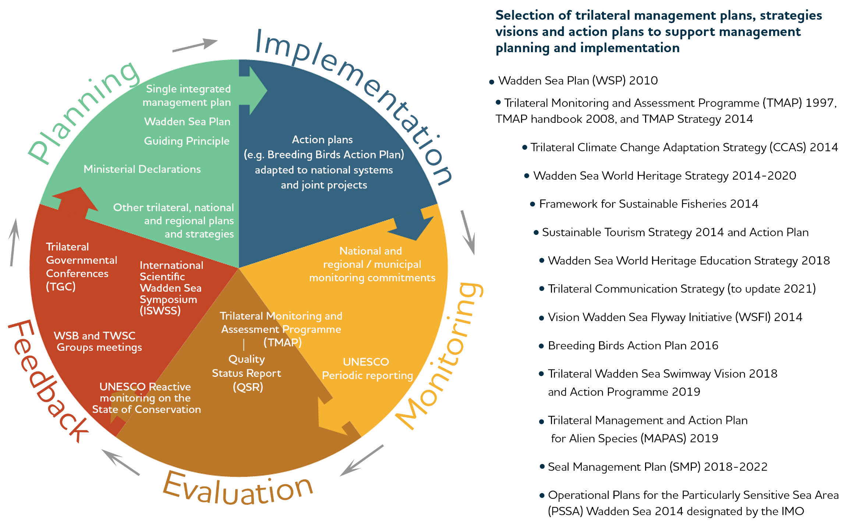

Figure 7. Phases of the management cycle required for an effective management system (as defined in § 111 of the Operational Guidelines for the implementation of the World Heritage Convention) adapted to the Wadden Sea World Heritage by including the elements in each phase. List of trilateral plans, strategies, and action plans to support management. All TWSC management plans, visions, strategies, and action plans can be found in www.waddensea-worldheritage.org.

Implementation
Trilateral visions, policies and agreements are implemented in the three countries according to their laws, management structures, political frameworks, and cultures. Specific action plans and joint projects assist the implementation on the ground by specifying who, where, when and how. Inversely, TWSC political decisions are fuelled by the local and national approaches and requirements (see an example in Box 2).

Examples of successful joint projects that promoted the development and current implementation of the Sustainable Tourism Strategy are the Interreg projects PROWAD, PROWAD LINK, Wadden Agenda and Wadden Agenda 2.0, and NAKUWA. The Wadden Sea Flyway Initiative (WSFI) collaborates with partners beyond the trilateral cooperation to jointly protect and manage the important sites along the East Atlantic Flyway (see Section 6. Global Dimensions).
Monitoring
The Trilateral Monitoring and Assessment Programme (TMAP) is one of the cornerstones of the TWSC and a prerequisite for the inscription on the World Heritage List. The aims of the trilateral Wadden Sea monitoring, assessment and research are:
- to provide a scientific assessment of the status of the ecosystem,
- to assess the status of the implementation of the Ecological Targets of the WSP,
- to use ecological monitoring and assessment to fulfil the UNESCO obligations for the World Heritage.
The assessment results are presented in periodic Quality Status Reports (QSR) authored by TWSC experts and independent scientists.
Further, the World Heritage Convention (Art. 29) requests the State Parties to participate in regular periodic reporting on the implementation of the World Heritage Convention. The report is submitted every six years to the World Heritage Centre (§ 199, Operational Guidelines for the Implementation of the World Heritage Convention).
Additionally, the three countries as EU member states, are obliged to monitor the conservation status for all habitats and species (§ 11 of the Habitats Directive) of community interest (as listed in Annex I, II, IV and V) and bird species under the Birds Directive as well as the status of marine waters under the Water Framework and the Marine Strategy Framework Directives.
Evaluation
Since 1993 the TWSC between Denmark, Germany and the Netherlands has periodically produced QSRs describing and evaluating the current ecological status of the Wadden Sea. The QSRs identify changes in this status and their possible causes, classify issues of concern and indicate possible measures of improvement, including evaluation of the likely effectiveness of these measures. They also indicate knowledge gaps. Between 1993 and 2022, six QSRs have been produced. The QSRs are part of the TMAP. The latest QSR reports are published online.
Additionally, the World Heritage Committee may request the state parties to report on the state of conservation of the property through the reactive monitoring procedure (§ 169-176, Operational Guidelines for the Implementation of the World Heritage Convention). In the reactive monitoring procedure, the State Parties shall submit specific reports and impact studies each time exceptional circumstances occur, or work is undertaken which may have an impact on the Outstanding Universal Value of the property or its state of conservation (§ 172-173). Replies to the World Heritage Centre requests regarding information from other sources than the State Parties (§ 174) are done jointly by the three Wadden Sea countries.
Cyclically, the World Heritage Centre develops regional reports with the periodic reports submitted for each property. This is presented to the World Heritage Committee for examination, adoption, and formulation of recommendations.
As most of the Wadden Sea World Heritage area is also designated as EU Natura 2000 sites, each EU member state reports every six years about the progress made on the implementation of the Habitats Directive, specifically on the status and trends of the habitat types and species (§ 17, Habitats Directive Reporting), as well as the Birds Directive, Water Framework Directive, and the Marine Strategy Framework Directive.
Feedback
Feedback as part of the management cycle takes place at all levels of the TWSC structure (Section 3.1. Trilateral cooperation structure and Figure A.1 in Annex 1).
Feedback from the task, expert, network and working groups of the TWSC flows between the groups and to the WSB. TWSC groups meet three to four times per year to exchange information, coordinate monitoring, assess results and provide advice on the scientific basis for management. The WSB meets at least two times per year.
The external advisors in the WSB for example, representing the Wadden Sea Forum of stakeholders and the Wadden Sea Team of environmental NGO’s meet at least once a year to exchange and coordinate with their sector. They give advice and feedback to the WSB.
During the Wadden Sea Conferences, including the International Scientific Wadden Sea Symposium (ISWSS), the Youth Conference, the Wadden Sea Day and additional thematic workshops, the research community, site managers, environmental NGO’s, stakeholders, and the younger generation, give their views and advice on management and political decisions addressing the Trilateral Governmental Council.
The QSR recommendations represent scientific advice to the Trilateral Governmental Council about priority issues that need further attention.
The Trilateral Governmental Council, as the politically responsible body of the TWSC, meets generally every four years at the TGC, which serve to assess the implementation of the planning instruments in terms of policy and management and to prioritise the issues that need further attention. Trilateral Governmental Council meetings result in Ministerial Council Declarations and the adoption of annexed strategies and plans, which completes the management cycle.
Since the time of inscription, the World Heritage status has been an integral part of all phases of the Wadden Sea management cycle.

- Climate Change Vulnerability and Adaptation

  - Climate Stressors in the Wadden Sea
Three key climate stressors impacting the Wadden Sea OUV in a time frame of 50 and 100 years were identified by applying the Climate Vulnerability Index (CVI) rapid assessment method: 1) temperature trend (air and/or water), 2) extreme temperature events and 3) sea level rise (see the CVI report). In a “business as usual” scenario, representing the most probable outcome of current greenhouse gas emissions policies worldwide, the OUV vulnerability was assessed high, meaning there is potential for major loss or substantial alteration of the majority of the key values that convey the OUV. Enhanced sea level rise may seriously affect structure, functions, and the characteristic biodiversity of the Wadden Sea ecosystem. As substantiated in trilateral reports of the former working group on coastal protection and sea level rise in the Wadden Sea (2005 and 2010), strong sea level rise may lead to a significant reduction in tidal flats and salt marshes as well as in safety of the inhabitants of the region. Furthermore, climate change may severely impact the present distribution and abundance of species. Also, additional climate stressors (like precipitation trend, storm surge, flooding of breeding habitats in spring and summer, ocean acidification) may have an impact on the OUV.

  - Adaptation and Mitigation Agreements
Adaptation measures in the Wadden Sea are guided by the Trilateral Climate Change Adaptation Strategy, which was adopted by the responsible ministers in awareness of these implications at the 12th Trilateral Governmental Conference on the Protection of the Wadden Sea in Tønder, Denmark in 2014. The aim of this strategy is to enhance and promote policies and measures necessary for increasing the natural resilience of the Wadden Sea. A trilateral expert group evaluates the possible impacts of climate change and looks at possible strategies for adaptation in the Wadden Sea region. In order to successfully counteract or minimise these impacts to the extent possible and to restricting measures to what is necessary, seven strategic objectives and guiding principles are considered, such as the use of natural dynamics and flexibility, interconnectivity of habitats as well as site-specific approaches, trilateral cooperation with long-term planning, and the participatory approach. The seven principles are being applied in a wide range of projects and policies in the trilateral Wadden Sea Area. The implementation of the strategy focuses on trilateral cooperation, not only in the application of responses, but also in the areas of policies and management, monitoring and evaluation, and communication and education. Particular attention is paid to sea level rise and increasing sea and air temperatures, also underlined by the CVI process results.
Responses to adapt to sea level rise build upon locally and regionally established scientific and technical support. These might have significant influence on the OUV as they will most likely lead to an increase of activities for coastal flood defence and protection, such as dike strengthening and sand nourishments. Nature-based solutions for coastal protection, for example by restoring saltmarshes, beaches, dunes or soft edges, may have to play a more important role in the future given their potential to act in synergy as blue carbon, biodiversity safeguard and coastal protection.
Very limited responses for adaptation are currently known and ready to implement to adapt to increasing air and water temperatures or extreme temperature events thus improved knowledge is needed to develop additional management options, if there are any.
Imperative for combating climate change impacts are local and global climate mitigation measures, such as CO2-reduction as outlined in the Paris Agreement on Climate Change of 2016. Mitigation measures in the Wadden Sea aim towards developing the Wadden Sea Region into a CO2-neutral area by 2030, putting the focus on the special threats for coastal zones by global warming and sea level rise”. Thereby, agreed to “support the global and national efforts to mitigate causes of climate change at the regional level, by calling especially upon local and regional competent authorities and stakeholders”. CO2-reduction policies and plans at the national and regional levels include the transition to renewable energy.
Potential conflicts as well as opportunities related to coastal flood defence and protection and renewable energy are addressed in Section 5.

  - Proposals for Management Activities
- Stimulate and maintain trilateral knowledge exchange and interdisciplinary discussions about, among other: best practices for adapting to climate change, projects for restoration and re-dynamizing of threatened habitats as an adaptation measure, methods to limit the damage or prevent negative impact of climate change on the OUV, the cumulative and combined effects of both climate change and human use to advise permitting procedures, water withdrawal and water management on the islands, improve knowledge about the potential effects of climate change on economic, social, and cultural aspects.
- Integrate and mainstream the Trilateral Climate Change Adaptation Strategy into all activity fields and make it more publicly known.
- Continue monitoring the Trilateral Climate Change Adaptation Strategy and embed the results in long-term trilateral climate change policies.
- Improve communication on OUV key values and climate change effects on the ability of the Wadden Sea to deliver ecosystem services in relation to economic, social, and cultural values.
- Improve the potential of the Wadden Sea as “blue carbon” ecosystem. As marine and coastal ecosystems naturally store carbon, a natural and resilient Wadden Sea ecosystem may play an important role in mitigating climate change, while at the same time conserving biodiversity and protecting the coast.
- Recognize the role that Wadden Sea management has in terms of climate change mitigation, for example the impact of bottom-contact fisheries and the impact of drainage on saltmarshes in terms of releasing carbon from sediments. Act accordingly to minimize the additional release of carbon into the atmosphere.
- Investigate which anthropogenic pressures on the Wadden Sea ecosystem should be reduced in order to boost adaptive capacity, improve resilience, reduce vulnerability to climate change and thus safeguard the Outstanding Universal Value while taking into account potentially unavoidable ecosystem changes.

- Towards a Sustainable Management of the Wadden Sea
The World Heritage Convention (1972) commits each State Party with the duty of ensuring the protection, conservation, presentation, and transmission of the cultural and natural heritage to future generations. Since the beginning, the TWSC aims to protect the Wadden Sea. In the Joint Declaration (2010), the governments of the Wadden Sea countries renewed their commitment to continue to manage the Wadden Sea as a single ecological entity for its natural, landscape and cultural heritage values, for the benefit of present and future generations. As stated in the Wadden Sea Plan (2010) as the commonly agreed policy and management plan, human activities in ecosystems must be managed for all aspects: species, habitats, processes, and interactions.
The effective management of the Wadden Sea needs to assure nature conservation and an ecosystem approach that integrates the management of the existing protected areas with other key activities affecting the property, including the most important economic activities, whilst safeguarding the OUV. In this way, the continued priority for the protection and conservation of the Wadden Sea is an overarching objective of the planning and regulation of use (Statement of OUV as adopted in 2014).
In line with the existing protection regimes, human uses have been combined as best as possible to the Wadden Sea World Heritage Site and surrounding area. Participation of the civil society in actions towards protection and sustainable use in the Wadden Sea Region is facilitated by the Wadden Sea Forum (WSF) and the Wadden Sea Team (WST) of environmental NGO’s.
The level of integration of sustainable use and protection of the OUV regarding the prioritised key topics varies. Nevertheless, the Statement of OUV identifies the topics as requiring ongoing further attention.
This section contains the objectives setting the level of ambition for each of the five key topics, a summary description of the main risks and challenges associated with these topics and the enabling environment including basic agreements and common strategies, which constitute a favourable and conductive framework for future action. Finally, activities are outlined for all key topics based upon the site managers’, experts’, and policy makers’ proposals. The described activities should be performed within the TWSC in collaboration with the competent authorities and relevant stakeholders. In the implementation of the activities, the existing standards are to be maintained or, when necessary, improved to preserve and enhance the area’s OUV. The implementation of the activities shall in no way lead to lowering the existing environmental standards.
Common to all five key topics’ activities are:
- trilateral exchange of knowledge and best practices for the benefit of nature conservation management, and
- raising awareness/advocacy.
These have been major elements of the TWSC for decades and continue to be important. Trilateral knowledge exchange contributes to bring trilateral experiences together to build common approaches and thus to strengthen the Cooperation’s joint arguments for nature conservation. Exchange of best practices at the trilateral level helps the speedy identification of the most beneficial practices for nature conservation. Consequent and consistent awareness raising, and advocacy may influence activities and behaviours in favour of maintaining the Wadden Sea’s OUV. Trilateral knowledge exchange and advocacy activities need to be continuously improved to adapt to thematic as well as technological and societal changes.

  - Key Topic Fisheries
Objective
Implement the Framework for Sustainable Fisheries, which elaborates on the catalogue of principles about impact assessments, best practice, closed areas, monitoring and control, stock assessment, best available knowledge and learning by doing, with the fishing sector, which provides regional food, in a collaborative approach and taking into account that the existing nature conservation standard needs to be improved, which means better protection of underwater species and habitats and the possibility for lost or depleted species and habitats to return to the Wadden Sea.
Main risks
- Significant harm of habitats and species due to fishing and marine aquaculture activities including bycatch and overfishing, depletion across the food web, habitat destruction, negative effects of man brought non-indigenous species, litter pollution, underwater noise and reduced recolonisation possibilities for reef-building and other species.
- Damage to vulnerable ecosystems, habitats, food chains and species due to fishing activities in closed areas within the Wadden Sea World Heritage.
- Climate-driven increase of fishing pressure in the Wadden Sea e.g.expanding wind farms and other uses in the offshore areas.

Enabling environment
- National laws and regulations and agreements with the fisheries sectors.
- Trilaterally agreed Framework for Sustainable Fisheries (Annex 3, Tønder Declaration 2014).
- Existing national and trilateral effective good examples from fisheries and aquaculture management e.g. in cooperation with the competent authorities closed areas for fisheries, buying up fishing licences, use of sieve nets, de minimis regulation in crab fisheries, voluntary renunciation of dolly ropes, to learn from.
- Studies on ecological impacts and projects on best practices, transdisciplinary research and use of the results in management.

Activities
- The CWSS to stimulate exchange of information, knowledge, best practices, management experiences about fields of action especially important for their potential impact on the Wadden Sea World Heritage Site. The outcome of such stimulation may lead to identify and develop, where adequate, pilot studies and concrete measures.

Potential subjects for the dialogue process:
- Fisheries management measures including co-management of fishing activities, the effects of implementing management measures and regulations such as closed areas, spawning protection, and fish sanctuaries.
- Scenarios and risk analysis of shifting fishing areas in the context of the current and future EEZ use expansion.
- Ecosystem-compatible fishing techniques (results of projects).
- Permitting procedures, effective control mechanisms and future developments in fisheries including opportunities offered by digital methods.
- Mitigation, handling and monitoring of bycatch of undersized target species (e.g. flatfish, brown shrimps) and non-target species (e.g. invertebrates, protected species, migratory fish, sharks, rays, etc.), improvement of the manipulation procedures to release bycatch alive.
- Possible mechanisms and control to prevent loss of fishing gear, ensure the quick removal after loss, and removal of already existing lost gear.
- Recreational fisheries (status and significance, including ecological impact and best practices).
- Opportunities for measures to restore lost habitats and species, in line with the Guiding Principle.

- The TWSC to collect relevant information on (effectiveness of) closed areas within the World Heritage Site. The information gatheredwill serve as a basis for further discussions on implementation of the EU Biodiversity Strategy..

- The TWSC and the fishing schools to continue to improve the awareness of the Wadden Sea World Heritage values and vulnerability, location of closed areas, their need and potential benefits, ecosystem-compatible and sustainable fishing techniques and fishing gear, waste prevention and the potential problems associated with marine litter (e.g. lost gear, dolly ropes) and the importance of fisheries as local and sustainable food security. This can be accompanied by information to the broad public through visitor and information centres, and the work of the International Wadden Sea School (IWSS).

- The TWSC to encourage the science and site managers to develop and test new methods and practices in areas with existing/current fisheries, e.g. further sustainable and ecosystem-compatible fishing techniques and practices with the aim of reducing impacts on the sea bottom and by-catch, and to share the knowledge gained to foster their implementation. The TWSC through the trilateral groups responsible for research and fisheries: Initiate fisheries research projects.

- The TWSC to through the trilateral groups responsible for science and fish to initiate fish research (e.g. quantity and quality, ecosystem function, no-take zones, nursery function for juvenile fish, endangered species, historic species and habitats occurrence, food chain, ecological basis for closing areas) to support the OUV and sustainable management.

- The TWSC to produce a coordinated proposal to contribute to reaching the objective of the EU Biodiversity Strategy for 2030 of at least half of the protected area of the Wadden Sea for strict protection. [Please note that discussions at EU and national levels are still ongoing regarding the interpretation and implementation of the objective of strict protection in the EU Biodiversity Strategy for 2030. Results of the discussions will be considered and reflected in the final version of the SIMP and aligned with the Ministerial Declaration].

  - Key Topic Tourism
Sustainable tourism in and around the Wadden Sea World Heritage includes a range of aspects from services offered in the region (i.e. accommodation, public transport), nature experience, health and wellbeing activities, destination marketing, to certification and promotion of sustainable offers, communication, as well as management to avoid negative impacts and to promote the conservation of the Wadden Sea ecosystem. In the SIMP, the agreed activities focus on the nature conservation aspect of the holistic view of sustainability , incorporating aspects to promote and preserve the cultural identity, authenticity and quality of life of the people living in and around the Wadden Sea World Heritage Site.
Tourism plays an important role regarding income for the municipalities in the Wadden Sea region and local population.
Objective
Maintain and increase the support of visitors and inhabitants, local entrepreneurs, destination marketing organisations and other stakeholders in the tourism sector for nature conservation by continuing to advance the implementation of the Sustainable Tourism Strategy and Action Plan in the work fields: tourism operations and nature conservation, One World Heritage destination, transport, accommodation and gastronomy, environmental education and interpretation and capacity building and raising standards in a collaborative approach. Overtourism and its impacts must be avoided.
Main risks
- Negative effects of existing touristic activities especially those of high intensity on the fauna, flora, and habitats of the Wadden Sea.
- Damages on the environment caused by infrastructure for tourism in the Wadden Sea World Heritage Site and adjacent region.
- Disturbances caused by future trends in recreational activities and sports, including new forms that may develop in future.
- Increased pressure on the ecosystem due to future growth of number of guests and/or the associated spatial demand.
- Increase Iof emissions and pollution in relation to tourism.
- Overtourism could harm the OUV.

Enabling environment
- Existing trilateral Sustainable Tourism Strategy and Action Plan developed by the TWSC together with Stakeholders and green NGOs (Annex 1, Tønder Declaration 2014).
- The trilateral network group including stakeholders and green NGOs collaborates on the implementation of the Strategy since several years and coordinates the regular update of the Action Plan. Tourism supports environmental education and awareness raising in relation to the Wadden Sea.
- Existing national experiences and best practices to share.
- Visitor centres and other information and education facilities, rangers and green NGOs promoting nature friendly visitor behaviour
- Existing projects that support international collaboration and exchange.
- The trilateral Partnership Hub as a structure to enhance networking and better achieving joint intersectoral agreements on common projects and activities.

Activities
- The TWSC to continue to improve the awareness of the Wadden Sea World Heritage environment, suitable behaviour at the sites, and the motivations to maintain or improve the environmental quality by providing consistent information for the sites, through visitor centres and partnership programmes.

- Dependant on their specific competencies in the three countries, continue or start to connect site managers to the Sustainable Tourism Strategy in order to add their expertise on nature conservation. If necessary, they could be asked to provide advice on the effectiveness of the current national/local policies on sustainable tourism. Involvement of site managers is focussed on their experience in the field and their country specific role in monitoring, visitor management, surveillance, and enforcement. Desired results could be, where adequate or needed, the improvement of visitor management or zoning schemes, taking into account that the existing nature conservation standard should be maintained or improved.

- The TWSC, through the responsible trilateral group, to strengthen initiatives for cross-border cooperation for fostering the nature conservation aspect of sustainability in tourism by:
- Addressing gaps of knowledge regarding the impacts of tourism on the OUV, i.a. by research projects.
- Analysing existing national monitoring data in terms of effects from tourism and considering cumulative effects (obligation in Habitats Directive in case of projects or plans seeking permission).
- Developing appropriate trilateral tools to support visitors understanding for suitable and required behaviour in the natural environment and towards wildlife, while making the experience of nature possible,
- Improving the Wadden Sea World Heritage brand visibility emphasising that it promotes nature conservation via responsible tourism practices and according to the Sustainable Tourism Strategy and Action Plan,
- Enhancing coordination of the various supra-regional and regional projects and activities.
- Exchanging information about training and education initiatives.
- Strengthening and expanding the communication and collaboration with the authorities, agencies, and small and medium sized enterprises (SME) responsible for touristic activities.
- Strengthening interdisciplinary dialogue and research between natural and social sciences about values in nature conservation, protected area management and sustainable development.

- The local communities and municipalities to increase their willingness and their legal possibilities to deal with negative impacts of tourism or with overtourism, e.g. by limiting overnight capacities.

  - Key Topic Shipping and Ports
Objective
Further improve shipping safety, building on the comparatively high status of prevention of accidents, preparedness and emergency response, and foster nature friendly and climate-neutral operations including the maintenance of ports with reduced pressures on the environment, and enhance awareness, education, and cooperation in a collaborative approach at trilateral level.
Main risks
- Ship accidents resulting in the release of pollutants with severe impact on Wadden Sea nature and the coastal communities.
- Pollution from ongoing shipping operations including discharges of scrubber washwater, the use of dispersants in emergency response operations and the introduction of alien species, esp. by ballast water and biofouling.
- Disturbances due to underwater noise from ships and physical impacts from collisions with marine mammals and displacement due to visual disturbance.
- Negative impacts on natural dynamic processes, including reproduction of fish, due to dredging and dumping of sediment or by port expansion.
- Increase of disturbance, accidents (collisions) and other negative impacts due to marine traffic including water sports and traffic to offshore wind farms.
- Shipping and ports contribute to greenhouse gas emissions without the necessary reductions, both on the local/regional and the international level.

Enabling environment
- The Wadden Sea is a Particularly Sensitive Sea Area (PSSA), which would allow for IMO-accepted “Associated Protective Measures” to be put in place, thus making better use of the possibilities of a PSSA.
- The TWSC Operational Plans for the Wadden Sea PSSA aim to improve on prevention of accidents, operational pollution, awareness and education, preparedness and response and cooperation.
- As contracting parties of the OSPAR Convention, the three Wadden Sea countries are required to apply Best Available Techniques (BAT) and Best Environmental Practice (BEP) including, where appropriate, clean technology, in their efforts to prevent and eliminate marine pollution.

Activities
- The TWSC in cooperation with the competent national authorities, to discuss the further implementation of the Operational Plans for the Wadden Sea PSSA (Annex 5, Tønder Declaration 2014), including issues proposed by the site managers, green NGOs and municipalities, and an assessment of the response capacity to shipping accidents in each country.

- The TWSC to stimulate and facilitate trilateral exchange and dialogue among site managers and involving the experts, institutions and the industry working on e.g. the following points with direct impact on the Wadden Sea World Heritage Site and its key values and taking in consideration other ongoing initiatives and groups at the national and regional levels (such as e.g. MSFD groups dealing with underwater noise, speed limits, definition of Good Environmental Descriptors for under water noise, OSPAR groups handling sediment movements regulations). This trilateral exchange can result in the identification of priorities to address with related sectors (Activity 3), specific products relevant for site managers or in technical papers providing advice, and subsequently in the implementation of measures:
- Introduction of speed limits to limit emissions, underwater noise and disturbance, if not in place or inadequate.
- Place particular emphasis to regulate the speed, routing, schedule and overall volume of small “taxi boats”, which are increasingly operating in the Wadden Sea with growing impact on the environment.
- Create incentives and strengthen regulation for an environmentally-friendly design of new Wadden Sea vessels such as ferries and to modify existing ones, to avoid e.g. greenhouse gas and noise emissions.

- Place particular emphasis on strengthening the electrification of the shipping sector in the Wadden Sea, notably ferries and leisure boats (noting initiatives and rules at the EU and international levels).
- Reduce the impacts of underwater noise on marine animals, and where knowledge gaps exist encourage additional research (especially on poorly researched species such as diving birds, fish, and invertebrates).
- Develop Wadden Sea wide nature friendly navigation guidelines for marine traffic in the property considering the existing local (federal states, provinces, municipalities), national and regional (EU, North Sea) regulations.
- Strengthen piloting schemes within or adjacent to the Wadden Sea, especially for large and dangerous vessels.
- Research, exchange and support on nature friendly practices for dredging of shipping lanes and within Wadden Sea ports and related dumping (existing regulation, studies, good practices, avoidance options), where dredging and dumping seems unavoidable.
- Discuss how sediment management in the estuaries and ports can be handled in synergy with coastal protection measures.
- Identification and research on potential effects of climate change and adaptive measures for shipping and ports on the OUV of the Wadden Sea.
- Strengthen the benefits of the Wadden Sea PSSA by identifying and agreeing on “Associated Protective Measures” and implementing them in the framework of IMO and the Operational Plans.

- Site managers to participate as nature conservation stakeholders in trilateral initiatives involving shipping authorities, ship-owners, seafarer associations, and harbour operators, the Wadden Sea Forum, and the Wadden Sea Team of environmental NGOs to discuss about specific priorities and explore ways to implement and/or make use of:
- Best practices (showcase exemplary cases of environmentally friendly practices in ships and ports e.g. regarding the control of the spread of introduced species -in recreational and commercial shipping-, environmentally friendly ports);
- Effective ship traffic and container tracking systems and monitoring.
- International standards regarding e.g. safety, speed limits, and pollution.
- Voluntary good management practices to highlight best-practice for a World Heritage site.

- The TWSC in communication with the competent authorities, the site managers and stakeholders, to raise awareness and education among shipping and ports stakeholders about e.g. the Wadden Sea World Heritage values and vulnerability, best practices, the existing regulations and standards regarding safety, speed limits/zoning, pollution, introduction of invasive species.
- The TWSC together with the Wadden Sea Forum, relevant authorities, green NGOs and other partners to recognize the recent results in facilitating dialog regarding climate- and nature-friendly shipping in the trilateral Wadden Sea. This dialogue and engagement is to be continued and further strengthened.

- Introduction of Associated Protective Measures (of the Particularly Sensitive Sea Area) by the Wadden Sea states via the IMO.

  - Key Topic Energy
Objective
Terminate any exploitation of fossil oil and gas within or close to the Wadden Sea until 2030, while a nature friendly energy transition in the surroundings of the Wadden Sea at the mainland and the seaside is supported. For all installations and services establish or intensify the application of Best Available Techniques (BAT) and Best Environmental Practice (BEP) to avoid any negative impact on Wadden Sea habitats or species. Short-term demand for LNG must not override the long-term commitment of protecting the Wadden Sea World Heritage Site.
Main risks
- Impairment of habitats (especially sea floor) and disturbance of natural processes within the Wadden Sea World Heritage due to cable and pipeline laying (including the risk of washed-out cables due to inadequate consideration of hydrological conditions and the necessity for reburial causing avoidable disturbance).
- Disturbances of the natural migratory routes as well as loss of habitats at offshore and mainland areas for bats, breeding, resting and migratory birds, as well as increased risk of collisions with animals due to energy plants construction near the Wadden Sea World Heritage and ongoing operations.
- Increased risk of accidents at or with energy installations causing the release of harmful substances, with serious negative consequences for nature and for human health.
- Increased risk of additional noise and the associated impact on nature caused by construction and operation of energy installations.
- Future steep increase in number and density of energy plants and transmission infrastructures including increased maintenance and supply traffic to meet the raising energy transition targets will exacerbate risks – e.g. disturbance, habitat loss, collisions, noise – within the WSWH and in adjacent areas.
- Ground surface subsidence caused by gas exploitation and salt mining may affect habitats and species and in the future its effects can be exacerbated by sea level rise.
- Unknown effects of new types of energy production and transmission including hydrogen production, transport and storage and potential carbon capture and storage, during their construction and operation in and near the Wadden Sea World Heritage Site, including the risk of accidents involving harmful substances.

Enabling environment
- Existing trilateral agreement (in the WSP 2010 and World Heritage Nomination Dossier) prohibiting the construction of wind turbines, and installations for oil and gas, and not allowing oil and gas exploration and exploitation in or under the WH property.
- Existing trilateral agreement supporting global and national efforts to mitigate causes of climate change at the regional level and to work towards a Wadden Sea Region as CO2-neutral area by 2030 (Sylt Declaration 2010).

Activities
- Site managers to enhance and maintain dialogue and collaboration with the agencies, energy companies and authorities responsible for spatial planning and technical design to:

- Remind relevant stakeholders of the obligations in terms of managing a UNESCO World Heritage Site, where energy exploitation is not permitted.
- Learn in time about future plans and projects related to energy transition near the Wadden Sea World Heritage and get involved early in the process of planning and design of projects.
- Use the window of opportunity of planning and designing energy installations also in the vicinity of the Wadden Sea to advocate for the application of best practices for the reduction of impacts from e.g. technical shut-down options in times of mass migration of bird or bats, emissions of light and noise, implementation of buffer zones and functional safety distances.
- Compile lessons learned from the most advanced projects and from pilot projects and share this knowledge trilaterally (Activity 2).
- Work on a shared perspective on possibilities for effective nature compensation schemes.

- The TWSC to facilitate trilateral exchange in regular events for site managers involving the experts and/or institutions working on e.g. the following points with direct impact on the Wadden Sea World Heritage Site and its key values. This trilateral exchange can result in the identification of priorities to discuss with the agencies, energy companies and authorities responsible for spatial planning and technical design or in technical papers providing advice on:

- Ensure that the ecosystem-based approach is applied, cumulative impacts assessed and the ecological carrying capacity is not exceeded with regards to energy exploitation also in the vicinity of the Wadden Sea.
- Given the UNESCO World Heritage status, encourage the application of “net gain” principles with regards to offsetting measures for energy exploitation also in the vicinity of the Wadden Sea.
- Cable and pipeline laying: optimisation of sensitive routing, laying techniques, maintenance, the size of cables with a view to reduce their number as well as cable design, cumulative effects, application of EIA and SEA law and avoidance and mitigation of impacts of the upcoming planning and building of new subsea cables and pipelines. This exchange could lead to the development of a common Mitigation Toolbox and enhanced transboundary coordination of integrated grids and interconnectors., further developing §29 Leeuwarden declaration.
- Minimize negative nature impacts of solar platforms on islands or the nearby mainland by a nature friendly design.
- Prioritize the use of cables to transport energy from offshore wind farms to the mainland given the relative inefficiency of converting to hydrogen.
- Given that carbon capture and storage (CCS) does not align with the principles of managing a UNESCO World Heritage site, all efforts should be undertaken to avoid CCS application in the vicinity of the Wadden Sea, including a buffer zone that ensures that geological, hydrological or pollution impacts to not reach the Wadden Sea under any circumstances. A risk assessment should be produced in this context.

- The TWSC to set the end date 2030 for all fossile energy exploitation in or close to the Wadden Sea.

- The TWSC to extend the existing trilateral agreement (in the WSP 2010 and World Heritage Nomination Dossier) prohibiting the construction of wind turbines, oil and gas exploration and exploitation, and construction of new installations for oil and gas in the WSWH Site to other upcoming large-scale forms of energy capturing platforms like large solar platforms and/or tidal power plants.

5. The TWSC through the trilateral groups responsible for energy and for research and in collaboration with the relevant groups and experts, to formulate relevant research questions to investigate (potential) effects of new types of energy production, storage and transmission while considering nature conservation management and cumulative impacts (and when possible, develop trilateral research projects).

  - Key Topic Coastal Flood Defence and Protection
Objective
Enhance the use of nature-based measures and maintenance practices in a collaborative approach with the competent authorities, based on the Climate Change Adaptation Strategy, which aims at natural resilience to climate change effects and consists of seven basic elements: natural dynamics, interconnectivity, integration, flexibility, long-term approach, site specific approach and participation. In addition, place emphasis on strengthening the potential of coastal habitats such as saltmarshes and seagrasses in contributing to coastal protection, biodiversity conservation and carbon sequestration. Also stimulate societal debate and motivation for adapting to an inevitable sea level rise in a nature- and climate-friendly manner.
Main risks
- Severe alterations of the natural dynamic processes and the biodiversity of the Wadden Sea Cooperation Area due to the existing measures (in particular fixation of the coastline due to dikes, sluices and barrages, loss of tidal flats and other habitats, alteration of sediment supply erosion due to construction of groins, revetments and extraction of sand and clay, loss of connectivity due to existing structures and their maintenance).
- Increase in number and size of coastal flood defence and coastal protection measures to adapt to sea level rise may cause habitat and species loss.
- Sea level rise may cause difficulties with inland drainage i.e. tide gates are being converted into pumping stations that hinder connectivity between Wadden Sea and mainland.
Enabling environment
- Existing trilateral Climate Change Adaptation Strategy (CCAS) with guiding principles aiming to improve resilience of the Wadden Sea Region to climate change for the benefit of nature conservation and the safety of inhabitants and visitors (Annex 4, Tønder Declaration 2014).
- Existing permanent expert group which stimulates the implementation of the CCAS and updates the priorities, supports initiatives for knowledge exchange, studies to assess effects of climate change as well as adaptation measures.
- Existing knowledge and experience that site managers have in combination with the existing good cooperation with the coastal flood defence and protection agencies.

Activities
- Site managers to enhance and maintain communication and collaboration with the agencies and authorities responsible for coastal flood defence and protection to:

- Use the window of opportunity to introduce, where adequate and feasible with priority no-regret measures, nature-based solutions , especially when alterations or new costal flood defence and protection structures are planned.
- Ensure the Wadden Sea World Heritage OUV is considered in the application of Environmental Impact Assessments, Strategic Impact Assessments and regulations.
- Encourage cooperation of site managers and the agencies and authorities responsible for coastal flood defence and protection in pilot projects for nature-friendly coastal protection and win-win-situations with nature protection.

- The TWSC, to stimulate and facilitate regular trilateral exchange among site managers to:
- Continue to strengthen and share best practices, experiences, and knowledge about specific topics of interest (e.g. nature-based possibilities for coastal flood protection and defence (no-regret measures), good practice examples for coherence and compensation measures, relocation of (summer-) dikes, restoration of natural dynamics in dunes (e.g. washover) and salt marshes).
- Formulate relevant research questions to investigate potentials for nature-based solutions as well as andadaptation and compensation measures, to restore natural dynamics and, when possible, develop trilateral research projects.
- Continue to support and stimulate, where necessary, the agencies and authorities responsible for coastal flood defence and protection to implement more environmentally friendly solutions contributing to the safeguarding of the OUV.

- The TWSC through site managers and, where not being part of it, the responsible nature conservation authorities, and other relevant stakeholders to start an outreach programme to alert coastal communities, those managing areas at risk of flooding until 2100 and other relevant actors of the need for action with regards to coastal adaptation and restoration. This outreach programme should be accompanied by practical guidance on how to enhance the use of nature-friendly measures and maintenance practices in a collaborative approach with the competent authorities, based on the CCAS. More generally, continue to improve the awareness of the Wadden Sea World Heritage natural geological dynamic processes (sediment dynamics), the role of natural factors in coastal protection (islands, dunes, saltmarshes), the significance of river and marsh water body connectivity for fish and ecological processes, the role of tidal processes for some coastal habitats, among authorities and agencies responsible for planning, construction and maintenance of coastal flood defence and protection measures. This shall be accompanied by information to the broad public through visitor and information centres, and the work of the International Wadden Sea School (IWSS).

- Complementary Activities to Support Management

  - Science and Research
The more than four decades long Trilateral Wadden Sea Cooperation (TWSC), is based on science and research. To assess the status of implementation of the targets of the Wadden Sea Plan (WSP), reliable scientific evidence is crucial. The Trilateral Monitoring and Assessment Programme (TMAP), which also underpins the criteria for the inscription on the UNESCO World Heritage List, provides the necessary information in this regard. By regularly publishing Wadden Sea Quality Status Reports (QSRs), in which more than 100 scientists (QSR 2017) from the three Wadden Sea states are involved, the development of the Wadden Sea ecosystem is described, and trend analyses are reported (more detail in Section 6.2. Monitoring and Assessment).
Upon the invitation of the TWSC, the scientific community from the Netherlands, Germany and Denmark was invited to develop a Trilateral Research Agenda. This Trilateral Research Agenda gives an overarching, comprehensive, and integrated view on the trilateral research needed in the Wadden Sea Region. It focuses on three challenges addressing human-nature interactions, coping with climate change and sea level rise, and working towards a sustainable coastal region. Concrete research topics relevant for the management of the Wadden Sea Region are laid down in thematic lines touching upon 1) climate, water, sediments and subsurface, 2) ecology, biodiversity, and spatial processes, 3) cultural heritage, identity, and historical embedding and 4) economy, society, and sustainable development. Further integral parts of the Trilateral Research Agenda are monitoring, organisation and funding and outreach, communication, and education. The TRA was welcomed at the last Trilateral Governmental Conference (TGC, Leeuwarden 2018). To strengthen the cooperation with the scientific community a Trilateral Programming Committee on Wadden Sea Research (TPC) was installed in order to establish a joint programme on research issues relevant to the Wadden Sea World Heritage, taking into account the TRA. The members of this Committee represent science and policy-management of the three states.
Challenges and Outlook
The TPC will serve as focal point to foster science cooperation and applied research on the Wadden Sea World Heritage Site. Part of the assignments given to the TPC also includes the exploration of funding possibilities.
The incorporation of upcoming management requests resulting from the SIMP process is encouraged to be considered in the agenda of the TPC and/or in the Joint Trilateral Programme on research issues relevant to the Wadden Sea World Heritage.

  - Monitoring and Assessment
The main technical purpose of monitoring the ecosystem and human activities is to collect data necessary for a scientific evaluation of the status of the ecosystem and the intensity and impact of human use and its implications to the system. This scientific assessment is an important basis for the formulation of policies and measures. Scientific knowledge is a prerequisite for the development of appropriate monitoring, for the application of assessment criteria and for the formulation of policy goals for the protection of the ecosystem.
The TMAP covers the entire Wadden Sea Cooperation Area and spans a broad range from physiological processes over population developments to changes in landscape and morphology. The TMAP was implemented based on a decision made during the TGC in Stade 1997 and has been further developed to also respond to the needs of various national and international monitoring obligations; in particular those from the EU Habitats, Birds, Water and Marine Strategy Framework Directives, and since the inscription of the Site the World Heritage reporting.
Due to the further development of the reporting under these directives, the TWSC aims to foster the adjustment of the TMAP to today’s obligations (for example climate change and its impact) and to guarantee a future-proof approach with the necessary synergies with existing monitoring programmes. This requires ongoing systematic monitoring and a long-term financing. Focus is also on increasing the visibility and outreach of the TMAP and the advantage as a sound basis for reporting through the QSR (TMAP strategy, 2014).
The QSR Thematic Reports are written by scientists in consultation with relevant TWSC groups and edited by an Editorial Board in cooperation with CWSS. The QSR Thematic Reports are updated at regular intervals based on data availability, trilateral events, or emerging issues. A QSR Synthesis will combine the findings from the Thematic Reports and will be issued prior to the TGC every four years, to provide a condensed overview on the status of the ecosystem with relevant information for management and decision making.
Challenges and Outlook
In the coming years new requirements may apply for the TMAP. These requirements may be influenced by or have an influence on (new) trilateral policies and plans (like the SIMP), among other these could be:
- Impacts of climate change (see the Trilateral Climate Change Adaptation Strategy, CCAS)
- Invasive Alien Species (see the Trilateral Management and Action Plan for Alien Species (MAPAS)
- Tourism management (Sustainable Tourism Strategy)
- Other trilateral strategies (such as the WSFI) serve as roof for the TMAP parameters
- EU Directives, Habitats Directive (habitat types with unknown status, especially sublittoral), Marine Strategy Framework Directive (Wadden Sea relevant descriptors), Birds Directive, Water Framework Directive, and Alien Species Regulation
- Marine litter and new pollutants
Proposal for new or amended parameters and methodologies will be weighed and coordinated by the trilateral group responsible for monitoring and assessment in close cooperation with other trilateral expert and task groups, also considering input from relevant research and monitoring projects.

  - Knowledge Management
The TWSC is a globally outstanding example for the knowledge and experiences it holds when it comes to policy, management, research and monitoring of a large-scale mudflat and barrier islands ecosystem. To make this knowledge available to site managers and stakeholders has high priority for the TWSC. Management of the Wadden Sea as a single ecosystem shared by three countries, requires knowledge of the entire system. A milestone to collect and make this knowledge available started with the Wadden Sea network of engaged scientists in the 1960s. This resulted in the first scientific Wadden Sea symposium 1975 where scientists called for a better protection of the Wadden Sea and a trilaterally coordinated effort. Today, the scientific symposia, which take place about every four years, play a crucial role in the TWSC, by enhancing exchange between scientists, site managers, and stakeholders, and giving advice to the TGCs.
The CWSS, since its establishment in 1987, has developed into a trilateral “knowledge management hub”, providing access to data, publications and reports relevant for trilateral policy, management, research, and monitoring.
The annual Wadden Sea Day, dealing with management and research topics, supports exchange between site managers and provides the most recent knowledge across the three countries.
Trilateral working groups on expert and manager levels meet regularly to compile, assess, and provide recommendations for the three governments. They connect local and national management with trilateral management and policies.
On an international level, an ongoing exchange of knowledge and experiences with site managers from other Marine World Heritage Sites or mud-flat ecosystems sites is carried out to enhance understanding of natural systems and how to manage them.
Challenges and Outlook
The main challenge today, is how knowledge creation and exchange can be organised trilaterally and passed to the next generations. Furthermore, how diverse target audiences can be actively involved across various topics and governance structures.
New forms of cross-sector collaborations (such as “communities of practice” which are organised groups of people that collaborate regularly to share information, improve their skills, work on advancing the knowledge on a specific topic of their common interest) could be developed to foster knowledge exchange trilaterally. In addition, an enhanced use of appropriate technologies could be considered (such as knowledge bases, expert systems, information technology cooperative work and data exchange) to support effective and positive experiences during exchange and collaboration.

  - Education for Sustainable Development and Interpretation
Visitor information, environmental education, and offers for nature experiences have evolved throughout the Wadden Sea regions for several decades and are provided by various organisations and networks (public, private, NGOs) with over 65 information facilities (from small information points to large visitor centres).
Education, information, interpretation, and awareness building are obligations that ensue from the World Heritage Convention and inscription on the World Heritage List. In order to protect and maintain the OUV of the Wadden Sea it must be known, understood and respected. Thus, the interpretation of the Wadden Sea World Heritage Site is essential for a broad acceptance of and support for the long-term protection of the Wadden Sea.
The Wadden Sea Strategy on Education for Sustainable Development and World Heritage Interpretation, adopted in 2018, provides a transboundary framework for environmental education and interpretation in the entire Wadden Sea World Heritage Site. It builds on the local, regional, and national concepts and activities with the aim to promote the Wadden Sea’s OUV in a transboundary and interdisciplinary approach. It also addresses the qualification and training on a national level, to enable multipliers to integrate the trilateral and global context into their daily work.
At the trilateral level, the trilateral group responsible for education oversees the implementation of the strategy with the coordination of joint activities provided by the International Wadden Sea School (founded by the TWSC and nature NGO´s in 2003) in cooperation with the CWSS.
At the national level, the activities are coordinated by the respective national site managers and stakeholders according to the individual national strategies and concepts.
The strategy links and contributes to the implementation of other important strategies for the Wadden Sea, namely the Sustainable Tourism Strategy. It also contributes to the UNESCO Programmes for “World Heritage Education” and “Education for Sustainable Development”.
Challenges and Outlook
Engaging the diverse multipliers in cross border cooperation and enhancing their trilateral and World Heritage perspective remains an ongoing process and is an integrated part of education and information.
The provision of trilateral information, education and interpretation resources will enhance the quality of information and support consistent communication of the OUV across the regions. Visitor centres, visitor information systems and educational resources, as well as guided tours, class trips and seminars are provided on the national level and networks.

  - Communication
Communication is vital to make the Wadden Sea World Heritage Site known, understood, respected and appreciated, and to support the protection of the site and maintain its OUV. The TWSC follows a joint Communication Strategy that includes the World Heritage designation.
The key audiences of the communication activities are politicians, nature conservation agencies, national parks, scientists, research institutions, environmental NGOs, national park partners, the local population and tourism marketing organisations. Beyond the TWSC, the audiences are the broader public and media.
The strategy defines four different approaches to be applied to the different target audiences according to their needs: scientific, popular science, general public including young people and child oriented. The strategy includes key messages about the Wadden Sea World Heritage Site, as well as other topics related to the TWSC. The key messages serve as input to partners, stakeholders and others while communicating about the Wadden Sea World Heritage Site.
The CWSS coordinates trilateral communication activities among its partners, e.g. the publication and updating of general information on the Wadden Sea World Heritage Site (website, leaflet, video, etc.). At the national level, the communication strategy is implemented by the site managers and stakeholders and integrated in the individual communication strategies and concepts.
The approach to treat the Wadden Sea World Heritage Site as a brand, and the development of a brand management toolkit, is quite unique. The Wadden Sea World Heritage Brand Paper and Brand Activation Guide are the tools that underpin this approach and aim to go beyond a graphical design guidance by creating a sense of place to continuously strengthen ownership.
The Communication Strategy, as well as all brand related tools (including the design manual) are accessible to all via the website www.waddensea-worldheritage.org. Stakeholders can also use the Brandspace platform to obtain information on the Wadden Sea World Heritage Site brand and logo use. The platform also gives access to marketing material (texts, videos, photos) to use in their Wadden Sea World Heritage Site communication efforts.
Challenges and Outlook
World Heritage communication and co-branding at national and trilateral levels must reach consistency. The communication of the TWSC concept and objectives to internal partners and the public can be challenging. The global dimension of the Wadden Sea World Heritage and the shared ownership to safeguard its OUV for present and future generations is an essence in the communication of multipliers at trilateral, national, regional, and local level.

In the future, it is aimed to creating a pronounced profile of the TWSC and World Heritage communication principles and providing internal partners with a TWSC communication strategy which can be easily applied.

  - Collaborations and Partnerships
Local and regional supporters have been of crucial importance in the protection of the Wadden Sea since its beginning more than 100 years ago, whether as individuals, NGOs or enterprises. The involvement of civil society at all different levels continues to be a great strength for the protection and sustainable development of Wadden Sea Region. Numerous site-specific partnership initiatives at local and regional levels, involving local businesses and communities, offer high-quality products and services from the region and by operating in an environmentally friendly manner. Local partners support protection and help to raise awareness for nature conservation and sustainable development among guests and locals.
The inscription of the Wadden Sea on the World Heritage List offered a further step and a unique opportunity to pool and strengthen the existing skills and experiences under one umbrella to ensure the protection and preservation of the Wadden Sea, whilst continuing to foster sustainable regional development within the entire Wadden Sea Region. Along this common path, the Trilateral Partnership in support of the UNESCO Wadden Sea World Heritage was founded in 2019, based upon the above mentioned existing proven structures and networks with a long history of achievements and contributions. The strategic partners including the Wadden Sea Forum, the Wadden Sea Team of environmental NGOs, the trilateral group responsible for sustainable tourism, the trilateral science community and the WSB chair representing the TWSC have been the first signatories of the Memorandum of Understanding sealing a mutual commitment to enhance the Wadden Sea World Heritage Site.
The management and organisation of the Trilateral Partnership is supported by the Trilateral Partnership Hub. The Partnership Hub facilitates the strategic partners collaboration in effective and trustful relationships, while sharing information, knowledge, and experience. The Partnership Hub is intended to initiate and help with the planning of specific trilateral projects, common actions and assist with applications for funding.
Challenges and Outlook
The Partnership Hub aims at broadening the engagement for the Wadden Sea World Heritage Site beyond the governmental sector and unlock potentials and resources for delivering on the goals and intended activities of the Trilateral Partnership as described in the Memorandum of Understanding. Basically by networking, it will build and intensify pathways for collaboration towards the realisation of the (Trilateral Partnership’s) vision and thus help to extend the network of strategic partners in line with the decisions of the TWSC and balanced intentions of the strategic partners while further considering the important role of the civil society.
All these forms of collaboration within the TWSC and with the business communities in the field of engagement with the World Heritage brand, marketing and sponsorship have and will be in line with the so-called ‘five C’s’ recognised by the World Heritage Committee: Credibility, Conservation, Capacity Building, Communication and Community.

- Global Dimensions

  - Global Interconnections
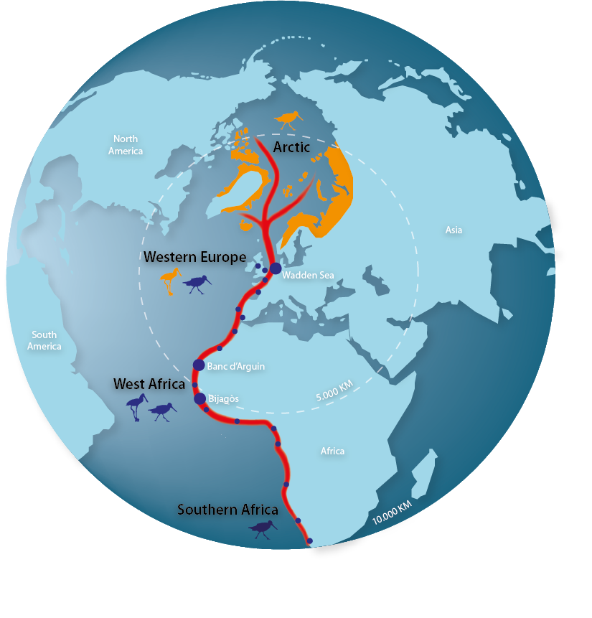
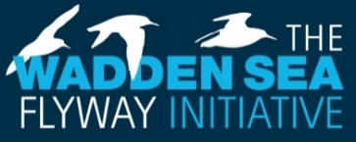
The global dimension of the Wadden Sea is not only apparent in its status as World Heritage property, but also in the fact that it is highly interconnected with other sites. In the statement of OUV it is explicitly mentioned that the Wadden Sea ecosystem sustains wildlife populations well beyond its borders and biodiversity on a worldwide scale is reliant on the Wadden Sea.
Figure 8. The East Atlantic Flyway Globus.
Many of the challenges for the Wadden Sea’s management are faced by protected areas all over the planet, such as the protection of migratory birds, dealing with impacts of climate change on ecosystems, or reduction of marine litter. This calls for close collaboration with partners beyond the Wadden Sea, since what may happen outside the Wadden Sea (for example in the Artic or in Africa) may have consequences for the management in the Wadden Sea (such as is the case with the protection of birds) and vice versa. The preservation of the Wadden Sea’s World Heritage key values is greatly influenced by the successful management of the interconnected sites. This underlines the importance of supporting the protection of other sites along the flyways.
Following the request of the World Heritage Committee on the occasion of the inscription 2009, the Wadden Sea Flyway Initiative (WSFI) was launched in 2012 to foster collaboration along the African Eurasian Flyways. The WSFI established a network of partners and important sites along the entire East Atlantic Flyway, from the Arctic region to the West African coast and beyond, with the Wadden Sea as an essential site used by different groups of birds through the seasons.

Partners in almost 30 countries are working together to protect and manage their shared bird populations by cooperating in monitoring and capacity building activities. In the coming years, the WSFI aims for an autonomous bird management in the African partner countries, to combat the impact of climate change for a resilient flyway and enhance the long-lasting cooperation with Arctic countries. Successful cooperation has been established with West-African countries in particular with the World Heritage Site National Park Banc d’Arguin in Mauritania (Memorandum of Understanding 2014), but also with the Bijagòs Archipelago in Guinea Bissau with regards to the protection of intertidal ecosystems.

  - International Cooperation
Putting the Wadden Sea on a global scene also offers new pathways for international cooperation, mutual learning and developing solutions for the preservation of the Wadden Sea in a rapidly changing world. Cooperation with other World Heritage properties also helps to raise the profile of the Wadden Sea internationally and within the World Heritage Convention.
The Wadden Sea World Heritage Site is contributing with its vast knowledge to support nomination efforts of future World Heritage properties. An exchange with Yellow Sea countries has existed for many years, both are tidal mudflat ecosystems of global importance for being among other, stopover sites for migratory birds.
The Trilateral Wadden Sea Cooperation (TWSC) cooperates with the Republic of Korea (Memorandum of Understanding 2009) regarding the exchange of management experiences and approaches, monitoring, research, education, and communication. Over the years this collaboration has involved in total over 2,100 persons at both sites. The TWSC also supported the Republic of Korea in the preparation of the World Heritage nomination dossier on the Korean Tidal Flats. The World Heritage Committee at its 44th meeting in 2021 decided to add the Getbol, Korean Tidal Flats to the World Heritage List under criterion (x).
Knowledge exchange will be the main topic of collaboration with the Yellow Sea countries, and aims to share scientific knowledge for management, strengthen the capacity for communication and education, and provide many valuable examples for practitioners which they can apply at their site. A collaboration between the globally significant flyway sites, such as the African-Eurasian Flyway and East Asian-Australasian Flyway, can promote a mutual exchange in improving flyway management and research in mud-flat ecosystems worldwide.
Also the management of swimways across and beyond the Wadden Sea is of increasing importance in the area of international cooperation. Our understanding of the interconnectivity and surprisingly long-distance impact and ecological relevance of fish movement has grown considerably. The Wadden Sea can act as a pilot for global swimway conservation, which might be relevant also for other World Heritage properties. Emphasis on implementation of the Swimway Vision and Action Programme is necessary, not least through national and trilateral projects focussing on measures, stronger integration into existing projects, and communication and outreach.
The UNESCO World Heritage Centre, which serves as the global Secretariat to the World Heritage Convention, not only manages all official processes around the Convention, but also runs thematic programmes to help State Parties and the World Heritage properties to implement the Convention.
Since its inscription on the World Heritage List the Wadden Sea has been an active contributor to the UNESCO World Heritage Marine Programme. This is a network of site managers from all 50 Marine World Heritage properties across 37 nations. Tapping into the vast expertise contained within the network helps to accelerate achieving sustainable marine protected areas. Expertise is shared from across the network through site-to-site field visits, communication, and tri-annual global managers conferences.
The Wadden Sea also cooperates with the UNESCO World Heritage and Sustainable Tourism Programme. This Thematic Programme underlines the shared responsibility of stakeholders for conservation of cultural and natural heritage of Outstanding Universal Value and for sustainable development through appropriate tourism management.
As requested by the World Heritage Committee in 2009, a Strategy for Sustainable Tourism in the Wadden See World Heritage Destination was adopted in the Wadden Sea in 2014. Through regular exchange with the World Heritage Centre and stakeholders from other World Heritage properties, the Wadden Sea benefits from the networks when implementing or further developing the Sustainable Tourism Strategy and action plan. The Wadden Sea is acknowledged worldwide as a useful example of transnational collaboration, pooling resources, and engaging tourism stakeholders in the protection of the OUV for mutual benefit.
Engaging in international cooperation creates opportunities for sharing knowledge and experience in the management of World Heritage properties. Managers, green NGO’s, and other stakeholders active in the Wadden Sea World Heritage Site have used these opportunities for mutual learning in areas such as protected areas tourism, monitoring and education.

  - Contributions to the EU Biodiversity Strategy for 2030
The Wadden Sea World Heritage Site, as one of the largest protected areas in Europe, contributes to the EU Biodiversity Strategy for 2030, most notably to the nature protection targets of protecting at least 30% of the EU’s land and sea, with one third thereof – 10 % of total land and sea area – for strict protection, but most importantly aids to build a coherent Trans-European Nature Network. The SIMP and the comprehensive management system of the Wadden Sea World Heritage Site including the Wadden Sea Plan (WSP) as joint management plan, can serve as a model for effective protected areas management.
Additionally, the management of the Wadden Sea World Heritage Site contributes to the nature restoration targets of “ensuring at least 30% of EU protected species and habitats are in favourable conservation status or have positive trends by 2030” and to “restore marine ecosystems”.
The Wadden Sea World Heritage Site, supported by the SIMP, also adds to the EU Biodiversity Strategy’s transformative change targets such as “building on an integrated and whole-of society approach”, “ensuring the full and timely implementation of the EU nature directives” and “improving knowledge and research”. Targets such as “tackle invasive alien species” are explicitly addressed in the TWSC’s own strategic approaches.
EU funding will continue to play an important role in advancing and enabling trilateral projects.
[Note: there will be a (new) “Post-2020 Biodiversity Framework” adopted by the CBD COP in the first half of 2022.]

  - Contributions to the Sustainable Development Goals of the UN Agenda 2030
The TWSC actively contributes to the implementation of the Agenda 2030 for Sustainable Development, with its globally accepted Sustainable Development Goals (SDGs). Not only does the Wadden Sea deliver important contributions to SDG 14 “Life under water” and SDG 15 “Life on land”, but it also strengthens the natural resilience and adaptive capacity to climate-related effects (SDG 13). Furthermore, the trilateral cooperation’s actions and plans to protect and restore water resources and water-related ecosystems contribute to SDG 6 and support the area’s sustainable economy and leverages local culture (SDGs 8 and 12). Education for sustainable development and the International Wadden Sea School, accessible in all languages of the cooperation, addresses SDG 4. The SDG 17 “Partnerships for the Goals” is contributed to by the “Trilateral Partnership in support of the Wadden Sea World Heritage” (Figure 10). [Note: After approval by the UN, in SDG17 can be added: “registered as transboundary, multi-stakeholder Partnership in the UN’s global registry on SDG partnerships”].

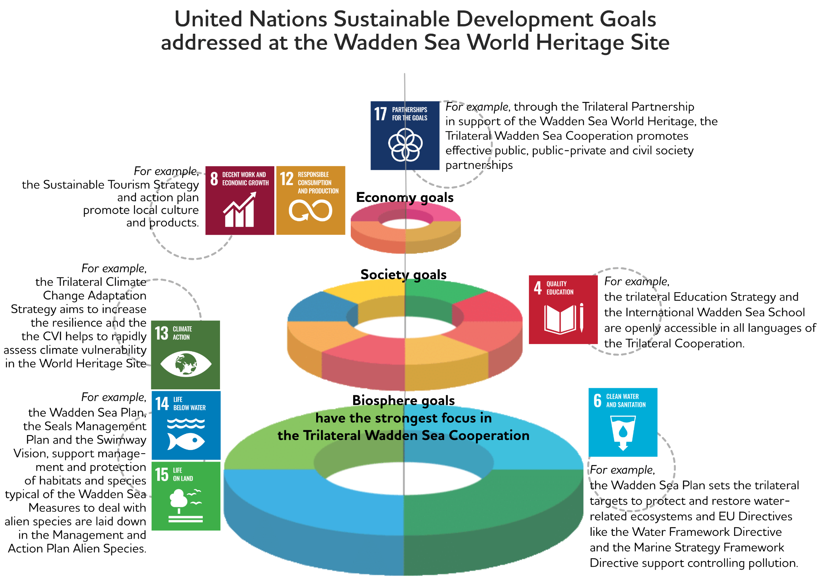

Figure 9. The TWSC addresses SDGs 4, 6, 8, 12, 13, 14, 15 and 17.

- Abbreviations

CCAS Trilateral Climate Change Adaptation Strategy
CVI Climate Vulnerability Analysis
CWSS Common Wadden Sea Secretariat
EU European Union
NGO Non-governmental organisation
OUV Outstanding Universal Value
QSR Quality Status Report
SDGs United Nations Sustainable Development Goals
SIMP Single integrated management plan
TGC Trilateral Governmental Conference
TMAP Trilateral Monitoring and Assessment Programme
TPC Trilateral Programming Committee
TWSC Trilateral Wadden Sea Cooperation
UNESCO United Nations Educational, Scientific and Cultural Organization
WSB Wadden Sea Board
WSFI Wadden Sea Flyway Initiative
WSP Wadden Sea Plan

- References

References to the documents used in the SIMP are included in the PDF version, and not in the printed version of the SIMP.

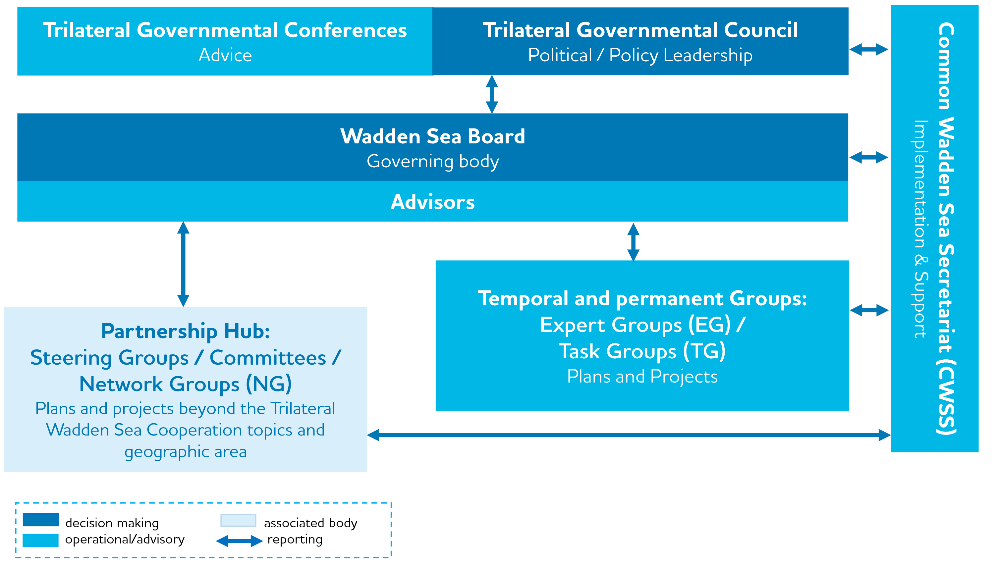
Annex 1

Figure A.1. Organisational structure of the Trilateral Wadden Sea Cooperation (TWSC). [Note: Pending on a WSB decision on the outcome of the evaluation of the pilot phase of the Partnership Hub by an external consultant, expertise is expected for early summer 2022].

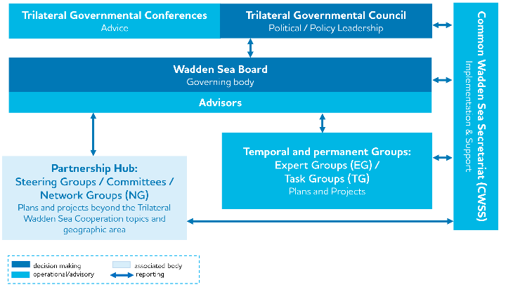
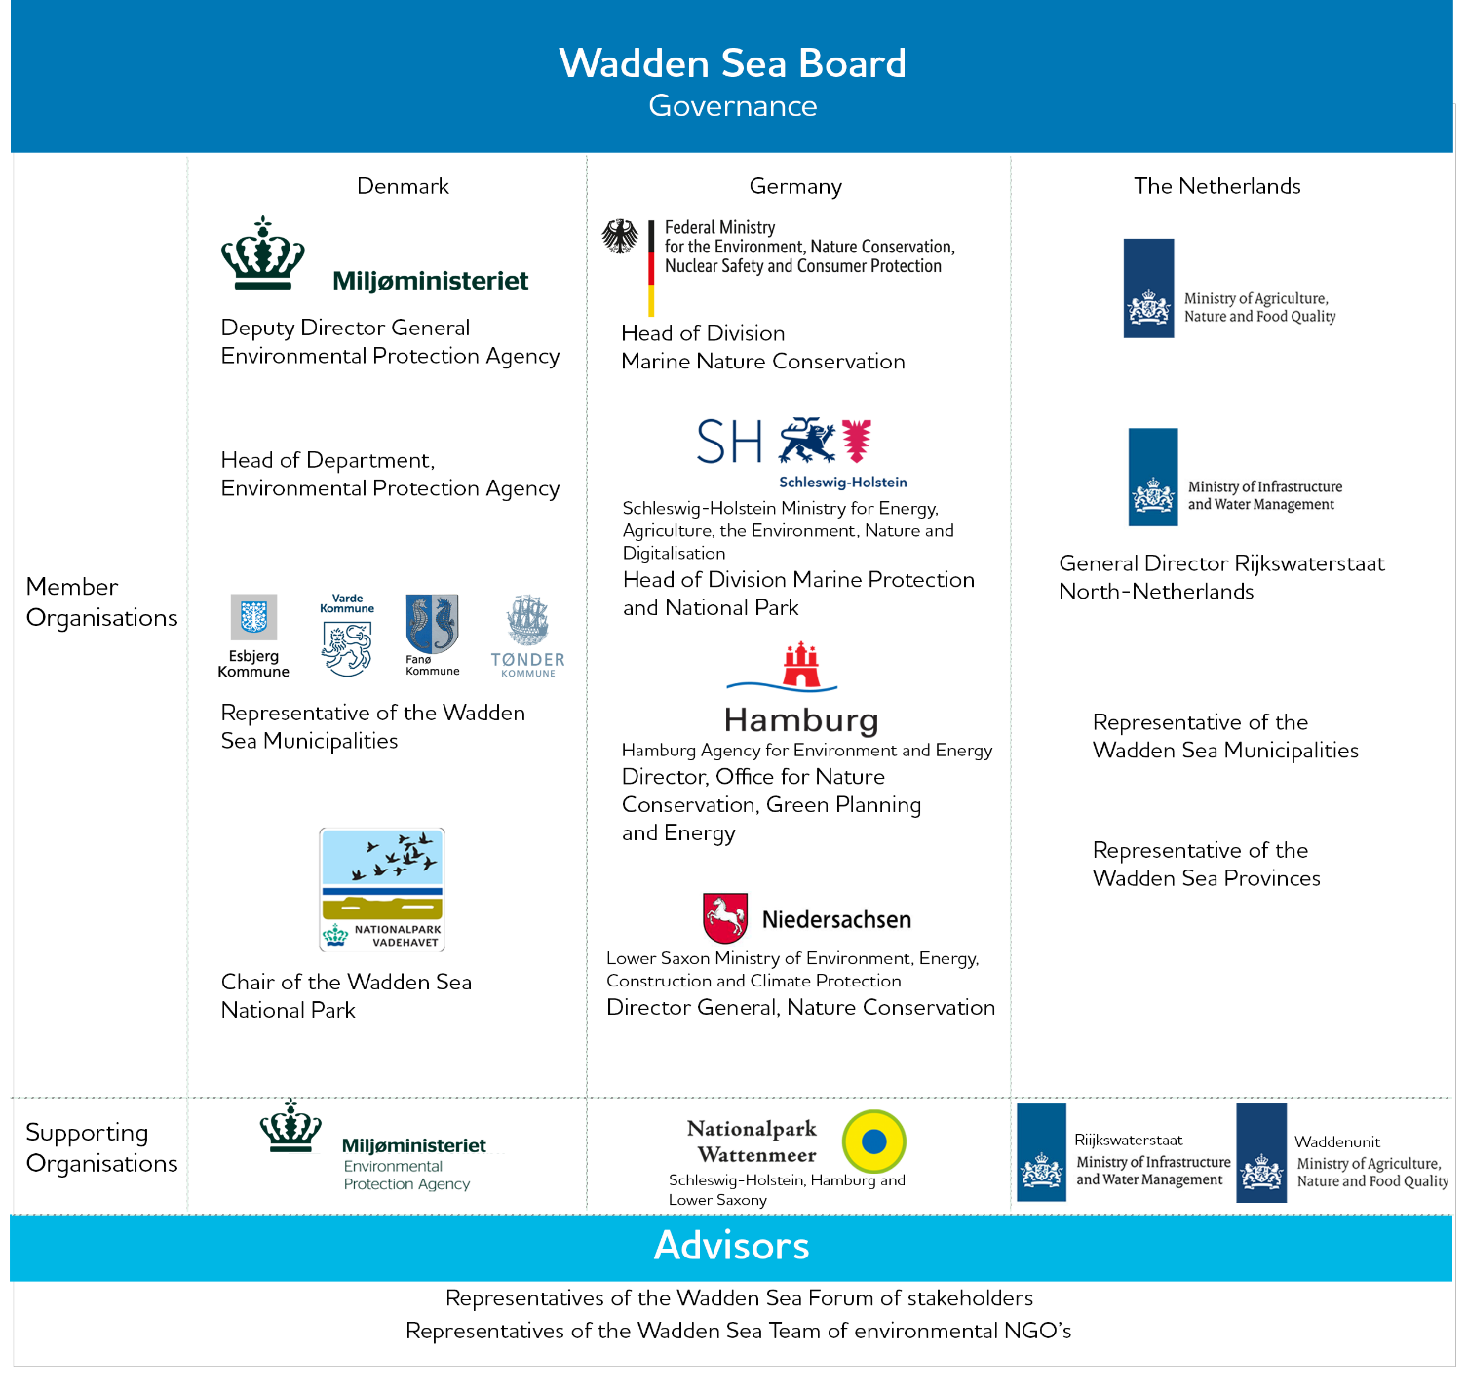

Figure A.2. Members, supporting organisations and advisors of the Wadden Sea Board. The supporting organisations are intricately involved in the task/expert/working groups of the TWSC and represent the link between policy and management.

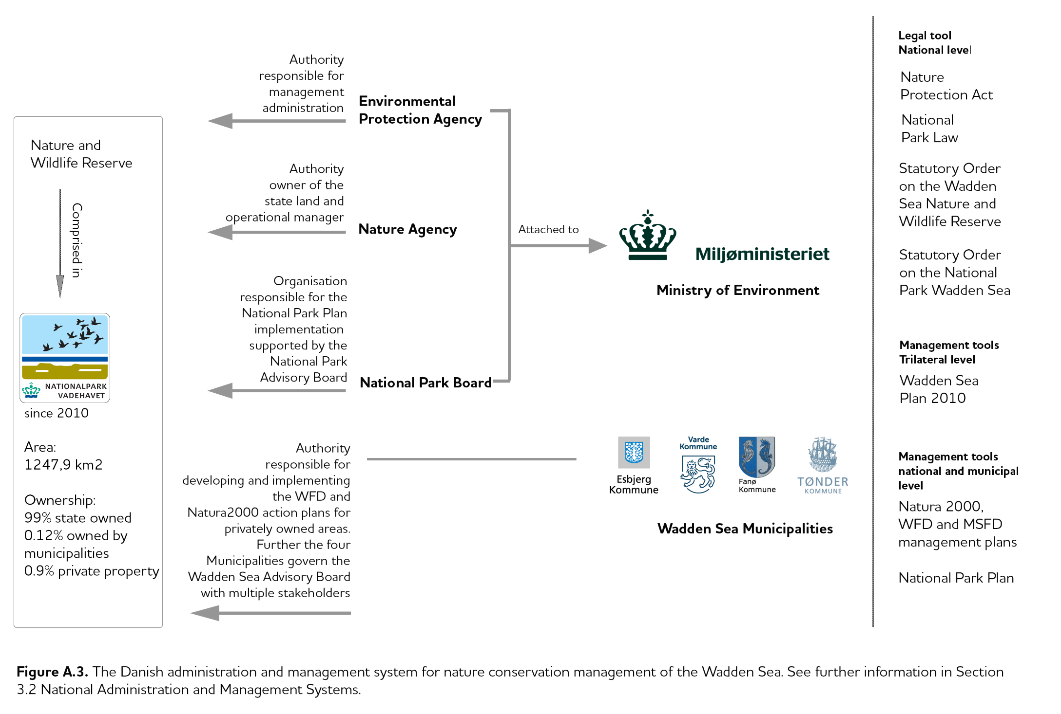

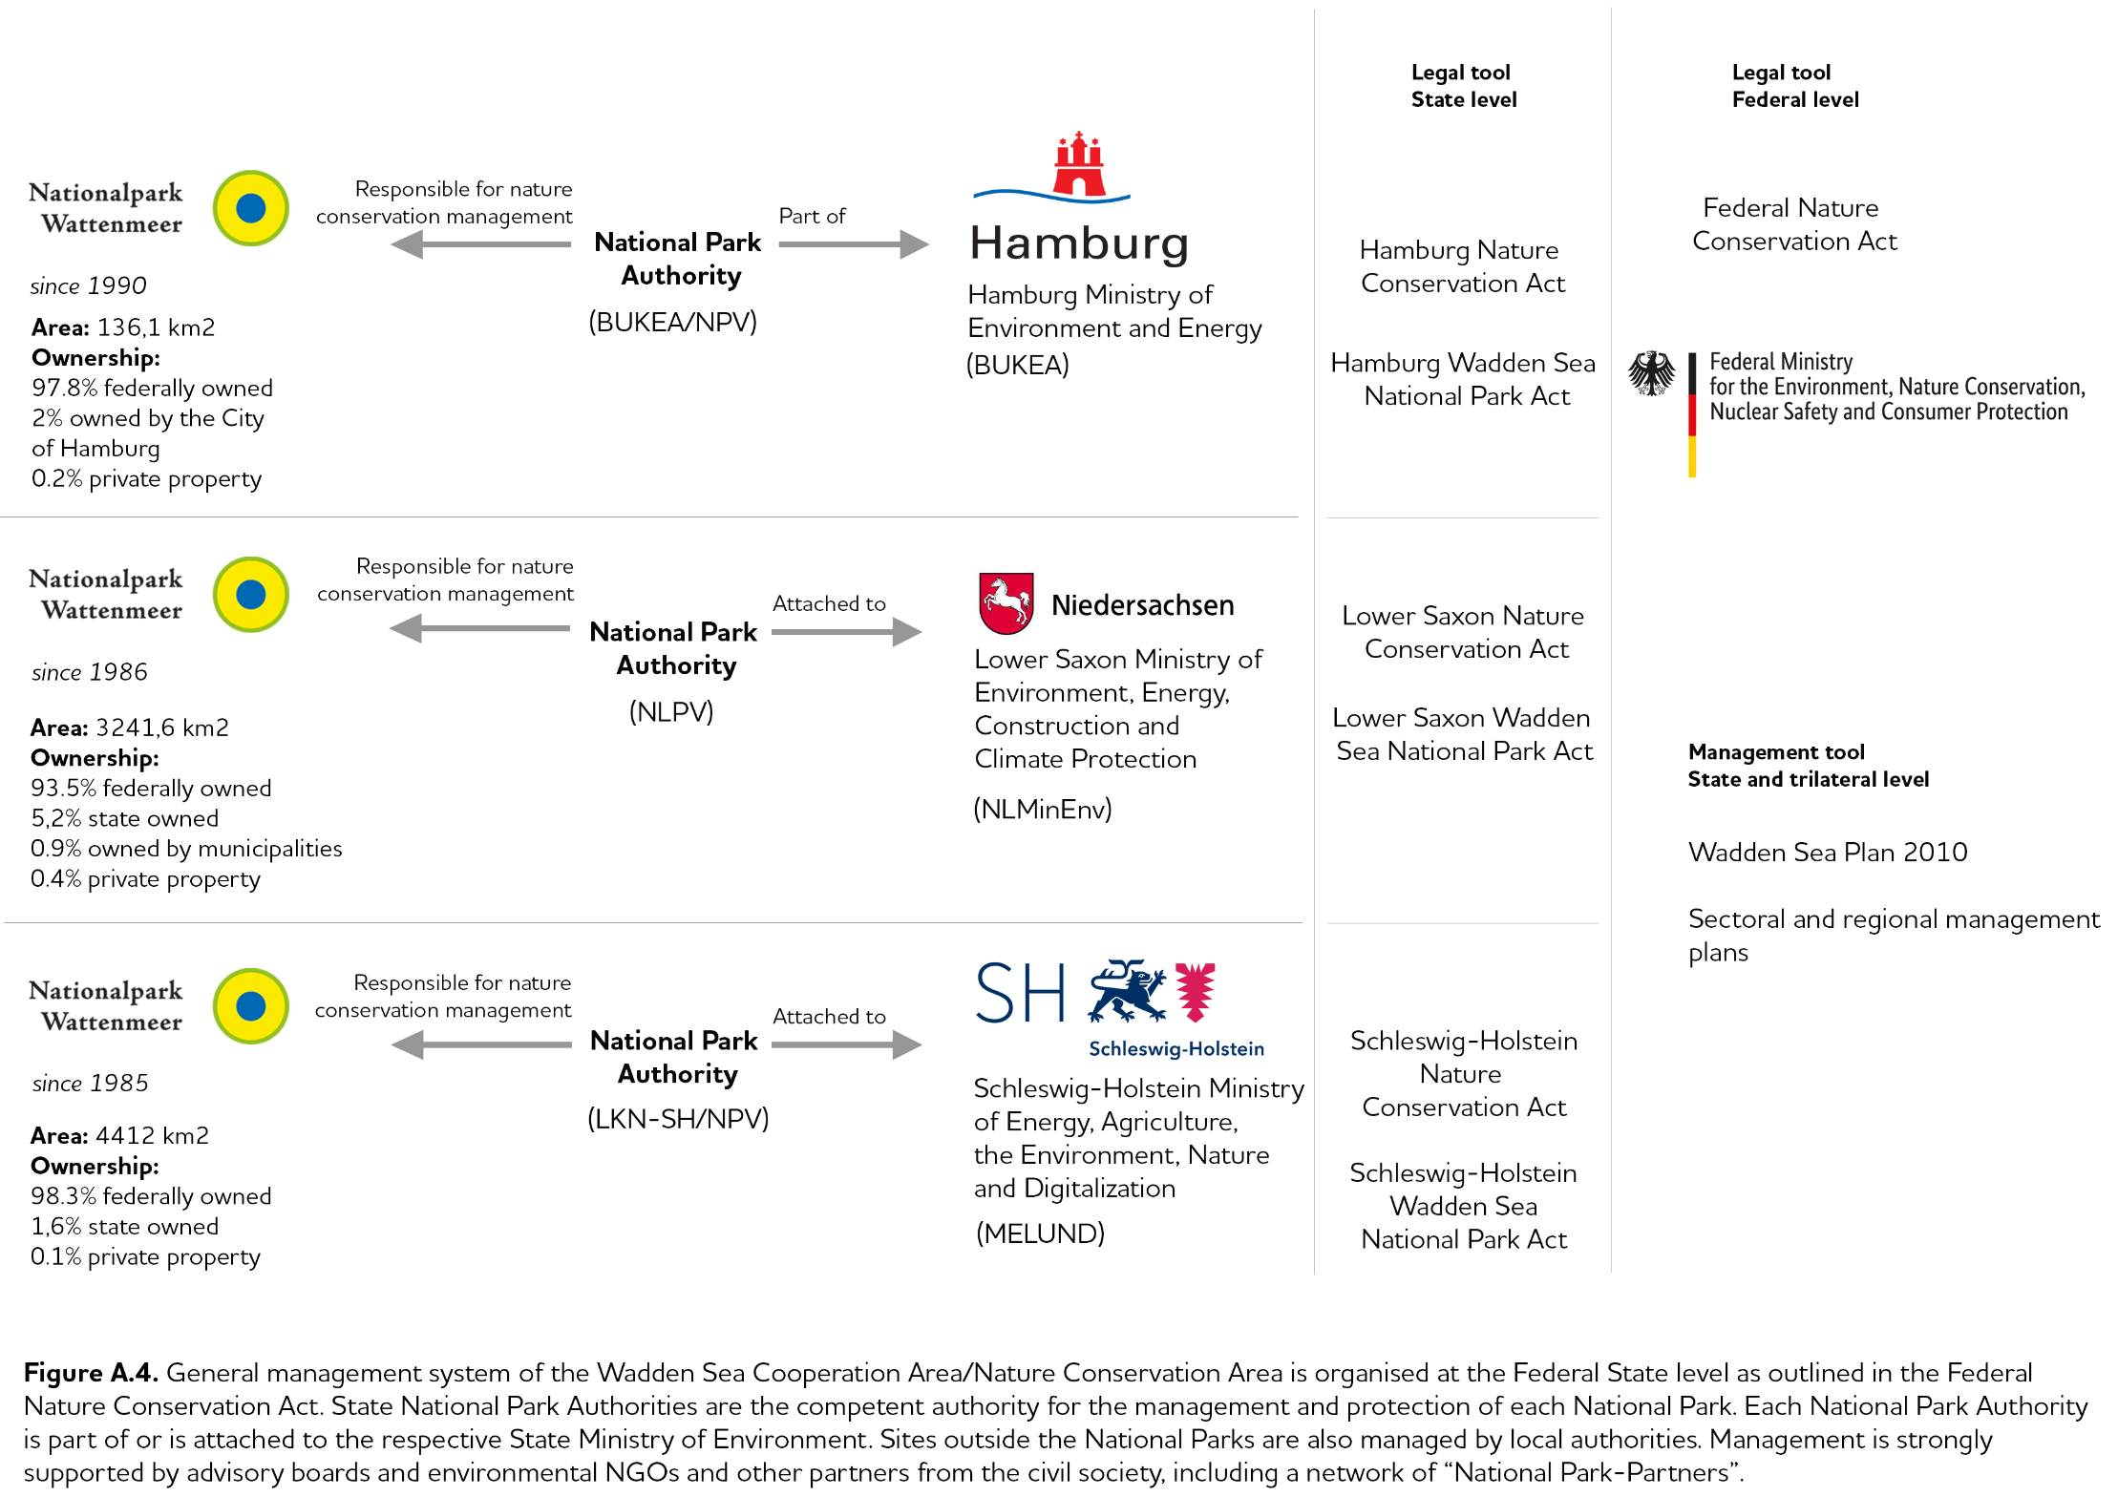

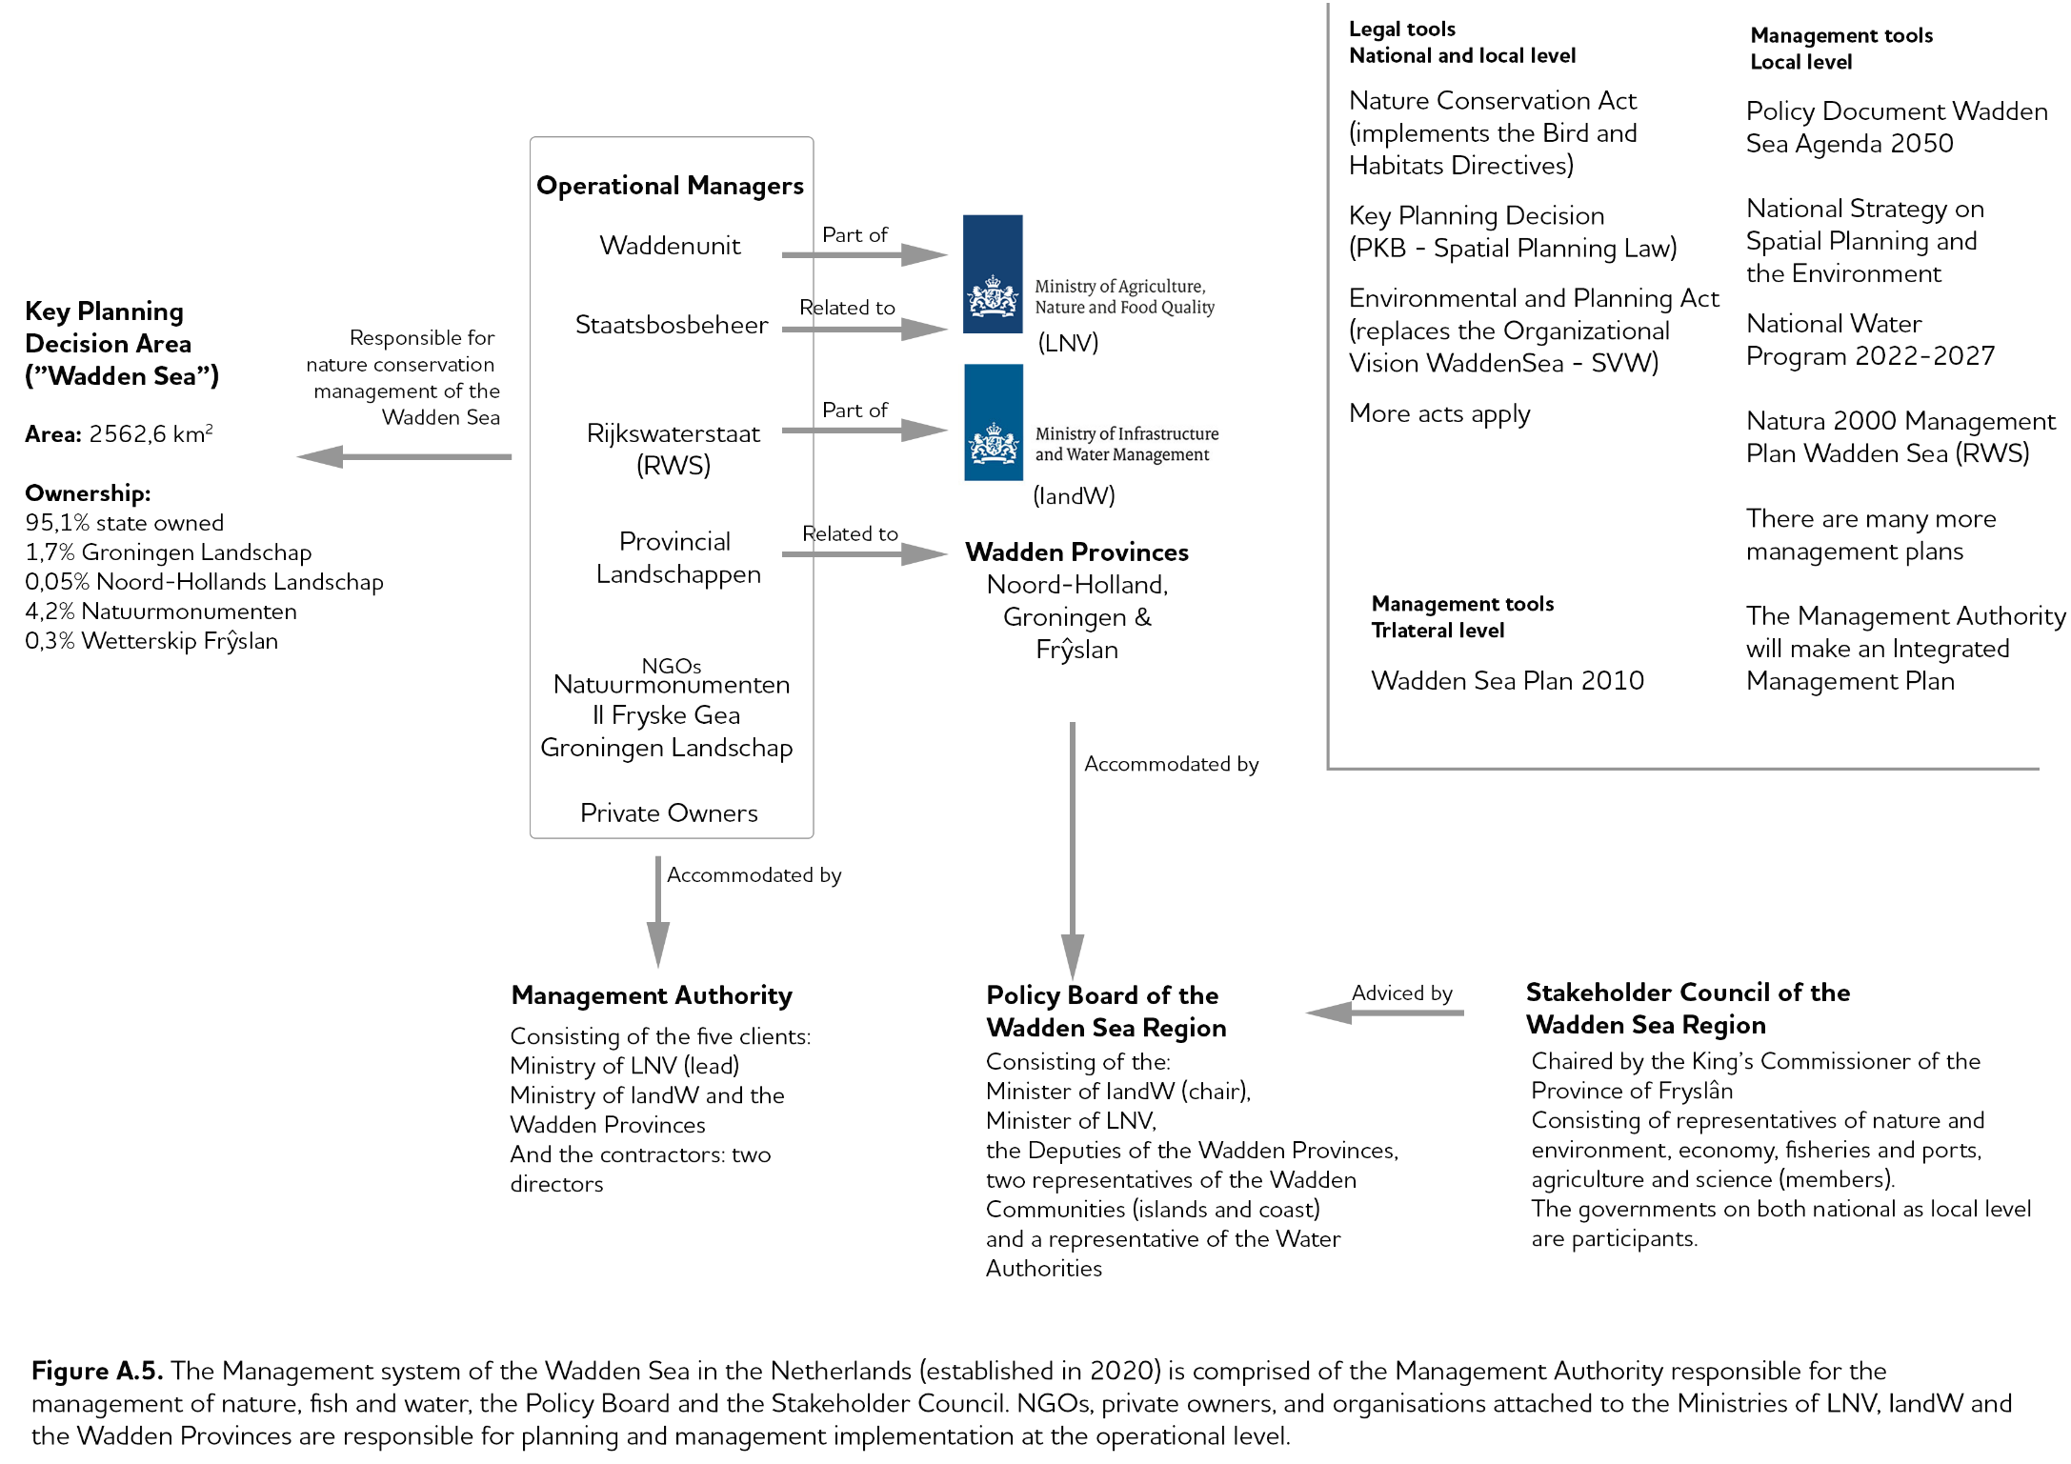

Endnotes

whc.unesco.org/en/decisions/1946/
whc.unesco.org/en/decisions/1946/
www.waddensea-worldheritage.org/prowad
northsearegion.eu/prowad-link/
www.ostfriesland.travel/service/watten-agenda-nl and www.watten-agenda.de/
www.interreg5a.eu/blog/projekt/nakuwa/
qsr.waddensea-worldheritage.org/
whc.unesco.org/en/periodicreporting/
www.waddensea-worldheritage.org/sites/default/ files/2020_CVI_Workshop_Report.pdf
www.waddensea-worldheritage.org/resources/ecosystem-21-coastal-protection-and-sea-level-rise
www.waddensea-worldheritage.org/sites/default/files/2010_Ecosystem28_cpsl.pdf
www.waddensea-worldheritage.org/sites/default/files/2014_TD%20annex%204%20climate%20strategy.pdf
No-regret measures: Measures which are beneficial independently of which event or scenario actually occurs. In cases of considerable uncertainty like climate change and its impacts regarding direction, timing and magnitude (e.g. plausible sea level rise projections vary among 0.2 and 1.4 m) no-regret measures provide some flexibility to adapt policy and management in response to new information regarding actual and projected changes in drivers and impacts. No regret’ should also be applied concerning the natural values and the integrity of the Wadden Sea (CCAS, 2014).
Nature-based Solutions: Nature-based Solutions are actions to protect, sustainably manage, and restore natural or modified ecosystems, which address societal challenges effectively and adaptively, simultaneously providing human well-being and biodiversity benefits (IUCN Global Standard for nature-based solutions, 2020).
www.waddensea-worldheritage.org/sites/default/ files/2018_Trilateral_Research_Agenda.pdf
www.waddensea-worldheritage.org/sites/default/ files/2018_Education_Strategy.pdf
www.iwss.org/
www.waddensea-worldheritage.org/sites/default/files/ 2014_tourism-strategy-en.pdf
waddensea.brandspace.online/b/ (beta version)
eur-lex.europa.eu/legal-content/EN/TXT/PDF/?uri=CELEX:52020DC0380&from=EN

