Single integrated management plan (SIMP)
Wadden Sea World Heritage

Draft version 0.3
Authors: Trilateral Wadden Sea Cooperation (TWSC)

This publication should be cited as:
Common Wadden Sea Secretariat. 2022. Single integrated management plan for the Wadden Sea World Heritage. Common Wadden Sea Secretariat, Wilhelmshaven, Germany.

Preface/Foreword
[Note: Text (written and) signed by the Ministers]

Contents

Preface/Foreword 2
1. Introduction 4
1.1. Background 4
1.2. Vision, Mission and Purpose of the SIMP 5
1.3. The Status of the SIMP 5
1.4. The Scope of the SIMP 5
1.5. The Process of Developing the SIMP 8
1.6. The Added Value 9
1.7. Monitoring and Review 9
2. The Outstanding Universal Value of the Wadden Sea 10
2.1. The OUV: Criteria and Key Values 11
2.2. The OUV: Integrity 12
2.3. The OUV: Protection and Management Requirements 13
3. Nature Conservation Management 14
3.1. Trilateral Cooperation Structure 14
3.2. National Administration and Management Systems 15
3.3. Management Cycle 19
4. Towards a Sustainable Management in the Wadden Sea 24
5. Mechanisms to Support Management 25
5.1. Science and Research 25
5.2. Monitoring and Assessment 26
5.3. Knowledge Management 27
5.4. Education for sustainable development and interpretation 28
5.5. Communication 29
5.6. Partnerships 29
6. Global Dimensions 31
6.1 Global Interconnections 31
6.2 International Cooperation 32
6.3 Contributions to the SDGs of the UN Agenda 2030 34
7. Abbreviations 36
8. References 36
Annex 1 37
Annex 2. Renewable Energy 40

- Introduction
  - Background
The Wadden Sea was inscribed on UNESCO’s World Heritage List in 2009 (and extended in 2014) in recognition of its Outstanding Universal Value (OUV). The global importance declared in the OUV recognizes that the Wadden Sea is the largest connected intertidal sand and mudflat ecosystem in the world. Natural processes continue to thrive largely undisturbed creating a variety of barrier islands, channels, flats, gullies, saltmarshes and other coastal and sedimentary features. The Wadden Sea is rich in species specially adapted to the environmental conditions. These conditions also make the Wadden Sea a vital spot for migratory birds in the East Atlantic Flyway and plays a critical role in the conservation of African-Eurasian migratory water birds.
To ensure the protection of this unique ecosystem for the benefit of the present and future generations, Denmark, Germany and the Netherlands, committed to work together to build a comprehensive national and international nature conservation system. In this framework, the Trilateral Wadden Sea Cooperation (TWSC) was established as a tool for cooperation and coordination for nature conservation as well as to leverage political support among the countries. This commitment, the objective of the cooperation, its guiding principle, vision, the areas of cooperation as well as institutional and financial agreements are specified in the Joint Declaration on the Protection of the Wadden Sea: working together to meet present and future challenges (1982, reviewed in 2010). The listing of the Wadden Sea as a World Heritage property, the utmost international acknowledgment for a natural area, shows great appreciation and is the recognition of the longstanding trilateral cooperation, the support of the region and its stakeholders and the conservation efforts.
Denmark, Germany and the Netherlands have built independently and during their over 40 years of trilateral cooperation, a comprehensive management system addressing some of the most urgent and important key aspects. There are various trilateral, regional and local strategies, management plans, plans of actions and networks. In short, plenty has been achieved and important milestones of what still needs to be done are on their way though there are still challenges to be faced.

  - Vision, Mission and Purpose of the Single Integrated Management Plan
[Note for TG-WH: vision and mission are being drafted by a group of TG-WH members. A discussion and agreement will take place in TG-WH 32].

Purpose
In light of the wealth and diversity of management systems and instruments that are in place in the Wadden Sea World Heritage (WSWH), the purpose of the single integrated management plan (SIMP), as agreed by the TWSC and stated in Annex 1 of the Leeuwarden Declaration (2018), is to further facilitate the continuous improvement of management coordination for the protection and maintenance of the Outstanding Universal Value by:
- providing a clear overarching description of the management system at the regional, national and trilateral level;
- addressing key topics to improve management and in a consistent way across the property to maintain the area’s Outstanding Universal Value.

  - The Status of the Single Integrated Management Plan
The single integrated management plan for the Wadden Sea is a political agreement of the Trilateral Wadden Sea Cooperation (TWSC), meaning it is a legally non-binding document of common political interest.
Existing policy documents and legally binding instruments at the trilateral, regional, national, or local level are not altered or affected by the single integrated management plan.
The single integrated management plan does not change existing national or trilateral plans, thus it is complementary to the Wadden Sea Plan. The SIMP acts as an umbrella for existing plans and policies and provides information on how these are implemented trilaterally for nature conservation management.
  - The Scope of the Single Integrated Management Plan
The focus of the SIMP is the Wadden Sea World Heritage and the conservation of its Outstanding Universal Value (OUV). The SIMP presents a clear overview of the nature conservation management structures in Denmark, Germany and the Netherlands and at the trilateral level describing how we work together, as well as the existing management elements in the context of the management cycle (as defined in § 111 of the Operational Guidelines for the Implementation of the World Heritage Convention).
Since the Wadden Sea holds a significant population and human uses, there are aspects that require an ongoing attention to maintain the area’s OUV. The SIMP addresses key topics identified in the Statement of Outstanding Universal Value, by the Wadden Sea’s site managers, prioritized by the Task Group World Heritage and endorsed by the Wadden Sea Board. These key topics relate to human activities relying on ecosystem services and taking place inside and adjacent to the World Heritage property: 1) fisheries, 2) tourism, 3) shipping and ports, 4) renewable energy and energy from oil and gas and 5) coastal flood defence and protection measures.
As science and research, monitoring and assessment, knowledge management, education, communication and partnerships are fundamental mechanisms to support management in the Wadden Sea, the SIMP compiles the useful information for managers.
Additionally, the SIMP featuring the inscription of the Wadden Sea as a World Heritage property highlights its global role and is linked to global responsibilities. Cooperation with partners worldwide is instrumental and supportive for the long-term protection of the Wadden Sea.

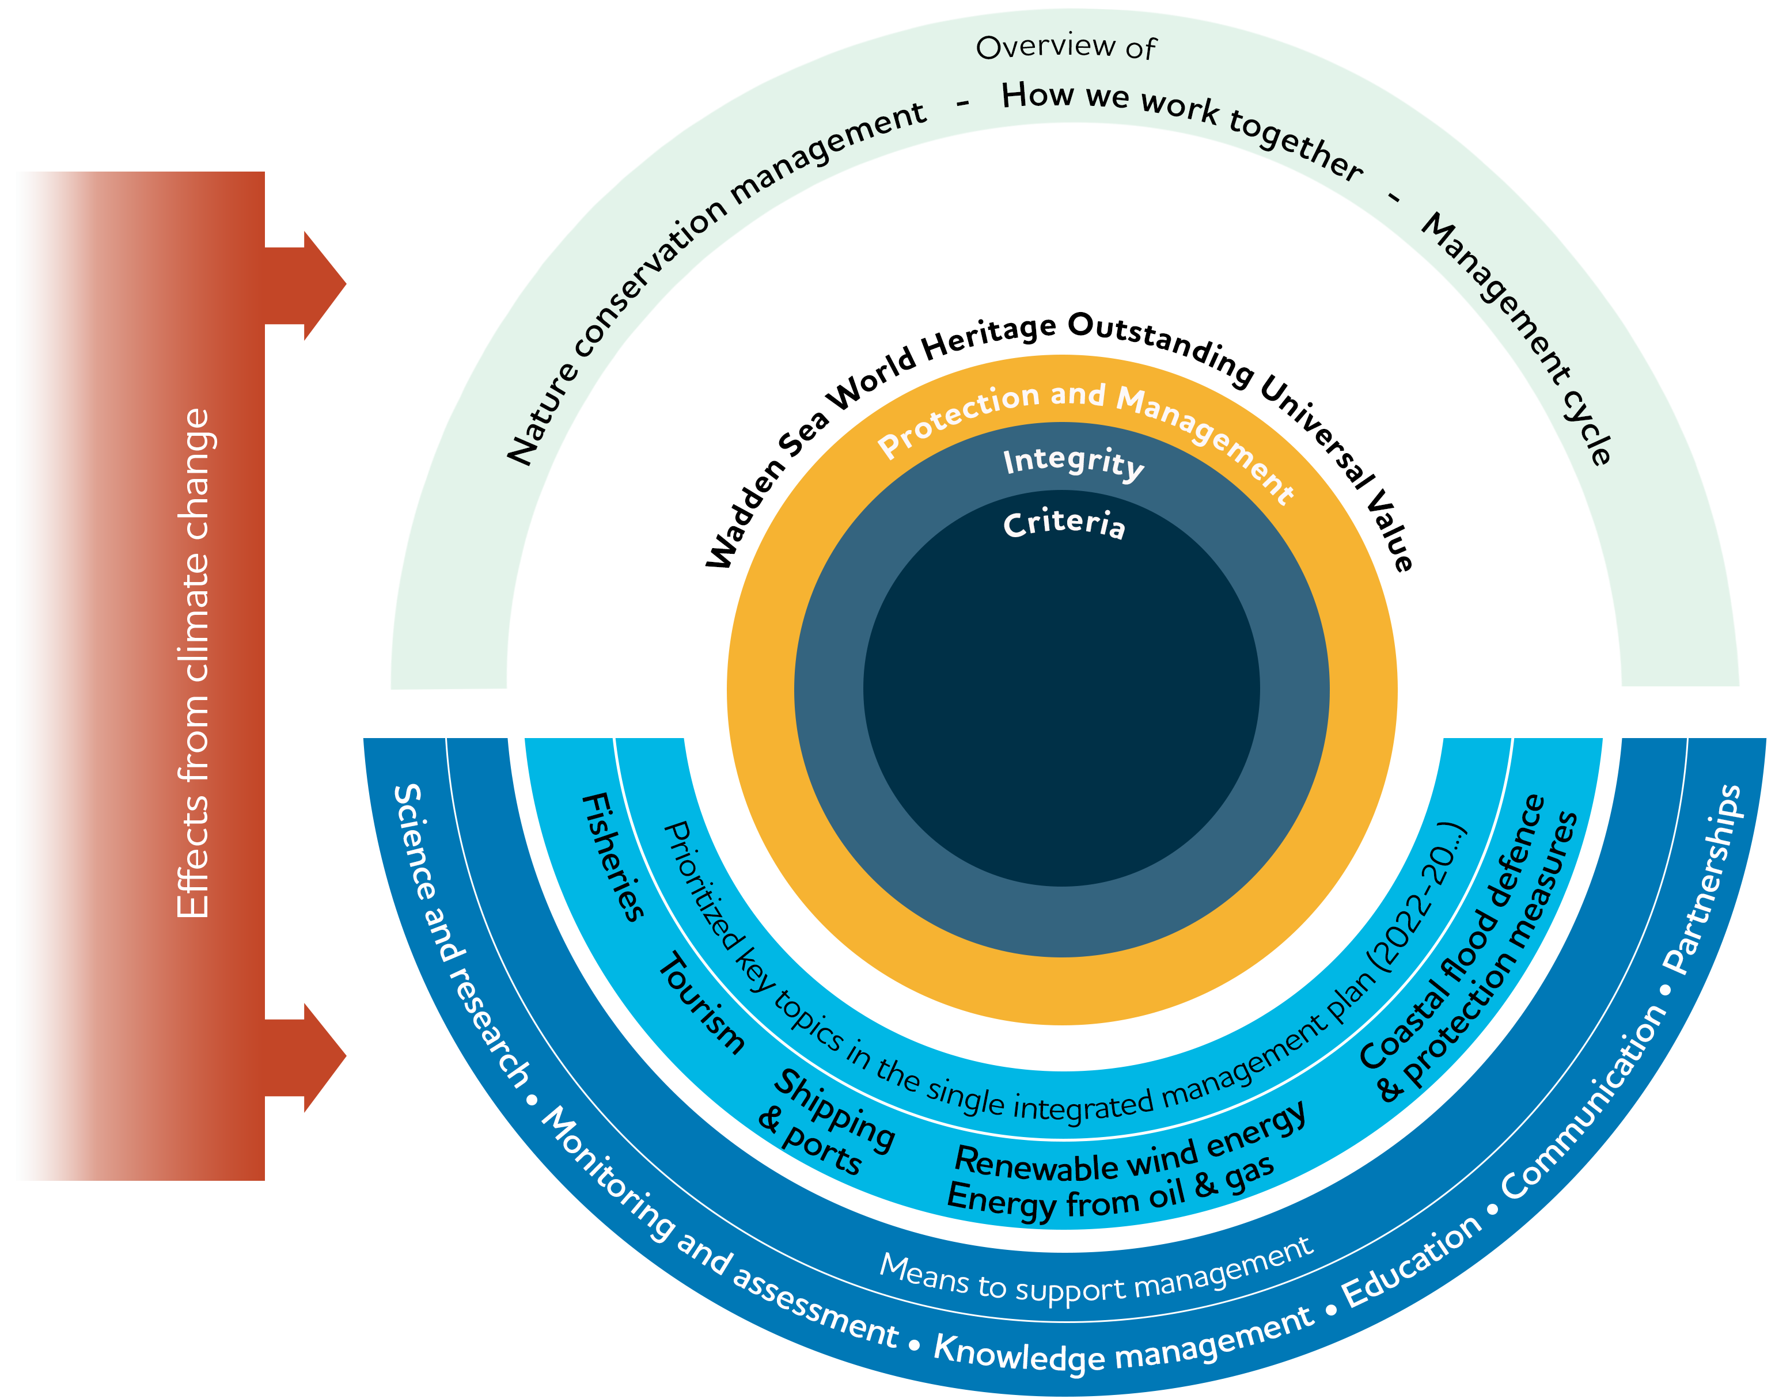

Figure 1. The scope of the single integrated management plan.
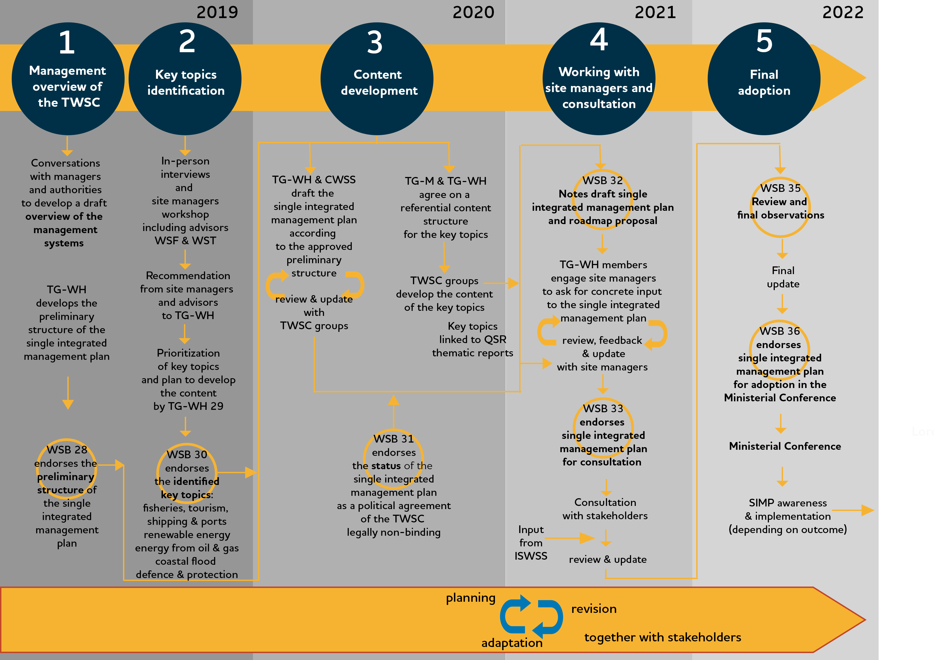
  - The Process of Developing the Single Integrated Management Plan
Figure 2. The five phases of the process of developing the single integrated management plan 2019-2022 and the detail of each phase. The approved preliminary structure of the single integrated management plan was the first step in the process. The identification of key topics was done in collaboration with managers and advisors from the three countries. A roadmap proposal for the next phases of development in 2021 and 2022 will be presented to WSB 32.

Abbreviations:
WSB: Wadden Sea Board
TG-WH: Task Group World Heritage
TG-M: Task Group Management
CWSS: Common Wadden Sea Secretariat
TWSC: Trilateral Wadden Sea Cooperation.

[Note to the WSB: In the future this figure will be simplified to show only the main steps relevant for site managers and other readers.]

  - The Added Value
[Note for WSB and site managers: this heading can be further developed during the working with site managers and consultation phase. Through this phase, it is aimed to further improve exchange among the TWSC partners, foster support and understanding in the region beyond the management level, add to civic pride and improve the understanding of the World Heritage.]
The SIMP has several added values; it provides a clear and updated overview of the existing nature conservation management. It compiles the status and management approaches of the key topics affecting the property addressed in a comprehensible way, usable and accessible, which can be easily communicated and used on the operative level. For each key topic, the SIMP describes the common ground expressed in the Wadden Sea Plan and other trilateral tools, shows how each country implements measures and links the key topics directly to the OUV.
In addition, exchange at different levels supports the development or update of trilateral initiatives and allows connecting existing and future trilateral strategies and plans with regional and local strategies and plans, showing how we work together and on which of the key aspects the cooperation could be further strengthened. Local, regional and national actions are backed at the trilateral level and trilateral decisions are integrated into the local, regional and national strategies and plans.
The SIMP contributes to the definition of feasible and innovative means to further the exchange of management approaches, experiences, knowledge, and lessons learned at different levels of management and among managers, decision makers, multipliers, volunteers, and interested public of the whole area.
  - Monitoring and Review of the Single Integrated Management Plan
[Note to WSB: to decide on the periodicity of the SIMP review cycle. TG-WH proposes a 10-year review cycle, which also should include an option for updating the operational parts if necessary.
Note for WSB and site managers: this sub-section will be updated once Section 4: Towards a sustainable management is finalized.]
The single integrated management plan will be evaluated regularly by the Wadden Sea Board. Given the nature of the SIMP a review cycle of 10 years is foreseen. This review includes the option to update the operational parts of the SIMP (Section 4 Towards a sustainable management) as appropriate. This review also presents the opportunity to adapt the SIMP to the management requirements of the TWSC with the support and participation of all key parties involved in implementing the plan. Regular evaluation processes under trilateral and national obligations (i.e. QSR, Natura 2000, etc) will feed into the SIMP review.
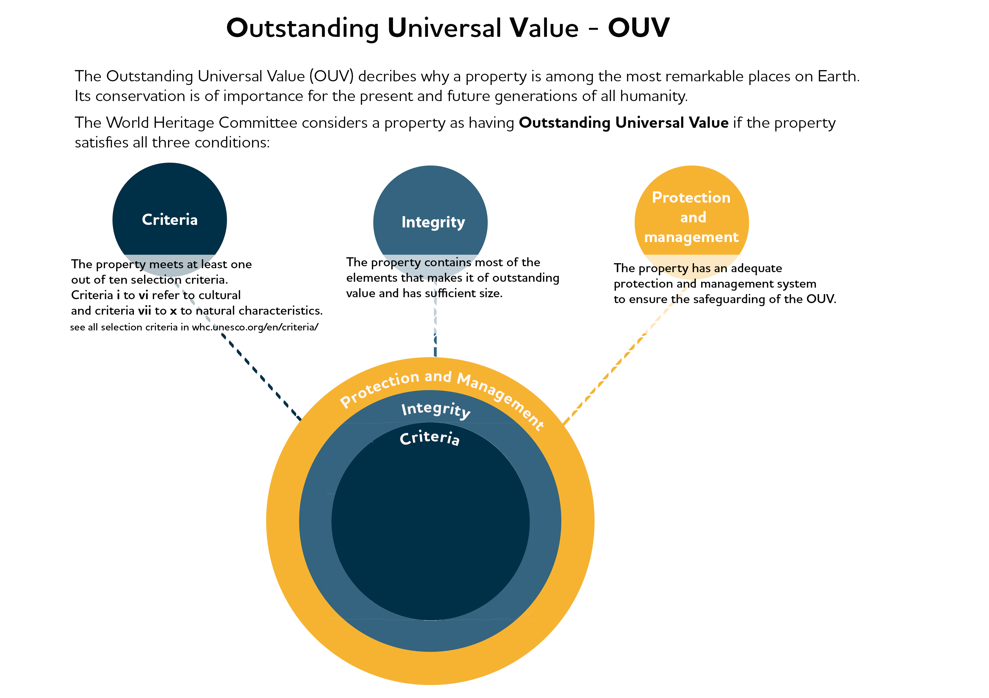
- The Outstanding Universal Value of the Wadden Sea

Figure 4. The World Heritage Committee adopts a Statement of the OUV (SOUV) when inscribing a property in the World Heritage List. The SOUV consists of the three conditions: criteria, integrity and protection and management.

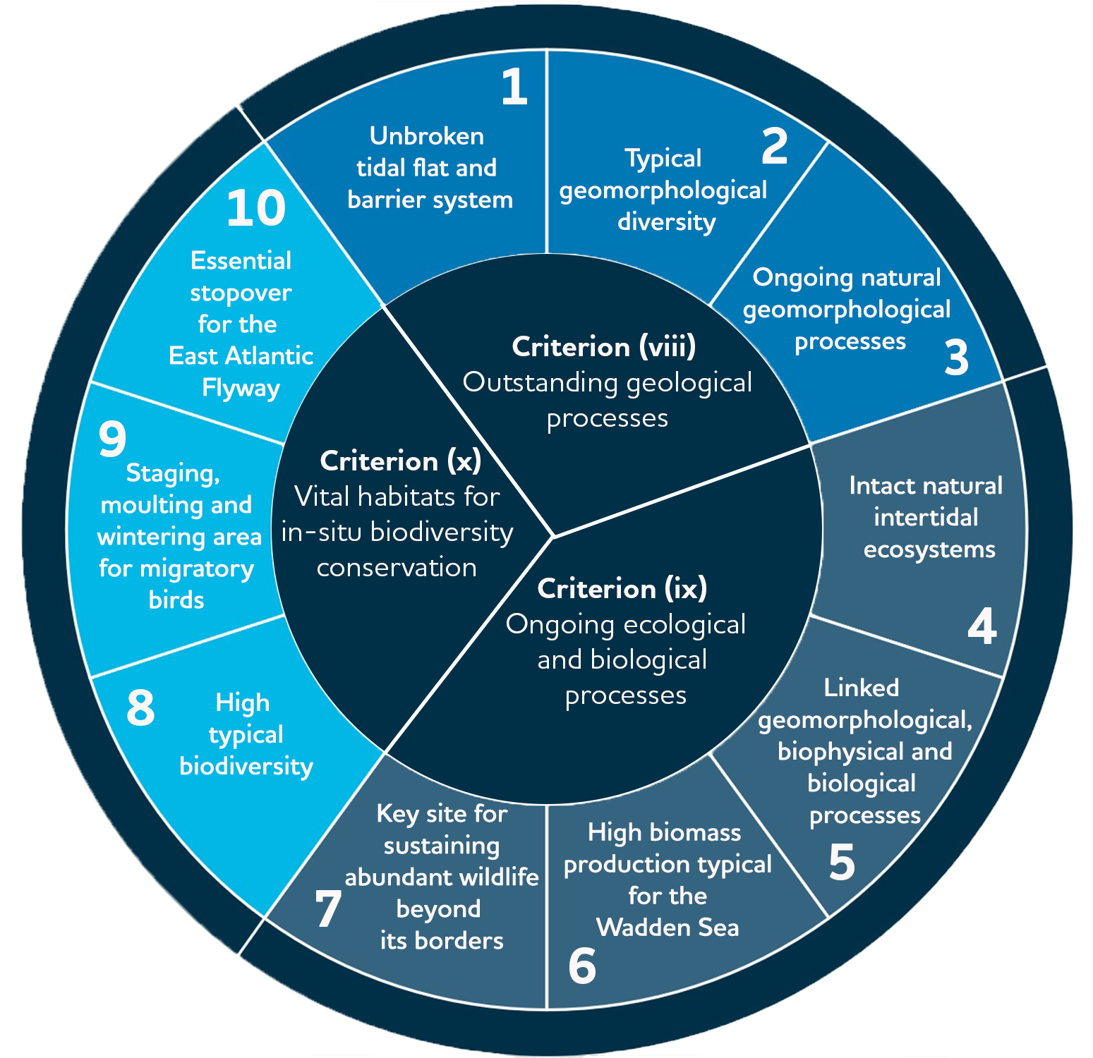
  - The OUV: Criteria and Key Values

The 10 key values for the Wadden Sea are directly derived from Criteria viii, ix and x.
OUV key values break down the criteria in the Statement of OUV into key phrases. In this way, it is easier to relate assessments and actions to the OUV.

Fig 5. The WSWH criteria and the respective 10 key values. The full description of the OUV can be found in the following link https://www.waddensea-worldheritage.org/becoming-world-heritage.

  - The OUV: Integrity
Integrity is a measure of the wholeness and intactness of the natural heritage and its attributes (§ 88, Operational Guidelines for the Implementation of the World Heritage Convention). The integrity is given by the degree of elements included in the property that reflect its OUV, as well as to the appropriateness of the property’s size to maintain the features and processes, and if it’s subject to adverse effects, also concerning effects from outside the property.
In that respect, the Wadden Sea World Heritage property from Denmark through Germany to the Netherlands includes all the Wadden Sea ecosystems and all the facets (species, habitats, processes) that constitute a natural and dynamic Wadden Sea. The area is large enough to ensure that these exceptional aspects are included and maintained (Source: https://www.waddensea-worldheritage.org/becoming-world-heritage, Statement of OUV, 2014).
The Wadden Sea World Heritage is subject to a comprehensive protection, management and monitoring system. The Statement of OUV (IUCN, 2014) recognises that key threats requiring ongoing attention to maintain the integrity of the property, include fisheries activities, developing and maintaining harbours, industrial facilities surrounding the property including oil and gas rigs and wind farms, maritime traffic, residential and tourism development and impacts from climate change.

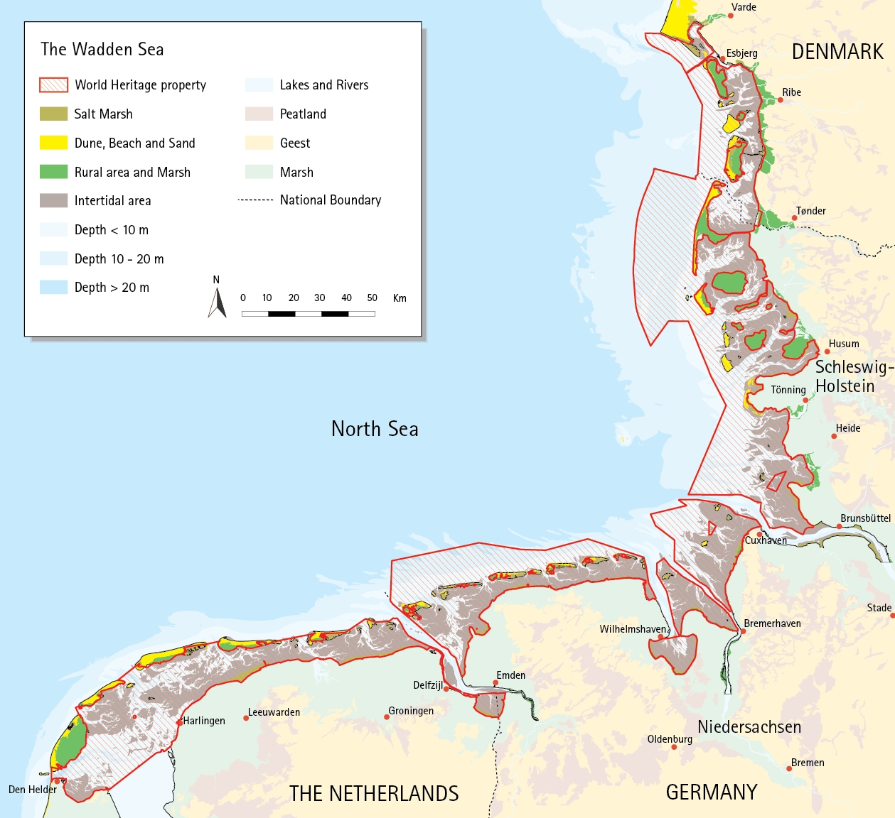

Figure 6. The Wadden Sea World Heritage encompasses all the natural habitats, species and processes that constitute the Wadden Sea ecosystem.

  - The OUV: Protection and Management Requirements
The Trilateral Wadden Sea Cooperation provides the overall framework and structure for integrated conservation and management of the property as a whole and coordination between all three States Parties (Statement of OUV, 2014) including the regional and local levels. In fact, the Wadden Sea’s accomplished state of conservation is the result of four decades of joint nature protection efforts of Denmark, Germany and the Netherlands, where the Wadden Sea is designated as national parks and nature reserves. Each State Party has comprehensive protection measures in place. Working together in the Trilateral Wadden Sea Cooperation, these countries ensure the coordinated management of the area. (Source: https://www.waddensea-worldheritage.org/becoming-world-heritage).
- Nature Conservation Management
The Wadden Sea Plan (WSP) constitutes the common framework for the protection and sustainable management of the Wadden Sea as an ecological entity. The Wadden Sea Plan is declared the coordinated management for the Wadden Sea World Heritage property as stated in the Nomination dossier presented to World Heritage Committee (2013). The WSP presents the trilaterally agreed targets, policies, and measures for the Wadden Sea Area as an ecological entity, as well as its landscape and cultural heritage, within the cultural entities. The targets agreed upon for landscape and culture, water and sediment, salt marshes, the tidal area, beaches and dunes, estuaries, the offshore area, the rural area, birds, marine mammals, and fish are the base for the trilateral and regional existing topic specific plans, strategies and action plans.
The management instruments for the regional and national legal designations are setup by each country and Federal State in coordination with the local governments and local actors. In Germany, the Wadden Sea Plan serves as the Natura 2000 and National Parks' management plan, that can, if deemed necessary, be supplemented by further detailed management tools (e.g. for certain habitat types, sectoral plans, management concepts).
The single integrated management plan does not change neither the content nor the function of the Wadden Sea Plan. The SIMP complements the WSP and acts as an umbrella for existing plans and policies and provides information on how these are implemented trilaterally for nature conservation management. [Note to TG-WH: the para. presents information already mentioned in Section 1.3. Do you agree to delete it and not double it here? Or is it important to keep?]
This section provides an overview of the existing management system. It serves to communicate and disseminate the trilateral management framework in an easy and clear way to national managers as well as to all stakeholders (local and regional) and the general public. The management system is a combination of the existing national management systems and the trilateral coordinated management of the transboundary area incorporating the responsible authorities.
  - Trilateral Cooperation Structure
The Trilateral Wadden Sea Cooperation (TWSC) comprises two levels of decision making:
I. The Trilateral Wadden Sea Governmental Council, composed of the responsible ministers of the participating governments to oversee the Cooperation, provide political leadership and strategic guidance, assure international policy development, harmonisation and decision-making between the three governments. Every period of 3 to 4 years, the three countries alternate the presidency of the Cooperation. Presidencies are handed over in the Trilateral Governmental Conferences.
II. The Wadden Sea Board (WSB) is the governing body composed of government delegations and representatives from the regional levels. It oversees the operational and advisory bodies and secures relations with key stakeholders.
They are supported by the Common Wadden Sea Secretariat (CWSS) as the coordinating body and first contact point.
The WSB receives further support from Advisors outside the governmental Cooperation, but with expertise and experience relevant to the Cooperation. Advisors are the trilateral Wadden Sea Team of green NGO’s and stakeholders from the different sectors of society brought together in the Wadden Sea Forum.
TWSC groups are operational bodies composed of representatives from the key entities at the policy and operational management levels in the national management systems (Section 3.2 and Figures 8-10). There are four kinds of TWSC groups with specific functions and composition:
- Task Groups (TG) are generally policy groups appointed by the Wadden Sea Board to prepare expert topics for the Board and to undertake specific tasks, plans or projects in line with the Ministerial Declarations.
- Expert Groups (EG) are generally long-term or permanent technical groups. They have operational and advising tasks.
- Network Groups (NG) are similar to Expert Groups but with more of a networking platform character, stakeholder involvement is explicitly necessary and appreciated.
- (ad hoc) Working Groups (WG) are installed by TGs for elaborating on certain aspects of issues targeted in the corresponding TG, or on specific requests directly by the WSB.
All trilateral groups are requested to generally foster the exchange with other groups during the various processes (TWSC review process, 2019). The structure of the TWSC is reproduced in Figure 7. The member and supporting organizations of the WSB are presented in Figure 8.
  - National Administration and Management Systems
Denmark
The Danish Environmental Protection Agency (EPA) is responsible for the Nature and Wildlife Reserve management administration. The EPA is accountable for the enforcement of the national legislation that provides the management framework: the Nature Protection Act and the Statutory Order on the Wadden Sea Nature and Wildlife Reserve. Their Advisory Board is a committee governed by the Varde, Fanø, Tønder and Esbjerg Municipalities (Annex 1, Figure A.1). The National Park Board is responsible for the implementation of the National Park Plan and the enforcement of the Statutory Order of the Wadden Sea National Park. Their Advisory Board is comprised of the local community members.

Germany
The implementation of the Federal Nature Conservation Act is the responsibility of the federal states, except in the area of the Exclusive Economic Zone (EEZ). The Federal Nature Conservation Act includes provisions for the establishment of nature reserves and national Parks but also for procedural matters concerning impact assessments, esp. regarding Art. 6 of the Habitats Directive (Nomination Dossier, 2008). The Federal Nature Conservation Act is supplemented by federal state level legislation that may vary in detail. Hence, the Federal Nature Conservation Act and the nature conservation acts of the federal states together form the legal basis. At federal state level, the highest nature conservation authorities are the Ministries of Environment. The National Park Authority in each federal state in Hamburg, Lower Saxony and Schleswig-Holstein is the competent nature conservation authority for the Wadden Sea area and is responsible for management and for the enforcement of their respective National Park Acts (Annex 1, Figure A.2).
Advisory Boards are important in terms of consultation, advice and involvement of the local stakeholders. In Schleswig-Holstein and Lower Saxony, the respective Advisory Boards are composed of representatives from the regional and local governments and regional stakeholders concerned with commercial, recreational, and environmental interests and of scientific institutions. The Boards provide advice to the National Park Authority and, in Schleswig-Holstein, must be consulted and give their consent on principal matters and on long-term planning.

The Netherlands
The Dutch Government installed in 2020 a new governmental organisational structure for the Dutch Wadden Sea comprising three groups (Annex 1, Figure A.3). The first is the Wadden Sea Management Authority chaired by the Ministry of Agriculture, Nature and Food Quality (LNV), the second is the policy council chaired by the Ministry of Infrastructure and Water Management (IandW), and the third is the stakeholder platform chaired by the King’s Commissioner of the Province of the Province of Fryslân. The chair of the platform is also the vice-chair of the policy council, ensuring the proper connection between stakeholders and the policy level.
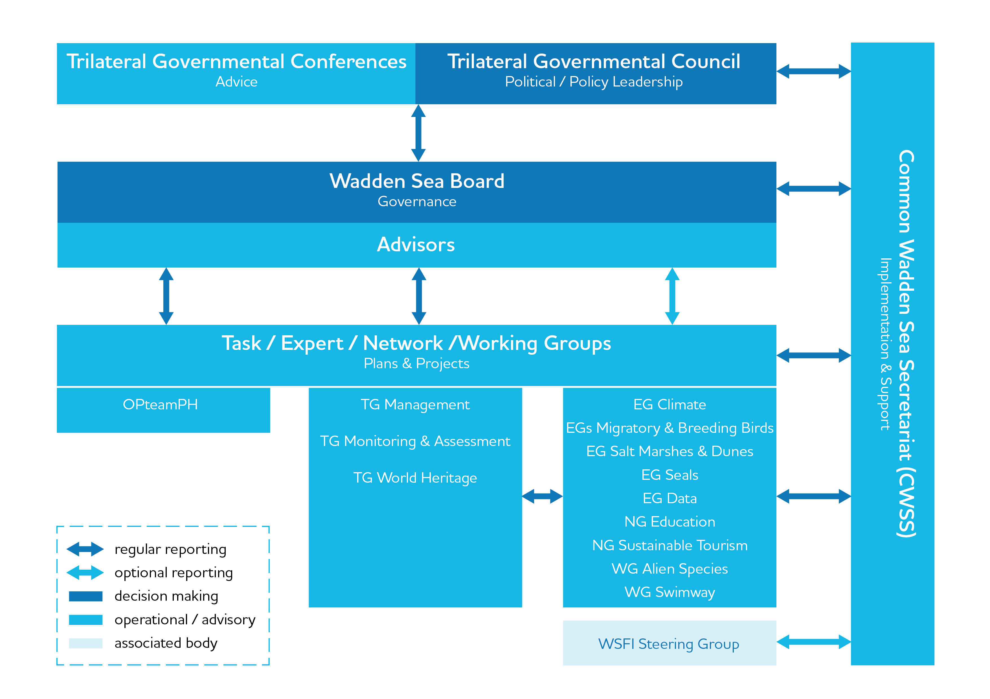

Figure 7. Organisational structure of the Trilateral Wadden Sea Cooperation (TWSC). Abbreviations: OPteamPH is the operational team for the Partnership Hub, TG are the task groups, EG are expert groups, NG network groups, WG working groups and WSFI is the Wadden Sea Flyway Initiative.

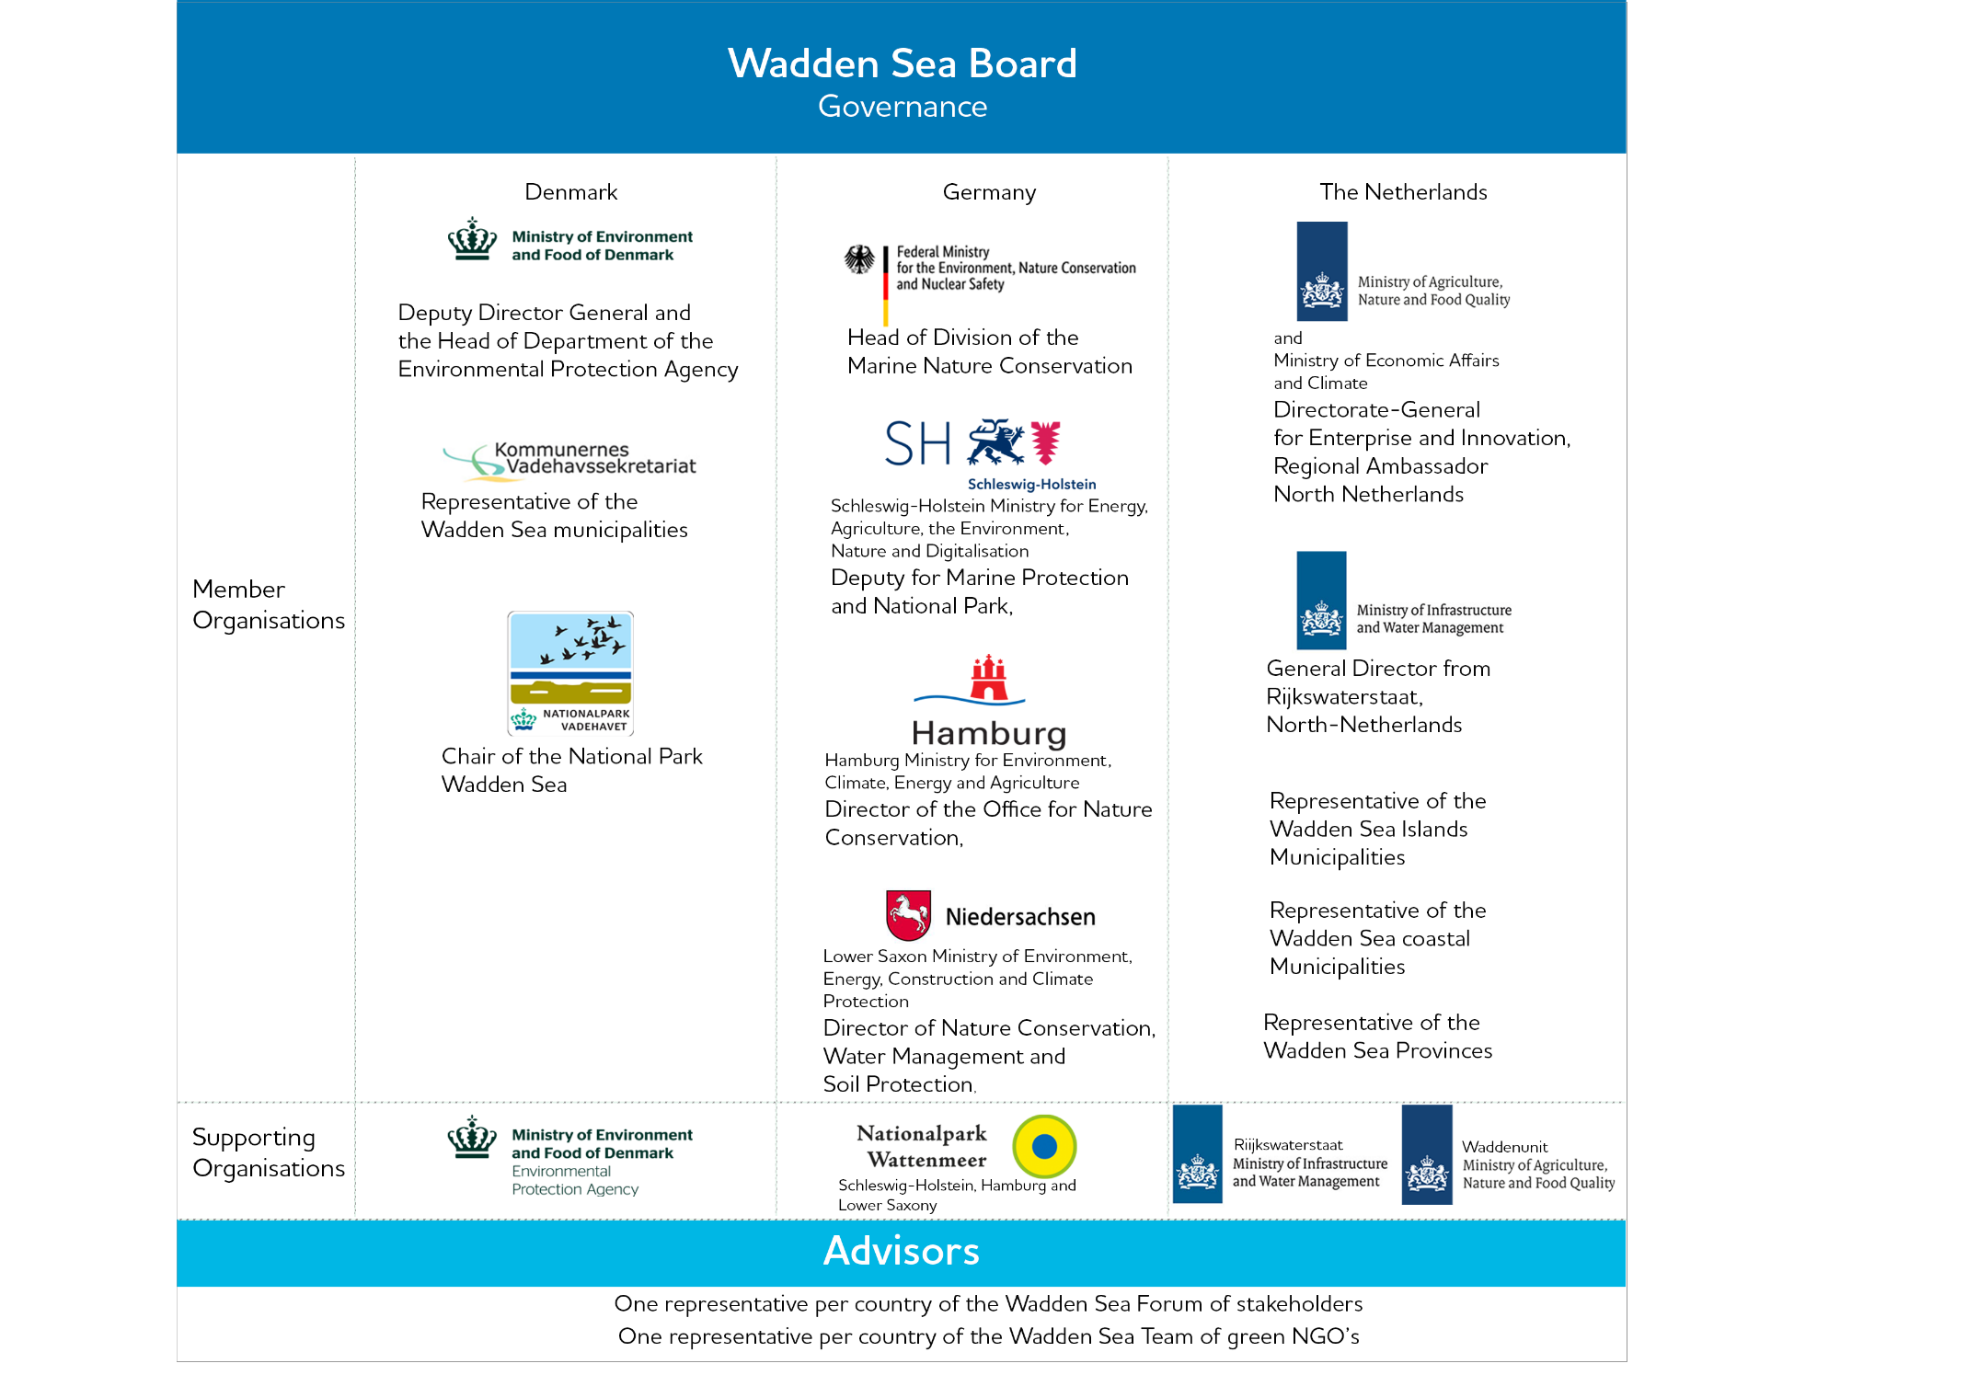

Figure 8. Member, supporting organisations and advisors of the Wadden Sea Board.

  - Management Cycle
[Note to site managers: Can we make this heading operational and useful for site managers? The management cycle highlights some of the gaps we have and can improve support for the responsible authorities in the management of the key topics. Site managers can showcase good practices for management on the ground, including challenges where further collaboration is needed.]
The existing TWSC management instruments are organized in the phases of the management cycle. The Operational Guidelines for the Implementation of the World Heritage Convention (§ 111) states that a management cycle of planning, implementation, monitoring, evaluation and feedback are among the elements of an effective management (Figure 9).
Planning
The Guiding Principle of the TWSC since 1991 is the guideline for management planning (6th Trilateral Governmental Conference in Esbjerg, 1991). An essential element of the management system and the backbone of the planning phase in the management cycle is the Wadden Sea Plan (WSP). The WSP was adopted at the 8th Trilateral Governmental Conference in Stade in 1997 and updated in 2010 (11th Trilateral Governmental Conference in Sylt, 2010) to take into account the EU Directives and the inscription of the Wadden Sea World Heritage.
The Ministerial Declarations issued on the occasions of the Trilateral Governmental Conferences every four years, are political declarations, in which agreements are made between the governments, which are relevant for all areas of the cooperation such as management, monitoring, international cooperation, etc. The declarations are therefore an integral part of the total protection and management scheme of the property to which the governments have committed themselves and are politically binding for the appropriate authorities in the three countries.
At the national level, management and monitoring activities are guided by the requirements of the national management systems and relevant EU law. Among these are: Natura 2000 management plans in Denmark and the Netherlands, National Park Management Plan in Denmark and several management plans for the Wadden Sea area in the Netherlands. In Germany, the WSP as the management plan for Natura 2000 areas within the Wadden Sea and the Wadden Sea National Parks.

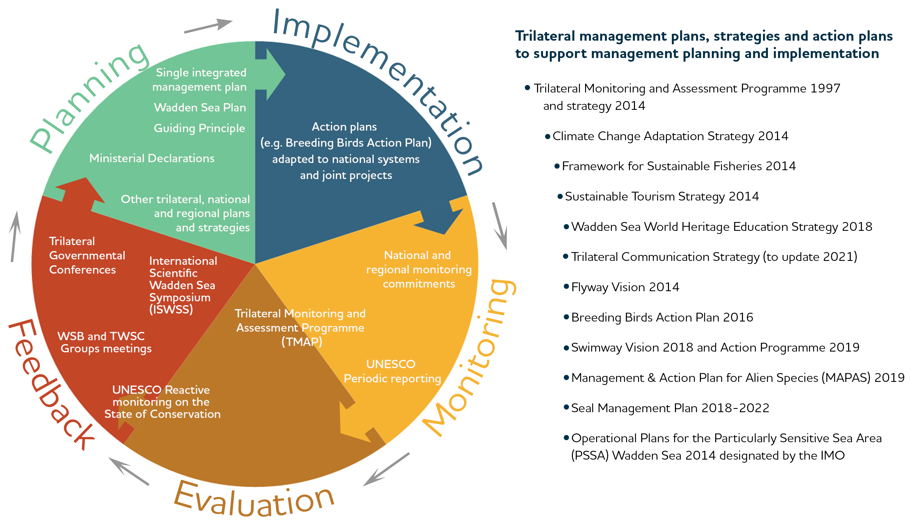

Figure 11. Phases of the management cycle required for an effective management system (as defined in § 111 of the Operational Guidelines for the implementation of the World Heritage Convention) adapted for the Wadden Sea World Heritage by including the elements on each phase. List of trilateral plans, strategies and action plans to support management.

Implementation
Trilateral visions, policies and agreements are implemented in the three countries according to their laws, management structures, political frameworks and cultures. Specific action plans and joint projects assist the implementation on the ground by specifying the who, where, when and how. Likewise, TWSC political decisions are fuelled by the local and national approaches and requirements.
As an example, due to the Wadden Sea’s significance for aquatic migration, the three Wadden Sea countries signed the Agreement on the Conservation of Seals in the Wadden Sea (WSSA) in 1991. The WSSA represents the first daughter agreement concluded under the Convention on the Conservation of Migratory Species of Wild Animals (CMS), and the CWSS acts as the secretariat. The aim of this trilateral environmental agreement is to cooperate closely in achieving and maintaining a favourable conservation status for the harbour seal population of the Wadden Sea. The WSSA contains provisions, amongst others, on research and monitoring, protection of habitats and awareness resulting in a stable harbour seal population which recovered well from the two PDV epidemics in 1988 and 2002. The underlying framework is the Seal Management Plan which is regularly reviewed and adjusted to the most recent developments.
An example of successful joint projects that promoted the development and current implementation of the Sustainable Tourism Strategy are the Interreg projects PROWAD, PROWAD LINK, Watten Agenda and Watten Agenda 2.0, and NAKUWA. The Wadden Sea Flyway Initiative (WSFI) collaborates with partners beyond the trilateral cooperation to jointly protect and manage the important sites along the East Atlantic Flyway (see Section 7. Global Dimensions).
Monitoring
The Trilateral Monitoring and Assessment Programme (TMAP) is one of the cornerstones of the TWSC and a prerequisite for the inscription on the World Heritage list. The TMAP covers the entire Wadden Sea cooperation Area and spans a broad range from physiological processes over population developments to changes in landscape and morphology. TMAP was developed to fulfil the needs of various national and international reporting obligations, in particular those from the EU Habitats, Birds, Water and Marine Strategy Framework Directives. The aims of the trilateral Wadden Sea monitoring, assessment and research are:
- to provide a scientific assessment of the status of the ecosystem,
- to assess the status of the implementation of the Ecological Targets of the Wadden Sea Plan,
- to use ecological monitoring and assessment to fulfil the UNESCO obligations for the World Heritage status and support the implementation of the single integrated management plan.
The assessment results are presented in a periodic quality status report.
Further, the World Heritage Convention (Art. 29) requests the State Parties participate in regular periodic reporting on the implementation of the World Heritage Convention. The report is submitted every six years to the World Heritage Centre (§ 199, Operational Guidelines for the Implementation of the World Heritage Convention).
Additionally, the three countries as EU member states, are obliged to monitor the conservation status for all habitats and species (§ 11 of the Habitats Directive) of Community interest (as listed in Annex I, II, IV and V) and bird species under the Birds Directive.

Evaluation
Since 1999, the Trilateral Wadden Sea Cooperation (TWSC) between Denmark, Germany and the Netherlands has periodically produced Wadden Sea Quality Status Reports (QSR) describing and evaluating the current ecological status of the Wadden Sea. The QSRs identify changes in this status and their possible causes, classify issues of concern and indicate possible measures of amelioration, including evaluation of the likely effectiveness of these measures. They also indicate gaps in our knowledge. Between 1993-2022, six QSRs have been produced. The QSRs are part of the Trilateral Monitoring and Assessment Programme (TMAP). (find QSR reports at http://qsr.waddensea-worldheritage.org/).
Additionally, World Heritage Committee may request the State Parties to report on the state of conservation of the property through the reactive monitoring procedure. The State Parties shall submit specific reports and impact studies each time exceptional circumstances occur, or work is undertaken which may have an impact on the Outstanding Universal Value of the property or its state of conservation (§ 169, Operational Guidelines for the Implementation of the World Heritage Convention).
Periodically, the World Heritage Centre develops regional reports with the periodic reports submitted for each property. This is presented to the World Heritage Committee for examination, adoption and formulation of recommendations (Further reading: https://whc.unesco.org/en/periodicreporting/).
As most of the Wadden Sea World Heritage is designated as Natura 2000 sites, each EU member state reports every six years about the progress made on the implementation of the Habitats Directive, specifically on the status and trends of the habitat types and species (§ 17 Habitats Directive Reporting), as well as the Birds Directive, Water Framework Directive and the Marine Strategy Framework Directive.
Feedback
Feedback as part of the management cycle takes place at all levels of the TWSC structure (Figure 7 and Section 3.1 Trilateral cooperation structure).
Feedback from the task, expert, network and working groups of the TWSC flows among groups and to the Wadden Sea Board. TWSC groups meet in person 2-3 times per year to exchange information, coordinate monitoring, assess results and provide advice on the scientific basis for management. The WSB meets at least 2 times per year.
The external advisors in the Wadden Sea Forum of stakeholders and in the Wadden Sea Team of Green NGO’s meet at least once a year to exchange and coordinate. Their representatives offer their feedback to the WSB.
In the Wadden Sea Conferences, among them the International Scientific Wadden Sea Symposium (ISWSS), the Youth Conference, the Wadden Sea Day and additional thematic workshops, the research community, managers and the young Wadden Sea stakeholders, give advice on management and political decisions addressing the Trilateral Governmental Council.
The Quality Status Reports (QSR) recommendations represent clear scientific advice to the Trilateral Governmental Council about the priority issues that need further attention. Each of the five key topics is linked to a respective QSR Thematic Report.
The Trilateral Governmental Council, as the politically responsible body of the TWSC, meets generally every 4 years at the Trilateral Governmental Conferences. Trilateral Governmental Conferences serve to assess the implementation of the planning instruments in terms of policy and management and to prioritize the issues that need further attention. Trilateral Governmental Council meetings result into Ministerial Declarations and/or the adoption of updated plans, closing in this way the management cycle.
Since the time of inscription, the World Heritage status is an integral part of all phases of the Wadden Sea management cycle.

- Towards a Sustainable Management in the Wadden Sea
The development of the SIMP addresses key topics that pose challenges for maintaining the OUV and takes into consideration the influence of climate change adaptation at all levels of planning and management. The prioritized key topics relate to human activities relying on ecosystem services and taking place inside and adjacent to the World Heritage property.
The five key topics are 1) fisheries, 2) tourism, 3) shipping and ports, 4) renewable energy and energy from oil and gas and 5) coastal flood defence and protection measures. These were identified by local managers and endorsed by the WSB. Furthermore, the SOUV states that these topics pose key threats to the integrity of the Wadden Sea World Heritage and therefore need permanent attention.
[Note for WSB and site managers: this section will present a summary of the most useful information for site managers regarding the key topics.
For each key topic, the SIMP document will present a summary of the inventory, the common ground and the legal framework, a rapid risk assessment of the impacts of each key topic on the OUV and recommendations as procedures or strategic actions to improve exchange, mutual learning and achieve common agreements.
These recommendations will be defined together with site managers during the “Working with site managers” phase. The recommendations can represent updated and adapted proposals for management improvement and coordination, directed by the TWSC Guiding Principle and considering the crosscutting influence of climate change effects. The recommendations will build on and respect the sovereignty of the local management authorities. Therefore, recommendations are meant to improve cooperation and not to prohibit activities.
This section will also include an indication on the necessary resources to implement recommendations/agreements and strategies to afford those resources.
The SIMP will include the heading “Climate Change Vulnerability and Adaptation” showing how is the TWSC addressing climate change and based mainly on the Trilateral Climate Change Adaptation Strategy (CCAS), the respective QSR Thematic Reports, the main results of the Climate Vulnerability Index (CVI) assessment (phase 1 and 2). The second phase of the CVI process, planned for February 2021, will assess the vulnerability of the associated community (local, domestic and international) with special focus on the five SIMP key topics.
Annex 2. Presents the key topic renewable energy as an example and indication of the aspired level of ambition.]
- Mechanisms to Support Management
[Note for WSB and site managers: site managers will be asked to pay special attention to this section to enrich with practical approaches, and operational information on how the mentioned trilateral strategies and plans are (or can be) implemented on the ground]
  - Science and Research
The more than four decades lasting Trilateral Wadden Sea Cooperation (TWSC) is based on science and research. To assess the status of implementation of the Targets of the Wadden Sea Plan, reliable scientific evidence is crucial. The common Trilateral Monitoring and Assessment Programme (TMAP) which also underpins the criteria for the inscription on the UNESCO World Heritage List, provides the necessary information. By regularly publishing Wadden Sea Quality Status Reports (QSR) in which more than 100 scientists (QSR 2017) from the three Wadden Sea states are involved, the development of the Wadden Sea ecosystem is described, and trend analyses are reported.
Upon the invitation of the TWSC, the scientific community was invited to develop a Trilateral Research Agenda (TRA). This TRA gives an overarching, comprehensive and integrated view on research needed in the future to contribute to the aim of the TWSC and safeguarding the Wadden Sea World Heritage OUV. The TRA was welcomed at the last TGC (Leeuwarden, May 2018) and subsequently a Trilateral Programming Committee (TPC) was established. The members of this Committee represent science and policy-management of the three states. The Committee will serve as focal point to foster science cooperation and applied research on the Wadden Sea World Heritage. Part of the assignments given to this TPC also includes the search for funding possibilities.
To underline the importance of the SIMP development with respect to potential research questions, reference is made to the TOR of this Committee. With a specific link to the SIMP, the incorporation of upcoming management requests by the SIMP process is stimulated to be considered on the agenda of the TPC and/or in the Joint Trilateral Programme on research issues relevant to the Wadden Sea World Heritage to be developed by the Committee.
  - Monitoring and Assessment
The main technical purpose of monitoring the ecosystem and human activities is to collect data necessary for a scientific evaluation of the status of the ecosystem and the intensity and impact of human use and its implications to the system. This scientific assessment is an important basis for the formulation of policies and measures. Scientific knowledge is a prerequisite for the development of appropriate monitoring, application of assessment criteria and the formulation of policy goals for the protection of the ecosystem.
The TMAP covers the entire Wadden Sea cooperation Area and spans a broad range from physiological processes over population developments to changes in landscape and morphology. The TMAP common package was implemented based on a decision at the Ministerial Conference in Stade 1997 and further developed to fulfil the needs of various national and international reporting obligations, in particular those from the EU Habitats, Birds Water and Marine Strategy Framework Directives.
Due to the further development of the reporting under these directives, the TWSC aims to foster the adjustment of the TMAP to today’s obligations and to guarantee a future proof approach with the necessary synergies with existing monitoring programmes. Focus is also on increasing the visibility and outreach of TMAP and the advantage as a sound basis for reporting through the Quality Status Reports.
The QSR Thematic Reports are written by scientists and edited by the QSR Editorial Board in cooperation with CWSS. The QSR Thematic Reports are foreseen to be updated in regular intervals based on data availability, trilateral events or emerging issues. A QSR Synthesis will combine the findings from the Thematic Reports and will be issued in the forerun of the Ministerial Conferences every four years to provide condensed overview on the status of the ecosystem with relevant information for management and decision making.
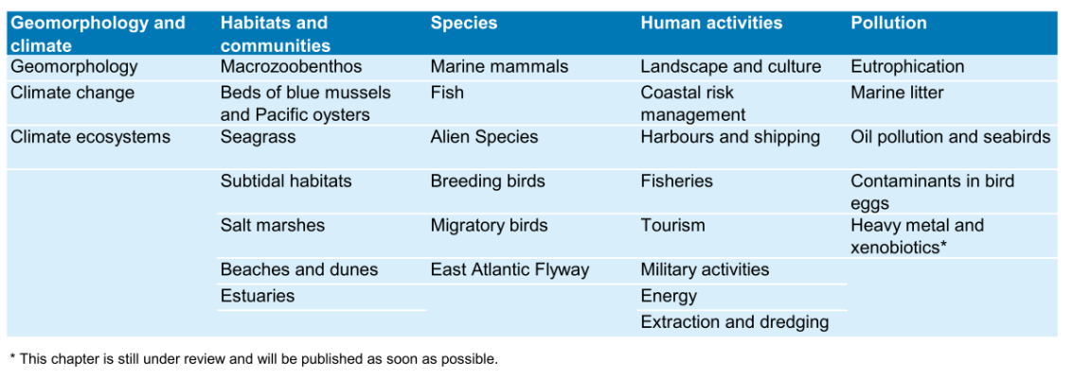
Table 1. List of QSR Thematic Reports 2017.

Challenges and Outlook
TMAP assessment and adjustment:
In the coming years new requirements to the TMAP will emerge, related to (new) trilateral policies with regard to, inter alia:
- Impacts of climate change (see climate adaptation strategy)
- Invasive Alien Species (see trilateral IAS Strategy, EU Directive on Alien Species)
- HD (Habitat types with unknown status, especially sublittoral), MSFD (Wadden Sea relevant descriptors)
- Sustainable human use, e.g. shipping
- Marine litter
- New pollutants
Proposal for new or amended parameters and methodologies will be coordinated by TG-MA in close cooperation with the trilateral expert and task groups, also considering input from relevant research and monitoring projects.
  - Knowledge Management
The Wadden Sea community is a worldwide outstanding example of knowledge and experiences when it comes to policy, management, research and monitoring of a large-scale mudflat and barrier islands ecosystem. To make this knowledge available to managers and stakeholders in the entire Wadden Sea has high priority for the TWSC. Management of the Wadden Sea as an ecosystem shared by three countries requires knowledge of the entire system. A milestone to collect and make this knowledge available started with the Wadden Sea network of engaged scientist in the 1960s. This resulted in the first scientific Wadden Sea symposium 1975 where scientist called for a better protection of the Wadden Sea and a trilaterally coordinated effort. Nowadays, the scientific symposia, which take place about every four years, play a crucial role in the TWSC to enhance exchange between scientists, managers, and stakeholders.
CWSS was installed in 1987 to facilitate and coordinate the TWSC. The CWSS has now also developed into a trilateral “knowledge management hub” with providing access to publications and reports relevant for trilateral policy, management, research, and monitoring.
Annual Wadden Sea Days dealing with management and research topics support exchange between site managers and provide the most recent knowledge across the three countries.
Trilateral working groups on expert and manager level meet regularly to compile, assess and provide recommendations for the governments. They connect local and national management with the trilateral management and policies.
On international level, an exchange with other World Heritage marine sites or mud-flat ecosystems are dealt with to enhance understanding of natural systems and how to manage them.
The main challenge nowadays is how knowledge creation and exchange can be organized trilaterally and how diverse target audiences involved in management can be enhanced. For example, through new forms of cross-sector collaborations (such as “communities of practice”) are enhanced using appropriate technologies (such as knowledge bases, expert system, and IT cooperative work).
  - Education for sustainable development and interpretation
Outreach and education are an obligation that directly ensues from the World Heritage Convention and inscription on the World Heritage List. In order to protect and maintain the OUV of the Wadden Sea it must be known, understood and respected. Thus, interpretation of the Wadden Sea World Heritage is essential for a broad acceptance and support of the long-term protection of the Wadden Sea.
The Wadden Sea Strategy on Education for Sustainable Development and World Heritage Interpretation (adopted in 2018) provides a transboundary framework for environmental education and interpretation in the entire Wadden Sea World Heritage Site. It builds on the local, regional, and national concepts and activities with the aim to promote the Wadden Sea’s OUV in a transboundary and interdisciplinary approach.
At the trilateral level, the Trilateral Network Group Education oversees the implementation of the strategy with the coordination of joint activities according to the Trilateral Education Work Programme provided by the International Wadden Sea School (IWSS) in cooperation with the Common Wadden Sea Secretariat (CWSS).
At the national level, the activities are coordinated by the respective national stakeholders according to the individual national strategies and concepts.
The strategy links and contributes to implementing other important strategies for the Wadden Sea, namely the overall World Heritage Strategy and the strategy for sustainable tourism. It also contributes to the UNESCO Programmes for “World Heritage Education” and “Education for Sustainable Development”.

  - Communication
[Note for WSB and site managers: This section will include communication objectives, communicative principle, strategic aims, key messages and key audiences and what to do/ who to contact if communication measures are needed.
The section will address the different users of the SIMP (visitor centres, communication units in National Parks, authorities, and more) according to their communication needs.
As this section will be based on the updated Communication Strategy (update planned for 2021) and the brand activation toolbox currently being created in the framework of Prowad Link, as well as correspond to the other SIMP sections, it will be drafted at a later stage]
  - Partnerships
The inscription of the Wadden Sea on the World Heritage List represents a unique opportunity to pool and strengthen existing skills and experiences under one umbrella, to ensure protection and preservation of the Wadden Sea, whilst continuing to foster sustainable regional development within the entire Wadden Sea Region. Only if these skills and experiences are jointly and mutually reinforced and linked by a high-quality level of collaboration and engagement of actors and society in the Wadden Sea Region, will the full potential of the World Heritage designation be achieved for the benefit of nature, but also for the society.
To realize such a practical engagement, a Memorandum of Understanding was officially signed at the 10th anniversary of the inscription of the World Heritage Wadden Sea in June 2019, in Wilhelmshaven. The signatories of trilateral strategic partners were: the Wadden Sea Forum e. V., the Wadden Sea Team of green NGOS, the trilateral Network Group Sustainable Tourism, the trilateral science community and the TWSC. Their objective is to establish jointly the multi-stakeholder “Trilateral Partnership in support of the UNESCO Wadden Sea World Heritage” (in short: Trilateral WH Partnership). The initiative aims to enhance ownership for the Wadden Sea World Heritage and to build an extended and stable, multi-level and cross-border community in a networking approach, complementing governmental and intergovernmental efforts in delivering on the goals of the WSWH strategy/ the WSWH management plan (to be discussed among partners later, once the SIMP draft is published). The initiative is open to further stakeholder networks and organisations, which commit to the objectives and are willing to collaborate within the framework of the MoU.
The Trilateral WH Partnership is based upon existing, proven structures and networks with a long history of achievements and contributions of stakeholders’ and partner‘s networks. Furthermore, the initiative aims at complementing national and regional, site specific partnership initiatives for nature conservation and sustainable development.
Developing and sustaining a successful Trilateral WH Partnership, particularly across sectors and existing collaboration structures, is challenging and requires a significant investment of both time and resources. It needs an organisational set-up to further develop, support it and keep it up and running effectively: A Partnership Hub.
The trilateral Partnership Hub supports management and organisation of the trilateral WH partnership as a networking unit. It strives to act as catalyst for innovative modes of collaboration, focussing on creation of collaborative advantages by also considering interests and individual value gained by the partners.
The structuring and setting-up of the Partnership Hub follow a stepwise approach to secure flexibility and adaptability as the partnership develops further. During the three years start-up-phase, the team of the Partnership Hub is associated to the Common Wadden Sea Secretariat to the TWSC, which provides a backbone during this phase. The hub will support the strategic partners to collaborate, encourage and facilitate effective and trustful working relationships, while sharing information, knowledge and experience. It will facilitate planning and initiation of specific trilateral projects, common actions and assist partners with applications for funding. The start-up phase of the Partnership Hub will be concluded by an evaluation, including a review of the governance and management structures. Based upon the outcome of the evaluation, the Partnership Hub will be developed into a more or less independent organisation for the long-term perspective.

- Global Dimensions

  - Global Interconnections
The global dimension of the Wadden Sea is not only apparent in the status as World Heritage property but also in the fact that it is highly interconnected with other sites. Many challenges for the Wadden Sea’s management can only be approached globally, e.g. protection of migratory birds, dealing with impacts of climate change on ecosystems, or reduction of marine litter. This calls for close collaboration with partners beyond the Wadden Sea since what may happen outside the Wadden Sea (e.g. in the Artic or in Africa) may have consequences for the management in the Wadden Sea (e.g. protection of birds). The Wadden Sea’s World Heritage key values can only be maintained if the other interconnected sites are managed successfully. This underlines the importance of supporting the protection of other (World Heritage) sites along the flyways.
As a consequence of the request by the World Heritage Committee, the Wadden Sea Flyway Initiative (WSFI) was launched in 2012 to foster collaboration along the African Eurasian Flyways. The Initiative established a network of partners and important sites along the East Atlantic Flyway from the wintering sites along the West African seaboard to the breeding sites in the Arctic areas.
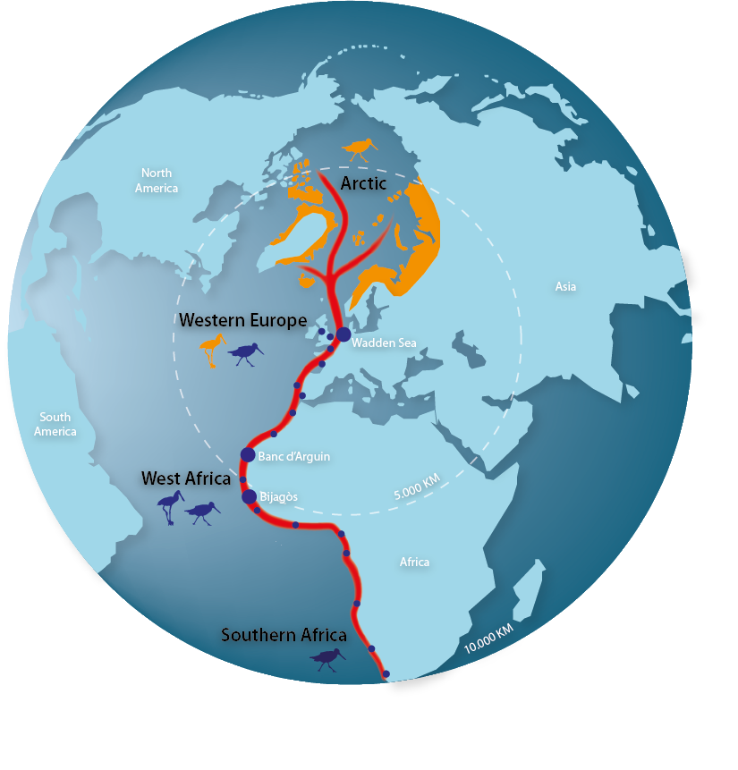
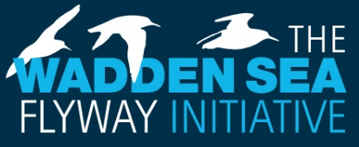
Figure 13. The East Atlantic Flyway Globus.

Partners in almost 30 countries are working together to jointly protect and manage their shared bird populations by cooperating in monitoring and capacity building activities. In the coming years, WSFI aims for an autonomous bird management in the African partner countries, to react on the impact of climate change for a resilient flyway and improve the cooperation with countries in the Arctic. Regarding the protection of intertidal ecosystems, successful cooperation has been established with West-African countries in particular with the World Heritage National Park Banc d’Arguin in Mauritania (MoU since 2014), but also with the Bijagòs Archipelago in Guinea Bissau.
  - International Cooperation
With the inscription, the TWSC has entered a commitment to contribute to the objectives of the World Heritage Convention by further enhancing international cooperation (World Heritage Convention, Article 7) including the obligation to contribute to the work of the Convention to protect and safeguard properties of outstanding universal value. At the same time, it presents a global recognition of its values and the many years of successful joint conservation work of the TWSC acting as a as a model for in particular trans-boundary World Heritage property management to other sites.
Putting the Wadden Sea on a global scene also offers new pathways for international cooperation, joint learning and developing solutions for the preservation of the Wadden Sea in a rapidly changing global world. Cooperation with other World Heritage properties also helps to raise the profile of the Wadden Sea internationally and within the World Heritage Convention.
The Wadden Sea World Heritage is contributing with its vast knowledge to support nomination efforts of future World Heritage properties. An exchange with the Yellow Sea countries already exists over many years as the Wadden Sea and the Yellow Sea both share tidal flat ecosystems of global importance as stopover sites for migratory birds.
The TWSC cooperates with the Republic of Korea (MoU with the Ministry of Ocean and Fisheries since 2009). Almost 240 experts have participated in the exchange regarding management, monitoring, research and communication. Over the years this collaboration has involved in total over 2,100 persons at both sites. The TWSC also supported the Republic of Korea in the preparation of World Heritage nomination dossier on Korean Tidal Flats covering the criteria (vii), (ix) and (x), same criteria as the Wadden Sea. The dossier was submitted to the World Heritage Committee for consideration at its 44th meeting in 2021 [Note for WSB: to be updated after Committee decision].
Knowledge exchange will be the main topic of collaboration with the Yellow Sea countries. It can provide scientific knowledge for management, strengthen the capacity for communication and education, and provide many valuable examples for practitioners which they can apply at their site. A collaboration between the globally very important flyways sites (the East Atlantic Flyway – EAF and the East-Asian-Australasian Flyway – EAAF) can promote a mutual exchange in improving flyway management and research in mud-flat ecosystems worldwide.
The UNESCO World Heritage Centre, which serves as the global Secretariat to the World Heritage Convention, not only manages all official processes around the Convention, but also runs thematic programmes to help State Parties and the World Heritage properties to implement the Convention.
Since its inscription on the World Heritage List the Wadden Sea has been an active contributor to the UNESCO World Heritage Marine Programme. This is a network of site managers from 50 marine World Heritage properties across 37 nations. Tapping the vast expertise contained within the network helps to accelerate achieving sustainable marine protected areas. Expertise is shared from across the network through site-to-site field visits, e-communication and tri-annual global managers conferences.
The Wadden Sea also cooperates with the UNESCO World Heritage and Sustainable Tourism Programme. This Thematic Programme underlines the shared responsibility of stakeholders for conservation of cultural and natural heritage of Outstanding Universal Value and for sustainable development through appropriate tourism management.
As requested by the Committee in 2009, a Strategy for Sustainable Tourism in the Wadden See World Heritage Destination was adopted in the Wadden Sea in 2014. Through regular exchange with the World Heritage Centre and stakeholders from other World Heritage properties, the Wadden Sea benefits from the networks when implementing or further developing the tourism strategy and action plan. The Wadden Sea is acknowledged worldwide as an example of transnational collaboration, pooling resources, and engaging tourism stakeholders in the protection of the OUV for mutual benefit.
Engaging in international cooperation creates opportunities for sharing knowledge and experience exchange in management of World Heritage properties. Managers, NGO’s and other stakeholders active in the Wadden Sea World Heritage have used these opportunities for mutual learning in areas such as protected areas tourism, monitoring and education. [Note for the WSB: At a later stage, priorities for the next years should be defined and included here or in a fitting heading.]
  - Contributions to the SDGs of the UN Agenda 2030
The Wadden Sea can be seen as a prime example for contributing to the implementation of the Agenda 2030 for Sustainable Development with its globally decided Sustainable Development Goals: not only that the Wadden Sea delivers an important contribution to SDG 14 and 15 “Life under water” and SDG 15 “Life on land” but also strengthens the natural resilience and adaptive capacity to climate-related effects (SDG 13). Furthermore, the trilateral cooperation’s actions and plans to protect and restore water resources and water-related ecosystems contributes to SDG 6 and supports the area’s sustainable economy and leverages local culture (SDGs 8 and 12). Education for sustainable development and the International Wadden Sea School (IWSS) openly accessible in all languages of the Cooperation addresses SDG 4. SDG 17 “Partnerships” is contributed to by the “Trilateral Partnership in support of the Wadden Sea World Heritage” (Figure 12). [Note for the WSB: After approval by WSB 32 and the UN, in SDG17 can be added: “registered as transboundary, multi-stakeholder Partnership in the UN’s global registry on SDG partnerships”].

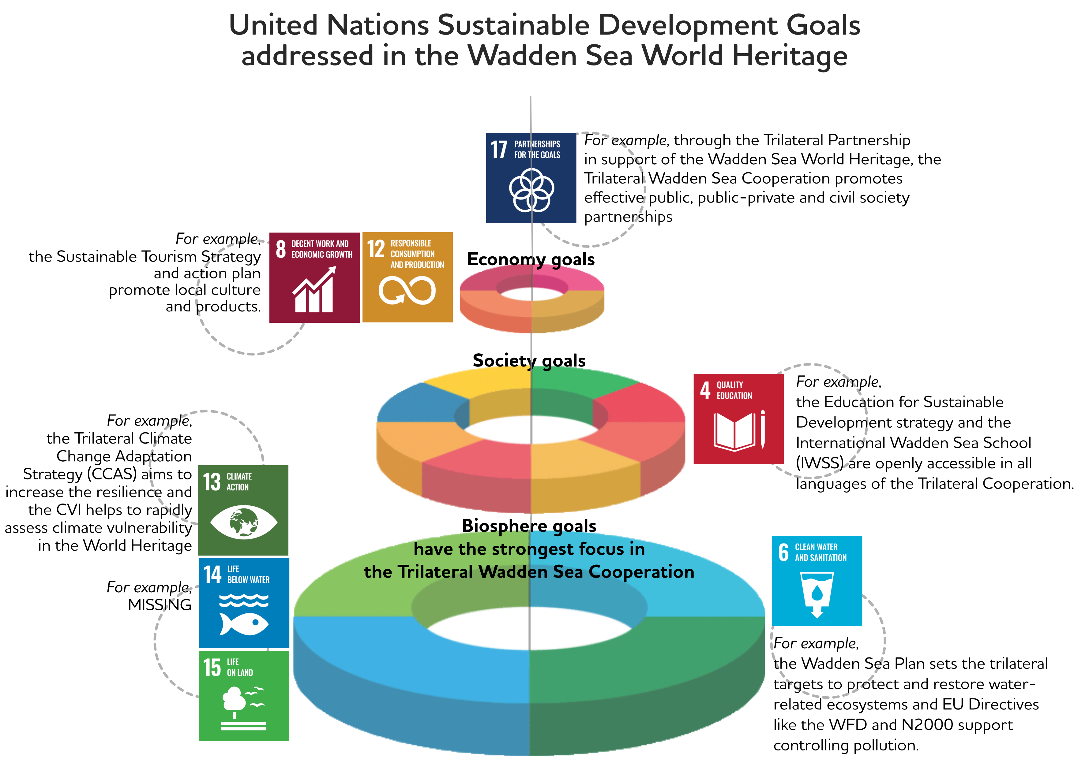

Figure 12. The TWSC addresses SDGs 4, 6, 8, 12, 13, 14, 15 and 17.

- Abbreviations
EPA
LNV
SIMP
SMP
STS
TWSC
…
- References
[Note: TG-WH to discuss how to deal with the references: as further reading on the margin of the page, as a list of sources of information, or in the scientific way. The references shouldn’t interrupt the reading flow]

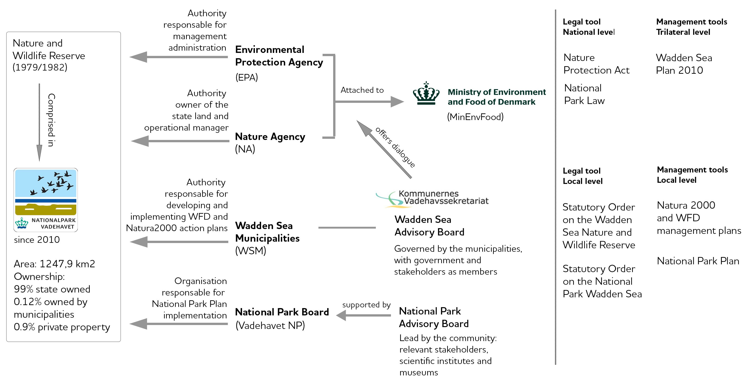
Annex 1

Figure A.1. The Danish Environmental Protection Agency as part of the Ministry of Environment and Food is responsible for the management administration of the Nature and Wildlife Reserve and of the enforcement of the national legislation. The Nature Agency is owner and operational manager. The National Park encompasses the Nature and Wildlife Reserve. The National Park Board is responsible for the implementation of the National Park Plan in accordance with the Statutory Order for the Danish National Park Wadden Sea.

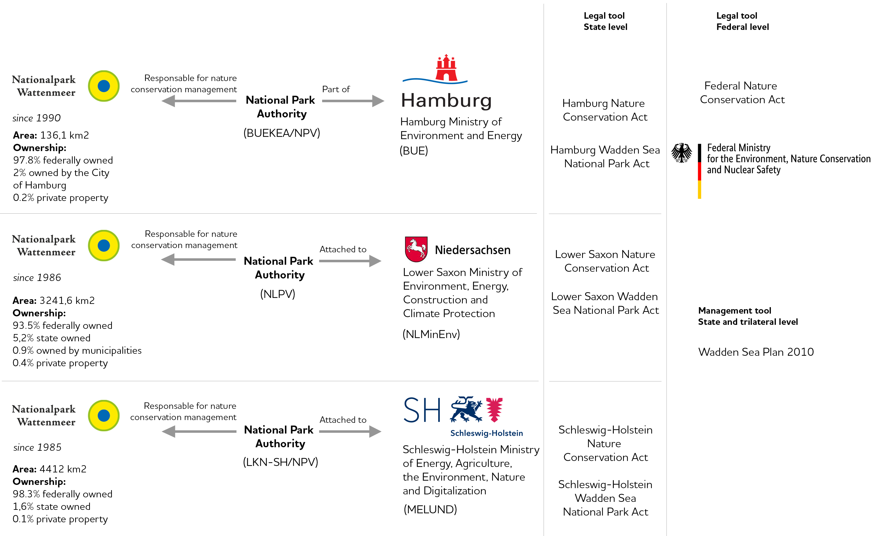

Figure A.2. General management system of the Wadden Sea Cooperation Area/Nature Conservation Area is organized at the Federal State level as outlined in the Federal Nature Conservation Act. State National Park Authorities are the competent authority for the management and protection of each National Park. Each National Park Authority is part of or is attached to the respective State Ministry of Environment. Sites outside the National Parks are also managed by local authorities. Management is supported by advisory boards and green NGOs and other partners from the civil society.
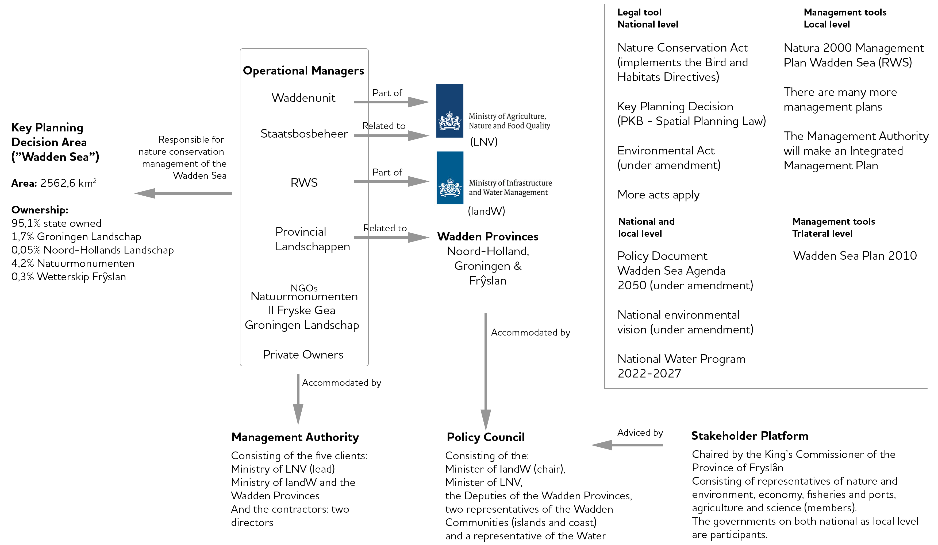

Figure A.3. The Management system of the Wadden Sea in the Netherlands (established in 2020) comprised of the Management Authority is responsible for the management of nature, fish and water, the Policy Council and the Stakeholder Platform. NGOs, private owners and organisations attached to the Ministries of LNV, IandW and the Wadden Provinces are responsible for planning and management implementation at the operational level.

Annex 2
  - Renewable Energy
Introduction
Playing a crucial role in combating climate change, renewable energies do already and will even more contribute to the reduction of CO2-emissions in the upcoming years. Renewable energy in the Wadden Sea in this context refers to wind energy both in the offshore area and the coastal area.
The impact of energy generation and transport with regard to the OUV key values is important to be highlighted as it serves to identify possible needs for closer cooperation, exchange and harmonisation of procedures within the existing frameworks of the TWSC.
The Common Policy
There are no offshore wind farms or wind turbines within the Wadden Sea World Heritage property. The Wadden Sea Plan (2010) presents the common policy that no wind turbines shall be erected in the Nature Conservation Area and to allow it outside the Conservation Area only if important ecological and landscape values are not negatively affected.
Nonetheless, the associated grid connections of offshore wind farms outside the property with the onshore power grids traverse the Wadden Sea World Heritage property as high voltage submarine cables in several corridors. In this regard, the three countries agreed to “concentrate cable crossings through the Wadden Sea within a minimum of cable corridors and a minimum of cables using the best available techniques, e.g. cables with highest capacity available, and to communicate regularly on this item in order to use synergies” (WSP, 2010).
Keeping this in mind, the Leeuwarden Declaration (2018) contains the stipulation to: “29. Instruct the Wadden Sea Board to review and monitor the impacts of renewable energy production and energy transportation on the Wadden Sea ecosystem and to consider measures to avoid or mitigate possible negative impacts by looking for best environmental practices also with the aim of developing, for example, related common principles to evaluate the impact of high-voltage power cables in the Wadden Sea Area in close consultation with the responsible bodies and stakeholders;”
Regulations
Spatial planning is one of the key instruments to balance competing spatial interests. Bearing in mind the impacts of wind turbines and power cables on the environment, especially on nature and human health, it has widely been recognized that the construction of wind turbines and the laying of cables shall be restricted to defined areas.
In Germany, spatial planning lies in the responsibility of the Federal States including territorial waters up to 12nm from the coastal baseline. The sectoral Site Development Plan (Flächenentwicklungsplan; FEP) is the controlling planning instrument for the use of offshore wind energy and offshore grid connections in the EEZ. Within the Federal States, special areas for wind farms (Windenergieeignungsgebiete) are designated. The construction wind farms, and their repowering is hence limited to these areas. Regarding the grid connection of the high voltage power cables which connect the offshore wind farms in the EEZ with the grid nodes in the mainland, the corridors have been defined and incorporated into the respective spatial development programmes.
The Nature Conservation Act states that when licenses for laying of high-voltage power cables are issued, avoidance and mitigation measures are part of the permits. First of all, the cable corridor with the least impact on the environment is identified after a thorough assessment of alternatives. Concerning the cable laying as such, best available techniques to minimize effects on soil, habitats, benthic organisms, birds, mammals are identified and have to be applied.
In the Netherlands, there are various procedures to be followed before windfarms can be build and decisions are final. The participation process is continuous and runs throughout the procedures. The needed decisions (integration plan and implementation decision) are brought in procedure simultaneously. The integration plan applies for both: the part of the project that runs over land and the part at sea.
Impacts arise throughout the cycle of marine renewable developments, including site selection, construction, operation, decommissioning and removal.
- Offshore wind farms operation: effects of noise on marine mammals and fish, disturbance and loss of habitats, bird collisions and visual intrusion.

- Grid connection planning, placement, operation and maintenance of the high voltage HDC submarine cables: the design of the cable as well as cable laying techniques are crucial factors regarding the impact on the key values, affecting benthic communities, the tidal flats, and subtidal habitats as part of the OUV (natural ongoing processes). Feeding, moulting, and roosting sites for birds as well as hauling-out sites for seals, marine mammals, biogeochemical processes.

- Onshore wind farms planning and operation: exchange between roosting, feeding and breeding sites, migratory routes might be impacted.
Threats regarding related shipping activities will be addressed in the key topic shipping.
Table 1. Existing legal framework that regulates the development of windfarms in the Netherlands, Denmark and the three German Federal States, the national policies that support the energy transition to renewable sources and international and national legal framework to regulate construction. Source QSR Energy, 2017; Nomination Dossier, 2012 and update by partner organisations.
 | Legal framework to regulate development of windfarms within the WS | Policy to promote renewable energy | International and national legal framework to regulate construction
The Netherlands | Dutch Conservation Area (PKB Area) | Energy Agreement for Sustainable Growth  National Government Vision Wind at Sea  Roadmap Wind Energy at Sea 2023  National Environmental Vision | Habitats Directive ++  EIA Directive  Wind Energy at Sea Law  Electricity law
Germany |  | Renewable Energy Sources Act (RES-Act) | EnWG  BNatSchG Incl. Habitats Directive  WindSeeG  UVPG
Lower Saxony | National Park Act; Spatial Planning Programme | Vision ‘Sustainable energy and climate protection policy’ 2016 | see above  NAGBNatSchG
Hamburg | National Park Act
Schleswig-Holstein | National Park Act  Spatial development plan and regional plans | Klimaschutzplan | LNatSchG  LUVPG
Denmark | Danish Statutory Order | Energy Act  National Energy and Climate Plan (NECP)* | Habitats Directive ++
* To meet the EU’s energy and climate targets for 2030, EU Member States need to establish a 10-year integrated national energy and climate plan (NECP) for the period from 2021 to 2030. Introduced under the Regulation on the governance of the energy union and climate action (EU/2018/1999), the rules requires the final NECP to be submitted to the Commission by the end of 2019 (ec.europa.eu/energy).
++ Habitats Directive for assessment and permission for construction of corridors for laying power cables across the area.

Threats and opportunities on the OUV key values
Preliminary ideas towards potential recommendations
(this is an example, not the outcome)
- Prepare and disseminate a toolbox that compiles the existing best environmental practices for planning, laying, and operating high voltage submarine power cables traversing the Wadden Sea.

- (Form a group with experts and members of the WS to) Work towards comparable standards. Consider what is being done at the transnational level OSPAR and MSFD to seize opportunities for mutual benefit.

